Output fact sheet

Pilot actions (including investment, if applicable)

Version 2

Project index number and acronym | CE1074 - LAirA
Lead partner | Municipality of 18th district
Output number and title | OT2.3.1 Pilot on low carbon mobility management - ITS tool application and awareness raising campaign
Investment number and title  (if applicable) | Total investment EUR 24,500.00
Responsible partner (PP name and number) | PP11 SEA Milan Airports
Project website | https://www.interreg-central.eu/Content.Node/LAirA.html
Delivery date | 2020.01.30

Summary description of the pilot action (including investment, if applicable) explaining its experimental nature and demonstration character
SEA Milan Airports procured the test of a car-pooling service, focusing on the provision of a “Software as a Service” which allows employees at SEA Milan Airports (Linate - LIN and Malpensa - MXP) and at other airport companies to access and register to a car-pooling platform, exchange information on commuting patterns with the aim of sharing trips, certify trips on the car-pooling platform, providing benefits to users.
The pilot project’s main goal is to develop low-emission solutions that will improve employees’ access to airports. The total number of employees at Milan Airports is about 27,000. The sites are very large and there are employees at different entities (employers) and with different roles, who work in various areas at the airports, sometimes far from each other; the car-pooling application aims at helping employees finding colleagues who have the most compatible home-work trip pattern and getting to know each other to share trips.
The objective of the pilot is to encourage employees currently commuting individually by their own cars and going to the same destination to share cars with colleagues, and consequently reduce car traffic. The objective is fostering behavioral change by employees and creating environmental benefits for the Airports’ FUA.

NUTS region(s) concerned by the pilot action (relevant NUTS level)
Country (NUTS 0): IT
Region (NUTS 2):
ITC4, Lombardia

Investment costs (EUR), if applicable
The total amount of the one-year contract with the carpooling provider for the activities related to the pilot implementation (SaaS implementation, service maintenance, communication campaign with materials and on-site days, periodical reports, etc.) is 24,500.00 euros, which is in part funded by LAirA and in part paid with SEA Milan Airports’ own funds.

Expected impact and benefits of the pilot action for the concerned territory and target groups and leverage of additional funds (if applicable)
The most important impact expected from this pilot is a contribution to changing the commuting behaviour of airports’ employees, that will result in benefits for the environment (in terms of CO₂ emissions reduction) and for community (in terms of less traffic and congestion). In order to encourage airport employees to share rides, SEA, with the provider support, launched periodic incentive plans, competitions dedicated to airport employees who certify their shared home-to-work trips. At the end of each competition, the best car-poolers (those sharing the most rides) are awarded with fuel vouchers (paid by SEA Milan Airports).

Sustainability of the pilot action results and transferability to other territories and stakeholders.
The LAirA pilot project has an experimental and demonstration nature and as such long-term sustainability depends on results at the end of the pilot phase, and in particular on the extent to which employees use and benefit from the service. This is independent of SEA’s availability to pay for the services once the pilot ends.
Nevertheless, SEA has already committed to sustain the car-pooling pilot with own funds. In particular, the car-pooling pilot started in July 2019 and will last 12 months, until June 2020 (6 months after the LAirA project closure). In fact, SEA assessed that a 6-month pilot was too short to evaluate the pilot longer-term sustainability, also considering:
- the summer period, which inevitably limited the number of users;
- the fact this is a new initiative and needs time for users to be informed of and confident with the service;
- eventual corrective actions, that will need time to generate effects.
Further than paying with own funds the car-pooling service in the period January-June 2020, SEA will take further actions to promote the service and this will be delivered by SEA internal staff. Actions will focus on enhancing communication to users, and in particular workshops and webinars to present the service, its functioning and benefits.
Finally, the pilot project has already generated an additional result. Based on user feedback SEA has launched a “Bike Race” for employees working at Linate Airport, with the aim of promoting cycling to work.

Lessons learned and added value of transnational cooperation of the pilot action implementation (including investment, if applicable)
These seven months of carpooling-scheme implementation have been extremely useful to think over the success and failure factors of the pilot project and to better understand the current employees’ mobility behaviours at both Milan Airports, especially for those who commute by car, and their real inclination to change their mobility habits.
It was not easy to implement the carpooling service because it was very difficult to reach and engage a critical mass of airport employees. For this reason, SEA decided to try further approaches to involve as many employees as possible in the carpooling community. In particular, the carpooling provider suggested to:
- train via webinar colleagues working in different company areas as “Carpooling ambassadors”, in order to create a “Carpooling team” that could help other colleagues using the tool and being aware of benefits and opportunities offered by the carpooling scheme; and
- train small groups of colleagues in short training lessons.
The active participation of the company representatives in the project was crucial, in terms of internal communication and colleagues’ engagement.

Contribution to/ compliance with:
- relevant regulatory requirements
- sustainable development – environmental effects. In case of risk of negative effects, mitigation measures introduced
- horizontal principles such as equal opportunities and non-descrimination
- Contribution to CO₂ emissions reduction, in line with SEA strategy for landside accessibility improvement and with the general sustainable strategy for Milan Airports development and growth;
- The pilot intends to involve not only SEA employees but also airport operators at both Milano Linate and Milano Malpensa, to guarantee equal opportunities to the whole airport community.

References to relevant deliverables (e.g. pilot action report, studies), investment factsheet and web-links
If applicable, additional documentation, pictures or images to be provided as annex
Website landing page: https://www.jojob.it/milanairports/
Mobile App: Jojob, Corporate Carpooling
All A.T2.2 deliverable and especially:
- D.T2.2.1 Transnational transferable ITS tool for low carbon mobility management of employees
- D.T2.2.2 Pilot planning workshop in each LAirA FUA
- D.T.2.2.4 Transnational pilot on low carbon mobility management – ITS tool application
- D.T.2.2.6 Planning the sustainability & future ownership of the low carbon mobility management ITS tool

Annex – Images from the communication campaign

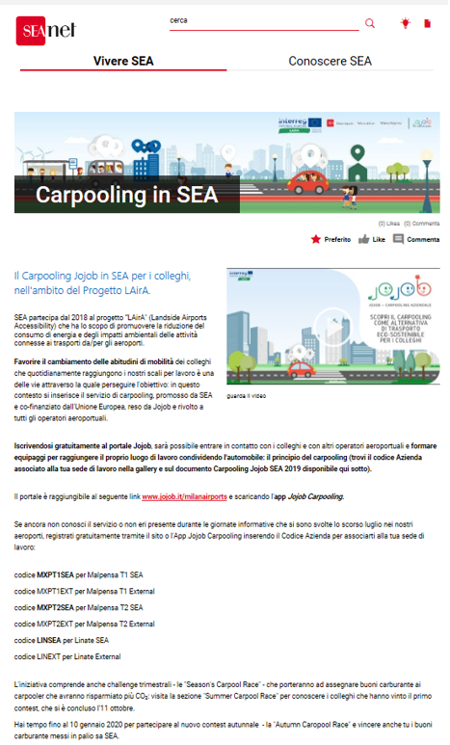
Figure 1. News on the LAirA car-pooling project published on SEA Milan Airports intranet
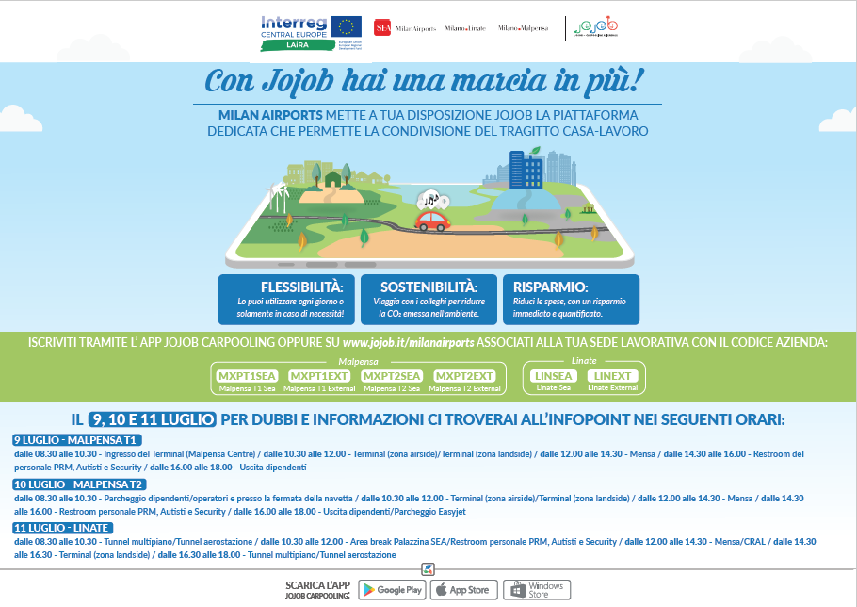
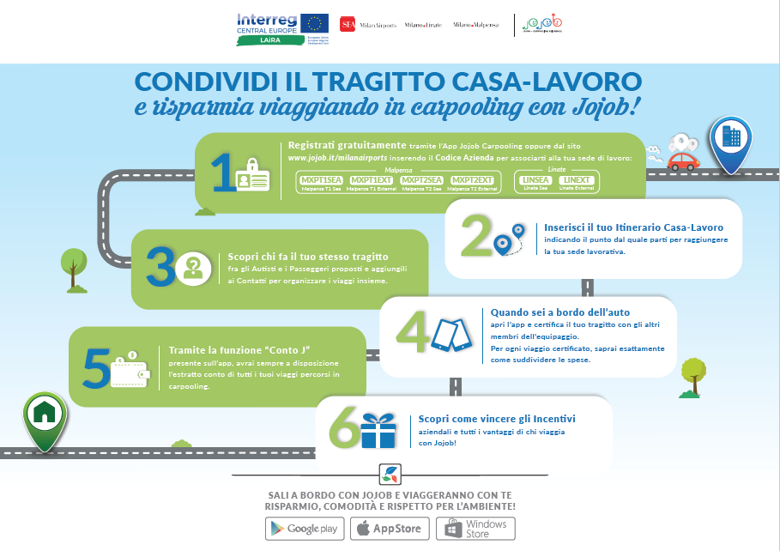
Figure 2. Communication material distributed to employees

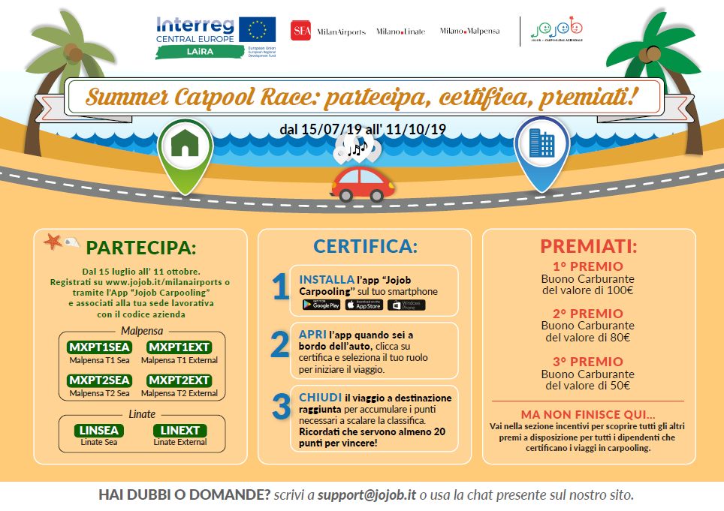
Figure 3. Leaflet on Summer Carpool Race founded by SEA Milan Airports

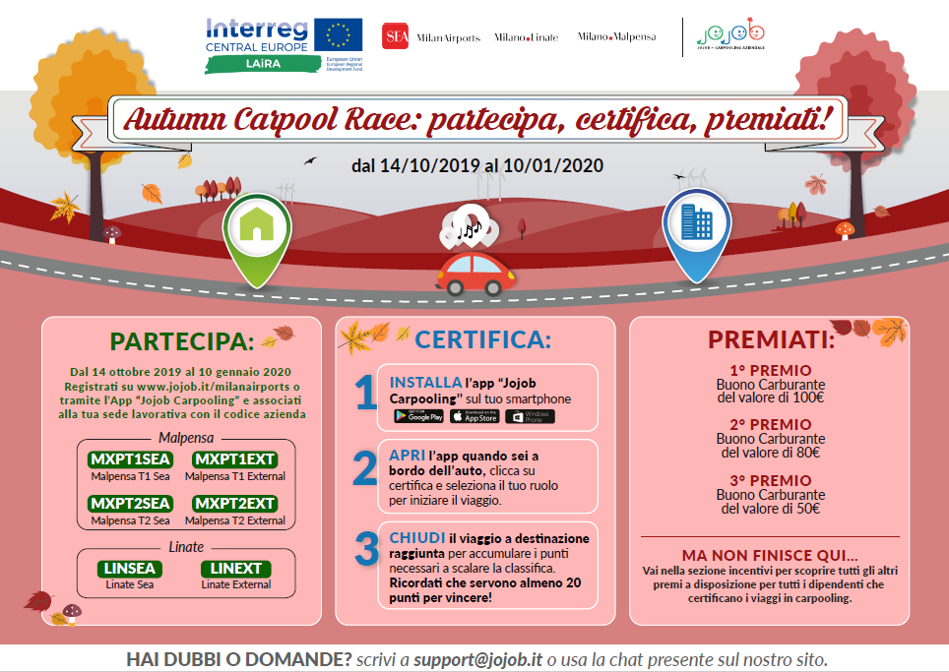
Figure 4. Leaflet on Autumn Carpool Race founded by SEA Milan Airports

