SMART URBAN RE-USE FLAGSHIP ALLIANCES IN CENTRAL EUROPE

Peter CHRABÁK¹, Ernő GARAMVÖLGYI²

¹Senior Researcher, Bay Zoltán Nonprofit Ltd. for Applied Research, peter.chrabak@bayzoltan.hu
² Senior Researcher, Bay Zoltán Nonprofit Ltd. for Applied Research, erno.garamvolgyi@bayzoltan.hu

Abstract
Waste is an extremely relevant issue in urban areas. It can cause social conflicts in housing areas as waste collection schemes in public spaces is visible for citizens and has an impact on the living quality of urban spaces. Reuse is a highly relevant approach to tackle the challenges of Waste Prevention in urban areas and to implement sustainable production and consumption patterns in practice.
The INTERREG SURFACE project’s main objective is to improve environmental management and quality of life of urban areas through the establishment of Multi-Stakeholder based Smart Re-Use parks (SRP) as a possible solution for increasing sustainability in selected pilot urban areas represented by project consortium partners. The change consists in the availability of a harmonized and evidence based decision making setting in the field of waste prevention and reuse in Central European area where: 1) reuse and waste prevention options become integrated options of environmental management strategies & action plans, 2) urban decision makers can share decisions, 3) multi-stakeholder cooperation schemes and Smart ReUse Parks Action Plans can be shared and used; 4) tested and validated pilots can be studied and 5) an increased set of immediately usable instruments be adopted through twinning training schemes as showcases for further implementing the project results on other European urban locations as best practices.

Keywords: Re-use, Smart re-use parks, Waste prevention, Functional Urban Area, Environmental sustainability.

Introduction
Large volumes of waste and waste water, poor air and water quality, high levels of ambient noise, lack of integrated environmental management nowadays are relevant issues in modern urban living areas. Reuse, as the second priority step in the EU waste hierarchy is a highly relevant approach to tackle them. Despite recent improvements at transnational level there is still a highly fragmented decision making landscape in this field.

The SURFACE project
The INTERREG SURFACE project (2017-2020) focuses on jointly creating the knowledge foundations of re-use related approach and demonstrate the potential of integrated reuse activities for urban resource efficiency and waste prevention strategies. SURFACE project plan to contribute for a more sustainable lifestyle by “mainstreaming” re-use as an alternative way of fulfilling customer needs. In this broad context re-use not only refers to waste management legislation but also has interfaces to a number of strategies, policies and concepts in the area of sustainable development (e.g. Europe 2020 Strategy, Circular Economy Strategy, Sustainable consumption and production and Sustainable Industrial Policy Action Plan, European Strategy on Sustainable Development).
The core project aim is to support the European Circular Economy Strategy by prolonging the product life time through re-use and subsequently saving resources and improving energy efficiency. The project concept is substantially based on the three dimensions of sustainable development:
- Ecological sustainability – Improving resource efficiency by reducing wastes and emissions by extending the lifetime of products.
- Social sustainability – The primary goals are the change of public behaviour towards a sustainable life style. Additionally creation of “green jobs” for low qualified / long-time unemployed people as well as providing good quality products for people with low income are also promoted.
- Economic sustainability – Strengthening regional economies by stimulating co-operations between different actors and development of new business fields and models (especially for social enterprises, SMEs and service providers) and supporting the sharing economy.
The demonstration of the potential of integrated re-use activities for urban resource efficiency and waste prevention strategies, as well as preparing the ground for the Pilot actions are supposed to illustrate re-use as a key driver for sustainable and environmentally conscious consumption.
More specifically the project SURFACE targets to improve the environmental management and quality of life in urban areas through the establishment of Multi-Stakeholder based “Smart Re-Use parks” as a possible solution for increasing sustainability in selected pilot urban areas delegated and represented by project partners, especially:
- fostering the exchange of know-how between countries and regions to be as efficient as possible with available resources.
- building up modular solutions for re-use centres and networks to fulfil the needs of all CE countries by easy adaption.
- promoting the setting up of a customised SRP considering the local/regional waste prevention plans and vice versa.
- defining a list of requirements on a basic and on an advanced level of an SRP development in order to adopt the concerned best practices.
- implementing pilots for testing the SRP concept in several CE countries.
With the successful implementation the re-use and waste prevention options may become integrated part of environmental management strategies and action plans, or local/regional waste prevention plans – in line with the Circular Economy strategy of the EU and multi-stakeholder cooperation schemes and Smart Re-Use Parks action plans can be shared and used for supporting urban decision makers.
The project consortium consists of several partners from CE region countries as Austria, Croatia, Slovenia, Poland, Czech Republic, Hungary and Germany, Italy (with certain regions). The Hungarian partner is the Bay Zoltán Research Institute.

What is a “Smart Re-use Park”?
Ideally a “Smart Re-Use Park” (SRP) is a flexible and modular combinations of re-use oriented services – located in visible and liveable urban areas – organically embedded into urban waste prevention strategies. Depending on each urban context the modular structure of SRPs is guided by urban strategies and plans which define the combination of services best responding to urban waste prevention goals for instance: reuse-collection points and shops, repair cafes, repair and upcycling workshops, rental services, swapping platforms, educational labs, Fab Labs, online reuse marketplaces, exhibitions for different target groups (schools, environmental initiatives, general public, etc.). For the straightforward development of an SRP the next essential dimensions should be clearly addressed:
- Geographical area
- Concerned (local) stakeholders, cooperation
- Organisation structure of an SRP
- Available and additionally required infrastructure
- Implemented functions and services within an SRP.

Smart Reuse Park actions
The core concept of the SURFACE project is the formation of SRPs in five pilot regions (IT, AT, DE, PL, HU) and preparing the implementation in the other four regions (IT, CZ, SI, HR). The SRP will be a place where products, goods and materials will be given a new chance to get back into the product cycle instead of ending up as waste or as recycled material with a lower value. The SRP is not solely a place where goods get reused or upcycled, it also provides a space where people encounter each other and have the opportunity for exchange and knowledge transfer in the area of Re-Use. Courses and workshops can give leverage to reach new horizons in environment conservation. Figure 1 shows one of the two premises of the FKF Nonprofit Zrt., as the assigned pilot for the implementation of SURFACE aims in cooperation with Bay Zoltán Research Institute.
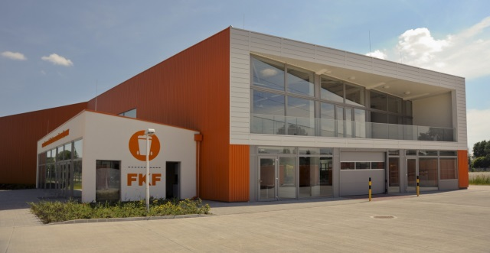
Figure 1. The premise for awareness raising re-use centre of of the FKF Nonprofit Zrt. in Budapest
As a first step a comprehensive survey had been made for project partners and their feedbacks were evaluated to unfold the initial phase of each participated pilot urban area, including the statistical data and actual waste management situation. The fact sheet of the pilot areas are presented in Table 1 capturing the situation of 2017.

Table 1: Fact sheet on participated pilot areas
COUNTRY | GEOGRAPHICAL LOCATION | TYPE OF AREA | AREA (km²) | POPULATION
Austria | Schwaz, Innsbruck Land and Innsbruck Stadt | Service area of the pilot host company | 3 938.00 | 389 126
Croatia | Labin | Service area of the pilot host company | 390.92 | 22 590
Czech republic | Stonavka and Brno | Service area of the pilot host company | 314.87 | 386 594
Germany | Lindau and Kempten | Service area of the pilot host company | 297 700 | 1 900
Hungary | Budapest | Service area of the pilot host company | 525 | 1 860 000
Italy | Vicenza | Province | 2 722 | 867 314
Italy | Rimini | Province | 863.6 | 336 898
Poland | Torun | Municipality | 115.57 | 193 000
Slovenia | Ljubljana | City | 163.8 | 270 000

Waste management situation in the pilot areas
At the local level waste management practice is rather similar in all concerned areas due to similar legislative environment: The responsibility of waste management is mostly given to the municipalities or group of them and therefore the municipal solid waste collection is a public service. According to the conducted surveys, there are two possible options for bulky waste collection: in some of these areas citizens are entitled to the free removal of bulky waste once per year free of charge. In this case bulky waste should be placed at the designated location on the day agreed for bulky waste collection or one day before. If citizens have already used this service, they can either take their bulky waste to the collection centre by themselves or they can order collection for payment. In other areas there is only an option for citizens to bring the bulky waste to the collection points for high volume waste by themselves or to give their re-usable goods to the re-use centres.
In SURFACE participated countries a general trend in quantity of waste is observed: it is noticeable that the amount of collected waste is rising while the percentage of disposed waste is significantly lower comparing to previous years.

Decision Matrix
Towards to achieve the project goals, important deliverable of the project has been developed: the Decision Matrix (DM) is assigned to scatter the built-up knowledge and know-how for a wider implementation of SRP concepts throughout in and outside the Central European territory. The DM is supposed to provide guidance about selection criteria to be adopted in other locations throughout Europe in order to implement the available practices via the project results. The DM is substantially based on the experiments of project partners to unfold and share their opinion and expertise, which are important for a common thinking.
In favour of the reason above, a survey was developed in cooperation with project partners for the widest consensus on guiding principles of an SRP. The survey comprises 8 categorized questions with predefined answers with marking from 1-5 at discrete steps of 1. The concerned categories are:
1. Legislation
2. Private business
3. State subsidy
4. Socio-economy aspects
5. Public awareness
6. Smart Re-use Park implementation potential
7. Demand on second-hand items
8. Supply on second-hand items
The eight questions were then followed by three additional questions on implementation, where the answers here were also predefined by “Yes” or “No” options. For every question a free text cell was offered for making remarks and amendments.
In fact the predefined answers may have inhere certain limitations on making the most precise answers, however for an easier comparison and common understanding the answers from different partners it was considered to be the most proper option.
All questions had got a hint aiming common perception, as well as short description on all optional answers (grades). Every project partner having pilot activity was asked to apply the questions specifically to their pilot area and fill in accordingly. Their inherently subjective answers were presented automatically in an excel spider web diagram for an easier review and comparison. So, overall we had 9 complete surveys at the end (examples are shown on Figure 1. and Figure 2.).
The individual partner surveys were composed into one common table summarising the status-quo situation on each area assigned within SURFACE project. It presents as a comprehensive summary of the survey with the questions with their answering options and all the answers and intends to serve as the Decision Matrix (DM). The DM is aimed to contribute for a swift benchmarking of the current situations in SURFACE pilots from different aspects of re-use, i.e. legislation, economic conditions, public attitude. It can also transfer information for new associated partners, or stakeholders having interest to implement and/or operate SRPs, or solely a variety of single re-use activities.

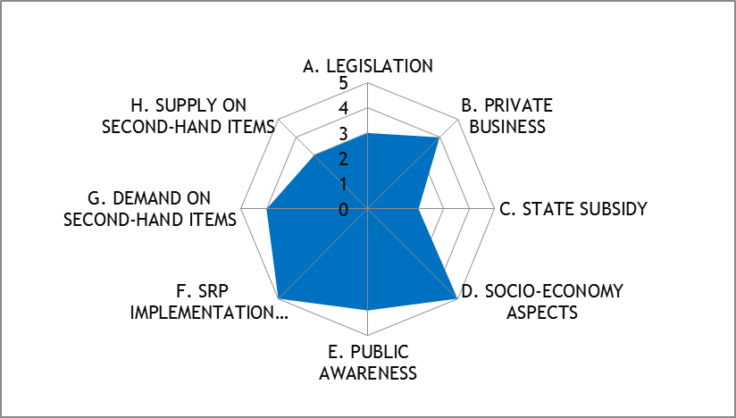
Figure 1. Austrian status-quo on Smart Re-use Park implementation

Austria has got the most developed SRP infrastructure among the project partners. In this pilot area the strongest dimension concerning re-use is its socio-economy aspect: there are one or more social programmes linking directly to re-use. It is in close relation with a definitely positive public awareness and the dominant presence of private for-profit and non-for-profit businesses as well in the field of re-use. These positive givens leads to a relevant potential to the development of SRP in the region. This intention is also promoted by the already existing re-use related initiatives in the region, i.e.: repair and upcycling workshops, repair cafés, swapping platforms, rental services, fab labs, Library of Things, guided city tours with the focus on Re-Use. There are 62 recycling facilities in the region where re-usable items can be collected. The operators of an SRP are not restricted on legal status, so it can be hosted even by NGO, civil association and private company as well.
The willingness of citizens to transfer their obsolete items to re-use facilities is generally positive, but as long as there is a (well-known) company which makes profit out of the sale of re-use items the willingness may decline. So, the public is mainly motivated by environmental aspect to donate their obsolete items.
Concerning the demand on second-hand items, in the Austrian pilot region there is a strong striving for people beyond the green movement community to buy them. Although in the other districts of Tyrol, especially in the touristic areas the interest deteriorates drastically.
The main drawback of the Austrian re-use system is the insufficient financial support, moreover the legislative background is also mentioned as a non-supportive factor.

As opposed Hungary has moderate tradition and public environmental consciousness as it is showed by Figure 2.
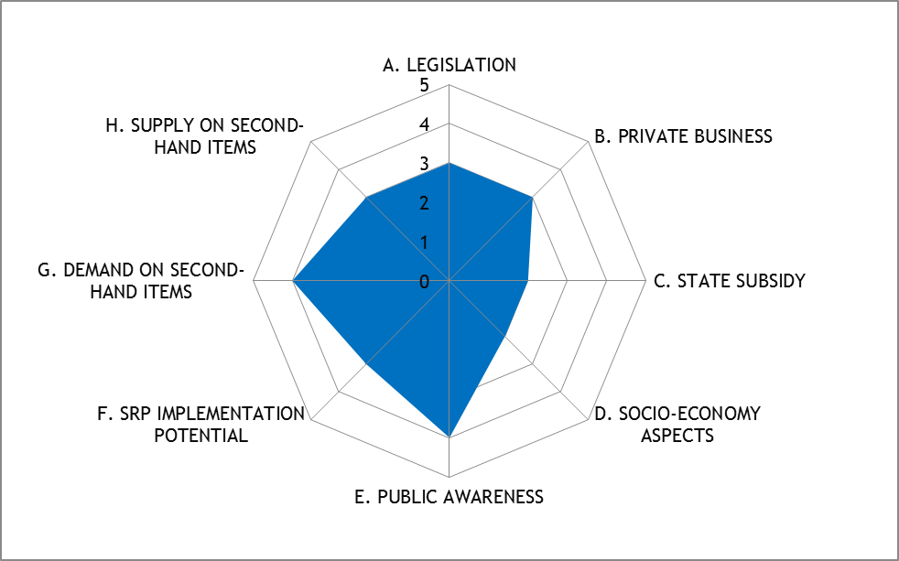
Figure 2. Hungarian status-quo on Smart Re-use Park implementation

The Hungarian pilot area can be positioned in a fully average status from every aspect and can make a step forward in each category. The two most promising givens are the generally positive perceptions of the public on re-use issues and the dominantly positive acceptance of using second-hand products.
Nevertheless the two identified most relevant drawbacks refers to the engagement of state aiming to support: nor direct financial subsidy, nor direct social programmes exist supporting re-use initiatives.
Some elements as building blocks for an SRP already exist in the pilot region, i.e. rental service, online re-use marketplace, exhibition for different target groups. From venture aspects there is no restriction on the type of legal body to implement or to run an SRP.

Overall conclusions on DM results
The overall impression gained by the evaluation of the individual surveys above accurately reflects the re-use situations in the concerned areas. The overall consequences on each analysed dimensions are introduced in this chapter.

Legislation
From legislative aspects the German pilot area is in the most favourable position: its legislative measures exceed the mandatory provisions proactively. Italian region Emilia Romagna and Austrian Mid-Tyrol can be assumed to have a supportive legislation on re-use.
On the other end of the scale, the Croatian and Bohemian areas reported a rather passive and insufficient legislative system from re-use dimensions. The other locations are positioned themselves being in a neutral legal status, where the related obligations (derived from EU and national level) are fulfilled, however re-use is poorly addressed in the national and regional legislations.

Private business in re-use field
The presence of private actors in re-use field is mainly dominant in Austrian, Italian, Croatian and Slovenian regions. In Austria the private sector also involves private non-profit organisations. Most of the respondents claimed that the private share in re-use business is considerable, but still minor. In the Polish area the sector is mainly dominant by governmental organisations.

State subsidy
According to the reported answers of the surveys the most depressed aspect in re-use field is the deficient state subsidy. In most of the pilot areas there are some not significant financial supports; even they do not address re-use directly, even in the well exemplary region like Austria and Germany.

Socio-economy aspects
This analysed dimension shows the biggest deviation of answers: Austria and Italy can be considered having the most developed region, which are being reflected by the answers. Austria and Italy (Vicenza) reported that there are more social programmes linked directly to re-use, and also in German region there are more social programmes, but with indirect relation to re-use. In other pilot areas there are no social programmes at all, or if there are any, they indirectly linked to general waste management, but not re-use.

Public awareness
The public awareness on preparing for re-use activities is generally positive, but in Italian Emilia Romagna region it is assumed to be neutral, but not negative at all. In Austria and in Vicenza this awareness manifests in practice due to the existing re-use related shops having intensive visits by costumers and for a generally good reputation of re-use. In Croatian region the awareness is also very positive, however it is lacking of re-use shops.

SRP implementation potential
The givens in project SRPs are considered to be the most developed in Austria, Germany, Italy (Emilia Romagna, Vicenza) and Slovenia. It means that in these regions there are already relevant activities that can be easily integrated within an SRP. In these FUAs there are several specific re-use related activities are present i.e. repair and upcycling workshops, rental services, swapping platforms, fab labs.
Despite the very positive situation in Austria, they identified development potential in the region. According to their opinion the scientific approach and a more conscious public awareness is missing currently, which can promote far beyond the situation.
The Croatian pilot area starts from a very basic level, where there is only one textile sorting facility with a shop represents the re-use activity.
In the other areas, there are few SRP related activities are present. Hungarian partner reported that there are ongoing re-use related activities, however their integration into an SRP raises financial and legislative questions. From starting SRP as a business (implementation, operation) generally there is no restriction on the legal status of its host (NGO, civil association, private, etc).

Demand and supply on second-hand items
The assessment of demand on second-hand items is the most ambiguous among the concerned areas: Austrian, German, Hungarian, and especially Polish partners reported that using and buying second-hand items are generally approved by the public. On the contrary Croatian, Italian (Emilia Romagna, Vicenza) and Slovenian partners shared that there is a massive negative opinion on using second-hand items. In Bohemian region there is ineligible experiment.
The feedbacks on supply of second-hand items reflect quite consistent situations in the concerned pilot areas. They generally assess that the public in the areas generally are conscious on the environmental gains of re-use, but as a common experience, they hardly turn it into practice, which means they do not make efforts to deliver their obsolete products to a re-use friendly option, i.e. collection centres, online marketing, etc.

Identification of potential Stakeholders
The recognition of concerned stakeholders in relation with urban waste prevention plan is organically linked to further, but practical steps of SURFACE project: the developed SRPs in dedicated areas highly require common thinking and interaction between project partners and external stakeholders from the beginning of the project implementation. For this aim, two main elements have to be integrated: on one hand the list of potential stakeholders having influence on the SRP development and on the other hand, a moderated platform for them to interact for changing information (Multi-Stakeholder Forum, MSF). Both actions are developed within the project.
The core concept of MSF is that each pilot area in the project should have its own group of interested actors (i.e. waste management companies, municipalities, policy makers) having direct relations on re-use activities in the concerned area. We can also call them as regional multi-stakeholder fora. However, in accordance with the practical implementation of re-use intentions on a higher (strategic) dimension, the long-term sustainability and boosting effect of project activities can be ensured by the involvement of actors having direct or indirect influence on regional (national) and/or local (urban) waste prevention plans. The waste prevention plans are strategic documents on an integrated approach of sustainable development of responsible waste management in the area bringing the national and European efforts closer to the local practice and also in consideration of urban givens.
The aim of the MSF is two-fold: it brings together all actors having role in waste management, especially in re-use and the stakeholders from strategic planning and legislation via regulations and plans. The MSF also serves as a conveyor for actors from level of implementation (actors having role on SRP development) with colligating their needs and expectations. Finally, a multilateral interaction of national and international stakeholders can lead to a cost and time effective cooperation with practical outcomes possessing the widest basement of their consensus.
For the sake of these aims, the first step would be to ask the project partners to think which stakeholders can be interested and which of them should and wants to participate in the regional MSF. Here the focus is on urban Waste Prevention Plans, where all contacted partners should have preferably direct, but at least indirect interest on the development of regional/national Waste Prevention Plans. That is why partners with (potent) influence on Waste Prevention Plan (policy making) should have priority. This task is now ongoing in the project and supposed to have the result as list of stakeholders having relation on SRP development in each project area. Stakeholders from national dimension are not excluded from the list, however they should have influence on strategic planning related to re-use intentions. Finally, the MSF could be a communication platform for these actors, where they can keep contact and can discuss the topic in more details.

Potentials and visions in FUAs
In every pilot areas from all participating countries, there is at least one re-use joint activity which is already established and great potential for launching new initiatives. Short overview of the potentials in the field of repair and re-use in concerned areas, based on the findings from separate questionnaires for each project partner, can be seen in Table 2.

Table 2: Potentials in the field of repair and reuse in concerned FUAs
Re-use joint activities | Austria | Croatia | Czech republic | Germany | Hungary | Italy (Vicenza) | Italy (Rimini) | Poland | Slovenia
Repair and upcycling workshop | + | (-)* | + | + | + | + | + | + | +
Repair café | + | (-)* | - | + | (-)* | (-)* | + | (-)* | +
Rental services | + | (-)* | + | + | + | + | + | + | +
Swapping platforms | + | (-)* | + | + | N/A | + | + | + | +
Educational labs | (-)* | (-)* | + | + | (-)* | + | + | + | +
Fab Labs | + | (-)* | - | + | + | + | + | (-)* | (-)*
Online re-use marketplace | + | + | + | + | + | + | + | + | +
Exhibition for different target groups | - | - | (-)* | + | + | + | + | + | +
Other, please describe: | (+)* | - | (+)* | - | - | (+)* | - | - | -
(-)* : don’t exist currently but are considered as a short or long term goal
(+)* : Austria –Library of things;
Czech republic – Mini library;
Italy (Vicenza) – proposals of tourism dedicated to visiting areas dedicated to re-use, creation of local network of subjects engaged in re-use

Prevention of waste and preparing for re-use must have priority in waste management according to the waste hierarchy defined in the European Waste Framework Directive. Considering the different level of re-use related development in countries, dimensions should be determined on different level in order to make a distinction between the level of development, especially considering the organisational structure, the infrastructure and the offered services of an SRP.
Therefore the necessity and advantage of SRP establishment are evident among all countries and urban areas participating in the project. An SRP may include all three pillars of sustainability (mentioned above) by offering an opportunity for stakeholders to interact with each other. Main idea behind the implemented SRP has several key points:
- It must have social, economic and environmental impact;
- It should be designed as centre for a separate collection of reusable goods on the spot or/and via external collections which would contribute to waste reduction, resource savings and circular economy;
- It should offer high range of preparation for re-use and re-use activities for different materials - such as repairing, restoring, redesigning, renovation, refurbishment, workshops and education and other activities to raise awareness;
- It may offer basic vocational education and employment for socially excluded and vulnerable groups of population; re-use and repair activities hold a big potential for creating jobs for people with different level of skills.
- It should be entertaining for children, youth and adults as well;
- It must be open and accessible for citizens.

Conclusions and next steps
The project is still ongoing until the middle of 2020.The following tasks will make strong efforts to develop methodology tools in order to fertilize the SRP concept on other urban locations throughout Europe.
The tasks will include the development of a tool, named Cooperation Matrix aiming to support the selection process of the most appropriate relationships to be established between public authorities (responsible for waste prevention and management), private companies (offering services for waste management), social enterprises (providing workplaces for disadvantaged people at local level) for implementing and managing an SRP.
Additionally the SRPs Activation Toolbox will be developed. It is a decision support tool based on SURFACE evidences which will allow urban managers to establish if, when and how to implement SRPs as part of their waste prevention strategies.
The project will also eventuate in a “Smart ReUse Twinning Scheme” for supporting a joint field training process which will allow transfer and implementation of SRP based systems in other locations outside the partnership.

Acknowledgements
This project is implemented through the CENTRAL EUROPE Programme co-financed by the ERDF. For more information and monitoring project progress, please visit the project website: https://www.interreg-central.eu/Content.Node/SURFACE.html

A fab lab (fabrication laboratory) is a small-scale workshop offering open access to (personal) digital fabrication. So a FabLab is a digital workshop which can be used by the public to create transform creative ideas into tangible prototypes. A FabLab comprises digitally controlled machines like a lasercutter, CNC-router, a 3D printer, a vinyl cutter and electronics with the aim to make “almost anything”. – source: http://fablab.nl/wat-is-fablab/?lang=en
Library of Things is an identical implementation of book library on any other items that can be found in a household, i.e. tools, sport equipment, toys, household appliances. The Library of Things movement is a growing trend in public int he United States and Western Europe.

