template

Output factsheet: Pilot actions

Version 1

Project index number and acronym | CE111 Focus IN CD
Lead partner | Municipality of Maribor
Output number and title | O.T3.1 DEVELOPMENT AND IMPLEMENTATION OF 10 PILOT PROJECTS/D.T3.2.7. Testing of CD antibodies in school children
Responsible partner (PP name and number) | PP6
Project website | www.interreg-central.eu
Delivery date

Summary description of the pilot action explaining its experimental nature and demonstration character
We have set the task of testing 1500 school children (both genders, 6-7 years old) on celiac disease. Testing was performed by a relatively non-invasive method of taking blood drops from a finger. The three main objectives of the study were: to detect celiac disease (asymptomatic), to prevent disease complications, to record the prevalence of celiac disease in our country (there is no Register of patients) and to suggest/compile a new disease management recommendation (a testing of preschool children for CD at regular systemic examination for enrolment in the first grade of primary school).

After all the prerequisites have been met; 1) obtaining the approval of the Ethical Hospital Committee and the Ministry of Education for the implementation of the Pilot project activity in elementary schools in our area; 2) the procurement of the rapid tests; 3) the main presentation of the Pilot project for principals of primary schools (Primorje - Gorski Kotar County) we were ready for implementation of the testing.
After intensive communication aimed at elementary schools (via mail and phone) and agreed arrangements for holding meetings with parents, we attended professional lectures on celiac disease and related illnesses, also at the same time held presentations about the Interreg CE program and the Pilot project "Testing the school children on celiac disease".
We met 33 primary schools, done about 66 outings on the 3 micro-regions of our county (mountains area of Gorski Kotar, coast and islands). We went to each school at least twice (to some schools we went three times because of different schedules); at first because principals had to approve school attendance and show first interest in project implementation and the parents who had to sign approvals and the second time to carry out the testing of children themselves.
We tested a total of 1478 children with non-invasive rapid celiac test and recorded 10 IgA deficits, which were not diagnosed as a positive celiac disease patient in a further diagnostic protocol in the Hospital (anti-transglutaminase antibodies).

NUTS region(s) concerned by the pilot action (relevant NUTS level)
NUTS 3/HR031 Primorje Gorski Kotar Caunty was concerned by the pilot action.
We tried to reach different areas of our 3 microregions: islands (Veli Lošinj, Mali Lošinj, Krk); mountain area (Gorski Kotar) and the coast (City of Rijeka with surroundings).
NUTS HRO4 Kontinentalna Hrvatska
Different geographical spheres are important for observing and influencing different geographic factors on the population and its characteristics. It is important to note that we have, at almost all the schools, encountered children who had some of the classic celiac disease characteristics (low growth, insufficient body mass, skin problems ...) but we did not confirm them as new patients suffering from celiac disease. Therefore, we set the challenge of further observing these children.

Expected impact and benefits of the pilot action for the concerned territory and target groups
Max. 1.000 characters

We have primarily expected to find celiac disease and in that way help in treatment and prevention of further illness complication.
It is important to note that through this Pilot Project we have been informed in directly communication with parents about so many health issues of their children concerning food allergies and even problems related to gluten consumption, also dermatological skin changes. Almost in every class we detected children below average body weight and lower growth for which there was a possible suspect of the disease (considering those are well-known CD symptoms), but this type of testing did not give positive results on those suspects.
Further we noticed that the parents (which are between 30-40 years old) suffer from many autoimmune diseases that are mentioned in relation to celiac disease (thyroid disease, diabetes, rheumatoid arthritis ...which they shared with us after given lecture about CD).
Because of the presence of such health issues with children and parents themselves, they were positive in decision to test children for CD.
We can also point out that parents that worked at the schools were very interested in this topic, they recognized their health issues related to CD, they pointed out problems their children have and gave us support for CD testing. We offered them new knowledge about CD.
Through lectures and presentations, we offered parents and teachers new knowledge about this health topic and the biggest benefit is raising awareness about celiac disease (for at least 2000 people/parents, school staff), its related illnesses, complications of untreated CD, hidden symptoms, CD with no symptoms at all, treatment of illness and so on. The most important result is raising awareness about the illness in general population. It can make everyday life of the people with CD easier with more understanding for their needs, and it can be expected that people will seek medical help in different conditions that can be related to CD and actively search for CD testing.

Sustainability of the pilot action results and transferability to other territories and stakeholders
Max. 1000 characters
Related to sustainability we can say that such researches so far haven't showed results which would be enough to improve health management about CD testing. We can ask the question of is this test being relevant/developed/sensitive enough to mark every case of celiac disease or is it not? Are there no children with CD in this generation? Or have we missed something? However, it would be interesting to repeat this testing on this generation in a year or two to see if we would find some positive cases or not or will some of these children be diagnosed with CD in the mean time? So, we can conclude that this kind of research is still not fully improved system for finding celiac disease (cannot replace serological vein testing, for example) but can be used as a preventative health CD program.

Certainly, do not exclude the possibility of further research by this method since a lot of data showed the rapid test to be useful. Testing through rapid tests should be carried out on patients who have symptoms of CD, on family members and those who has some specific autoimmune illnesses like diabetes I, rheumatoid arthritis, thyroid disease...which we can put in relation to CD. Although it is not yet scientifically based, but group of patients with wheat allergy should also be considered as possible celiac disease patients.

Lessons learned from the implementation of the pilot action and added value of transnational cooperation
Max. 1000
We have definitely proved that cooperation with educational institutions can be achieved in the implementation of pilot projects; that parents have an interest in participating in the health prevention program of their children's health by non-invasive methods; that they are interested in health education; and that there is an interest of the public (also media) to monitor such projects and to participate in raising awareness of different needs, such as celiac disease.
We certainly were helped with past experiences of Slovenian and Hungarian project partners who shared their opinions, experiences and discussed possible obstacles.
Also, we can highlight that we shared our experience and knowledge about implementation of testing on our workshop in Poland which is very interested in results and new possible cooperation based on new innovative educational system.

characters

References to relevant deliverables and web-links
If applicable, pictures or images to be provided as annex

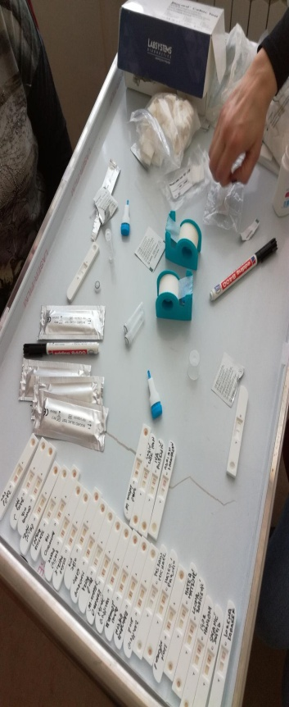

https://www.interreg-central.eu/Content.Node/Testing-for-celiac-disease-antibodies-in-preschool-childr.html

Max. 1.000 characters
