D.C.6.2

Media Info Kit | Version 1  13.11.2017

- Project Summary

Enhancing SME competitiveness through improved access to Key Enabling Technologies in Central Europe
Key Enabling Technologies (KET) are drivers of innovation and set important impetus for an intelligent and sustainable economic growth in Europe in order to ensure the future viability of our society. However, there are major differences in access for small and medium-sized enterprises (SMEs) to KETs within Europe. These are particularly evident in many Central European countries where a suitable infrastructure for KETs is still insufficiently available.
For this purpose on 1st July 2017 the Interreg Central Europe (CE) project KETGATE was launched to enable a CE-wide access to highly competent KET technology and infrastructure services for SMEs as well as to install a transnational KET Innovation Ecosystem in CE.
The KETGATE project, coordinated by Steinbeis-Europa-Zentrum (SEZ), connects business support organisations (BSO) and research institutes (RTO) in order to help SMEs accessing high-level technology for advanced materials, photonics and micro-& nano-electronics in the areas of transport, health and food.
The consortium encompasses eight partners (five BSOs and three RTOs) from 8 different countries.
A contact point will be set up at each partner location which offers advice to SMEs towards KET application. In pilot projects, jointly developed service models offer selected companies the concrete application of KETs through cross-border cooperation. In total, the network of smart access points will support at least 90 SMEs from Central European regions as well as at least 15 transnational pilot cooperation agreements.
Besides, contractual obligations will be made with 20 other organisations to expand and to strengthen the network. Thus, the project will not only contribute to the competitiveness of SMEs in Central Europe, but also generate significant change for the entire CE region by supporting regional Smart Specialisation Strategies (S3).

- Key Facts
- The consortium encompasses eight partners (five BSOs and three RTOs) from eight different countries
- Project duration: 07/2017 - 08/2020
- Countries involved: Austria, Croatia, Czech Republic, Germany, Hungary, Italy, Poland, Slovenia
- Project co-funded by European Regional Development Funds (ERDF) in the context of the Interreg Central Europe Programme under Priority 1 – Innovation and Knowledge Development
- Project budget: 2.02 Mio €
- ERDF funding: 1.66 Mio €
- Project website: www.interreg-central.eu/KETGATE

- Partner information
The consortium comprises 8 project partners (5 BSOs (marked in blue) and 3 RTOs (marked in red)) from 8 countries and 19 Associated partners.
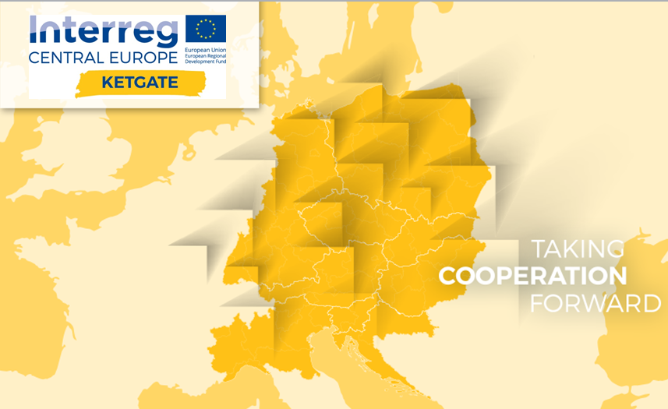

GAPR
NCA
BZN
JOANNEUM
SEZ

VI
JSI
TERA

  - Project Partners
    - Business Support Organisations
LP - Steinbeis-Europa-Zentrum (SEZ)
 | Lead partner (LP)
Address | Steinbeis Europa Zentrum der Steinbeis Innovation gGmbH  Willi-Bleicher-Str. 19  70174 Stuttgart  Germany
Website | www.steinbeis-europa.de
Contact details | Simone Jung  jung@steinbeis-europa.de  +49 711 123 4039
Description of organisation | The core activities of SEZ are to assist SMEs and R&D organisations to promote transnational innovation & technology transfer, and to support the internationalisation of SMEs.
Role in the project | SEZ is Lead Partner of the KETGATE project, thus responsible for project and financial management. Thematically, SEZ leads Work Package T3 (“Experimenting offer and delivery of KET access and service ecosystem”), bringing in the background knowledge on Key Enabling Technology support services to SME across the EU. SEZ ensures that the knowledge from the KET Action Plan & KET Technology Infrastructure Inventory of the European Commission is included at all relevant stages.

PP2 - Veneto Innovazione (VI)
 | Project partner (PP)
Address | Veneto Innovazione  Via ca’ Marcello 67/D  30172 Venezia Mestre  Italy
Website | www.venetoinnovazione.it
Contact details | Maria Sole D’Orazio  mariasole.dorazio@venetoinnovazione.it  +39 041 868 5301
Description of organisation | Veneto Innovazione is the in-house Regional Agency for research, innovation and technology transfer with the aim of promoting applied research and innovation in the Veneto Region.
Role in the project | Veneto Innovazione leads Work Package T1 which aims to analyze the regional KET ecosystems in order to define the cornerstones for the network of access points for SME. It will coordinate all project partners in profiling their regional/national KET innovation ecosystems. As member of the Enterprise Europe Network (EEN) it will also support regional SMEs in finding the right partners.

PP3 - National Cluster Association (NCA)
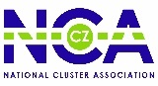 | Project partner
Address | National Cluster Assocation  U Tiskarny 616/9  702 00 Ostrava  Czech Republic
Website | www.nca.cz
Contact details | Filip Vitek  vitek@nca.cz  +420 731 534 179
Description of organisation | NCA brings together Czech cluster organisations and relevant supportive institutions to facilitate the cluster concept development, inter-cluster cooperation, innovation and internationalisation enhancement of clusters in the Czech Republic.
Role in the project | NCA brings in their broad networking and facilitation experience and competencies based on the proved mechanism of collaboration in the triple helix environment. In particular, NCA will support the assistance with KET SME access point network building, the use of clusters for the improvement of the SME access to KETs and the integration of the KET-based clusters in the S3 policy development in the Czech Republic.

PP4 - Upper Silesian Agency for Entrepreneurship and Development Ltd. (GAPR)
 | Project partner
Address | GAPR  Wincentego Pola 16  44-100 Gliwice  Poland
Website | www.gapr.pl
Contact details | Aleksandra Szczerbak  aszczerbak@gapr.pl  +48 323 393 148
Description of organisation | GAPR operates Regional Centre of Innovation and Technology Transfer assisting SMEs among others in strategy development, productivity techniques implementation, innovation management, technological partnerships creation.
Role in the project | Due to its competences GAPR has the lead of project communications and is actively involved in all Work Packagess. Having a broad experience in cooperation with regional authorities, R&D sector as well as SMEs and RIS3 actors GAPR will be responsible for managing tailored events and information strategies to reach target audience and ensure sustainability of the project.

PP5 - TERA Tehnopolis (TERA)
 | Project partner
Address | TERA Tehnopolis  Gajev trg 6  31000 Osijek  Croatia
Website | www.tera.hr
Contact details | Birgit Boehning  birgit@tera.hr  +38 531 251 009
Description of organisation | The activities of the centre focus on the development of knowledge-based economy implementing significantly improved tech-nologies and the commercialization of publicly funded research as well as protection of intellectual property.
Role in the project | TERA successfully integrates functions of Technology Transfer office and Business development unit of Josip Juraj Strossmayer University of Osijek. TERA can effectively train project partners in preparation and evaluation of partnership profiles. TERA competences will be used in the organization and delivery of educational programs (especially in the field of IP protection and management, technology transfer and business plan development) and dissemination of project results.

    - Research Institutes
PP6 - Joanneum Research (Joanneum)
 | Project partner
Address | Joanneum Research Forschungsgesellschaft  Leonhardstrasse 59  8010 Graz  Austria
Website | www.joanneum.at
Contact details | Daniele Cozzi  daniele.cozzi@joanneum.at  +43 316 876 3308
Description of organisation | Joanneum Research cooperates on a national and international scale with private and public sectors to generate innovations and the consequent know-how transfer into the economy.
Role in the project | Joanneum leads Work Package T2 (“New and advanced transnational KET services to SME across Central Europe”). Within this Work Package, Joanneum is responsible for enhancing the capacities of RTOs for effective KET delivery.

PP7 - Bay Zoltan (BZN)
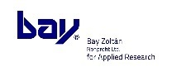 | Project partner
Address | Bay Zoltán  Kondorfa str. 1  1116 Budapest  Hungary
Website | www.bayzoltan.hu
Contact details | Katalin Kurucz  katalin.kurucz@bayzoltan.hu  +30 412 1370
Description of organisation | Bay Zoltán is Hungary’s largest public applied research institute. It provides innovation management services, technology transfer services and Research & Development infrastructure. Bay Zoltán is member of the Enterprise Europe Network and supports Hungarian companies in gaining sustainable competitive advantage,
Role in the project | BZN has a double function providing experience in applied research on the one hand and reaching a large number of SMEs in Hungary via the Enterprise Europe Network on the other hand.

PP8 - Jozef Stefan Institute (JSI)
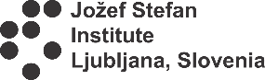 | Project partner
Address | Jozef Stefan Institute  Jamova cesta 39  1000 Ljubljana  Slovenia
Website | www.ijs.si
Contact details | Tomaž Lutman  tomaz.lutman@ijs.si  +386 1 477 38 01
Description of organisation | JSI is the leading Slovenian scientific research institute, covering a broad spectrum of basic and applied research, concerning production and control technologies, biotechnologies, new materials, nanotechnologies, and nuclear engineering.
Role in the project | JSI is the leader of Work Package T4 (“Mainstreaming the KET Innovation Service Network for a lively KET Innovation Ecosystem”). JSI is one of the three project RTOs and contributes to the development and implementation of joint transnational KET service offers to SMEs.

    - Associated partners

Austria
- Human.technology Styria GmbH
- Upper Austrian Research GmbH

Croatia
- Scientific Center of Excellence for Personalised Health Care, University of Osijek
- Faculty of Electrical engineering, Computer Science and Information Technology, University of Osijek

Czech Republic
- Central Bohemia Innovation Center
- Institute of Physics, Academy of Sciences of the Czech Republic

Germany
- Hahn-Schickard Organisation for applied research
- NMI Natural and Medical Sciences Institute at the University of Tübingen

Hungary
- Association of Hungarian Automotive Component Manufacturers
- Borsod-Abaúj-Zemplén County Development Agency Non-profit limited liability company

Italy
- CRIT srl
- Human Inspired Technology Research Centre
- Veneto Region

Poland
- Centre for Advanced Manufacturing Technology, Wroclaw University of Technology
- Institute of Medical Technology and Equipment
- Professor Zbigniew Religa’s Foundation of Cardiac Surgery Development

Slovakia
- Bioeconomy Cluster

Slovenia
- TechnoCenter at University of Maribor
- University of Ljubljana

  - KETGATE communication channels:
- KETGATE website:
www.interreg-central.eu/KETGATE
- KETGATE newsletter:
The KETGATE project releases newsletters on a quarterly basis. The newsletters contain information on the project results, upcoming events and calls related to KETs. Please register online to the newsletter via the KETGATE project website:
www.interreg-central.eu/Content.Node/KETGATE.html
- KETGATE LinkedIn Account: https://de.linkedin.com/in/interreg-ketgate-008b63149
- The KETGATE project logo is available here.
- The KETGATE project presentation is available here.
- The KETGATE factsheet is available here.
- Interreg Central Europe Programme
The Interreg CE Programme is a European funding programme that encourages cooperation beyond borders in nine Central European countries. Financed through the European Regional Development Fund (ERDF), it helps innovative ideas to grow into jointly developed, tested and accepted solutions for a better central Europe.
Countries of the programme area:
Austria, Croatia, Czech Republic, Germany, Hungary, Italy, Poland, Slovakia and Slovenia
Four different programme priorities:
Priority 1:
- Innovation and Knowledge Development
Priority 2:
- Low Carbon Cities and Regions
Priority 3:
- Natural and Cultural Resources
Priority 4:
- Transport and Mobility
Programme in numbers:
- Budget of 246 Mio. € from ERDF funding
- 10 specific objectives
Programme website:
www.interreg-central.eu

Contact of the associated partners shall be made via the corresponding project partner of the concerned country. Contact of the bioeconomy cluster in Slovakia and CRIT (Italy) via SEZ.

