D.T 2.2.4 "App for Android, Mac’OS AND WEB systems to monitor energy performances of schools”

Edited by PP6 UNIBO + FINMATICA

Version 01

07.2018

Edited by PP6 UNIBO + FINMATICA

D.T. 2.2.4 “App for Android, MacOS and web systems to monitor energy performances of schools”

Version 01

07.2018

CONTENTS
1. INTRODUCTION 3
2. AUTHENTICATION AND AUTHORIZATION 3
3. HOME PAGE 4
4. DESCRIPTION OF DATA ENTRY FUNCTIONS FROM APP 5
5. DAILY REPORT 9
6. EXAMPLE OF MEASUREMENTS AND RELETED GRAPHS 11

- INTRODUCTION
The Energy @ School App will be available for Android and iOS systems, while for the windows platform it will be usable in desktop web version through the browser.
The App will be downloadable from the PlayStore and the AppStore respectively.
The differences between the two versions will be mainly linked to the device, so on Android systems you will also have the virtual key to go back to the previous step, while on the iPhone and iPad navigation will be guided essentially by the menu on the top left (burger icon always available).

2. AUTHENTICATION AND AUTHORIZATION
For each school there will be a list of Energy Guardians users, who will be inserted and profiled to access only their school data.
Each Energy Guardians user will have access credentials available to log in:
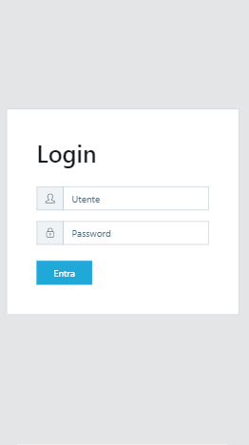
SCREEN 1: Access to the monitoring system

3. HOME PAGE

The home page will give access to the classes and sensors with colored buttons presented immediately after login (in addition to the access already provided in the menu that can be opened from the burger icon in the upper left).
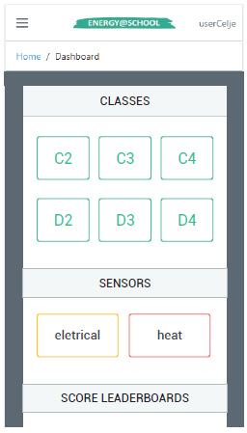
SCREEN 2: Screen of access (HOME PAGE) to detailed information for classes and sensor.

4. DESCRIPTION OF DATA ENTRY FUNCTIONS FROM THE APP

CLASSROOMS
From this page you can enter the measurements (in degrees Celsius) concerning the temperature inside the various classes monitored day by day.

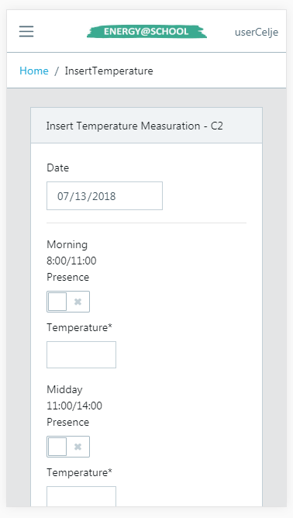
SCREEN 3: Detailed Screen for temperature detection.

The collection of data has no constraint but by entering them on time you can earn a point.
In the entry form you must respect the indicated time slots (Morning, Midday, Afternoon) and signal the presence or absence of people inside the room by ticking the relative box.
In the event that one of the recorded temperatures does not fit into the well-being area (which is between 18 and 22 degrees), a thermal phantom will be created which can then be analyzed and resolved in the dedicated "Ghosts Summary" screen.
Scrolling down you can view the temperature history and clicking on the last day you can correct any errors by changing the values ​​in the form above.

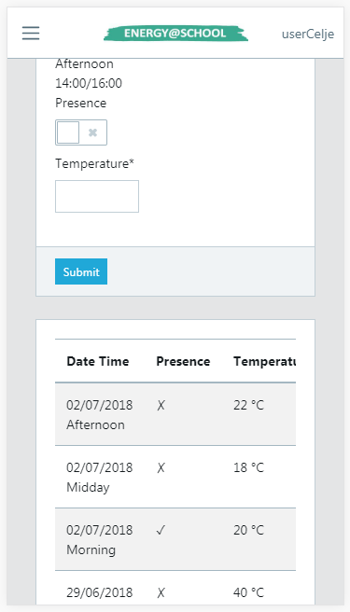
SCREEN 4: Detailed Screen for temperature and presence detection.

SENSORS
This page presents some differences with the previous one in the following points:
• The data must respect the indicated units of measure (kWh, m³, Mwh, etc.)
• The data must be the current value and not the already calculated delta
• Data entry must be sequential because the presence of holes would cause incorrect calculations on energy consumption delta and on averages (the date will remain blocked for this purpose)
• Mondays will be estimated consumption on Saturday and Sunday using minimum consumption data

• In case there is a forgetfulness and the data are not available for a certain day it is possible to generate them automatically in order to continue with the following days (NB: this procedure should be avoided as it may distort data collection by creating negative deltas or very large, so every time you use "Skip day" the score will decrease by one point)
• The latest data entered can not be changed

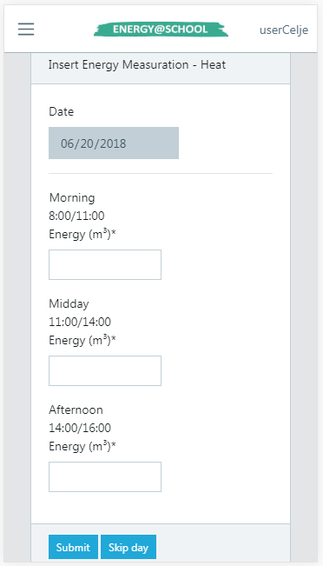
SCREEN 5: Detailed Screen for heat detection during the three time of the school day.

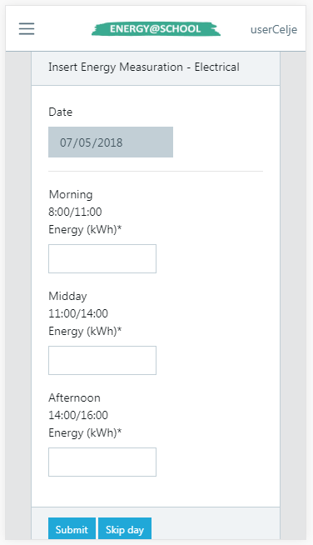
SCREEN 6: Detailed screen of electrical detection during the three time of the school day

5. DAILY REPORT

The graph of the energy consumption of a sensor (to be selected via the drop-down menu) compares, through the use of a histogram, the average consumption of that sensor with the consumption of the day (chosen on the calendar) divided into the three time slots.
HOW TO READ THIS DATA:
• The blue bar (delta relative to the selected day) when it is lower than the orange line (average value) shows a positive conduct
• If the blue bar exceeds the orange line of a difference greater than a fixed reference value (5%) it means that the behaviour was not optimal and, consequently, a ghost appeared.
The graph of the daily temperature works in a similar way to the previous one but brings into play two other factors, namely the external temperature (represented by a blue broken) and the wellness band (the green band that extends from 18 to 22 degrees)
HOW TO INTERPRET THIS DATA:
• The outside temperature gives an idea of ​​the situation outside the school during class hours
• The red bars (band temperatures) that are not part of the wellness zone, in addition to causing a ghost indicate a more or less serious problem based on how much difference is present
• Orange lines not within the wellness band indicate a persistent problem present in the selected class to be resolved as soon as possible
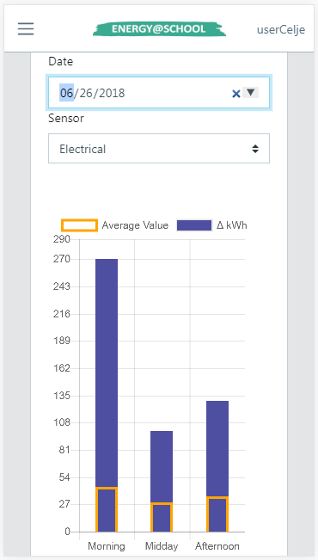
SCREEN 9: Detailed screen about daily electrical graph.

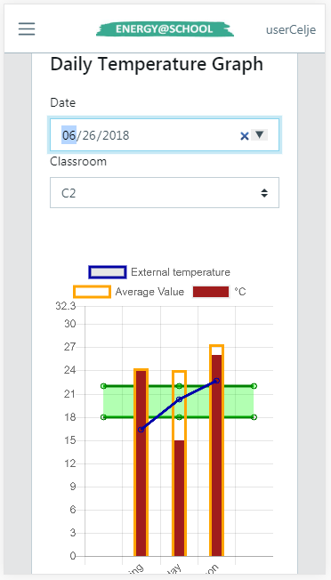
SCREEN 9: Detailed screen about daily temperature graph.

6. EXAMPLE OF MEASUREMENTS AND RELETED GRAPHS

INSERTION OF TEMPERATURE AND PRESENCE

The JEG inserts the three values ​​of temperature and presence for the date 26/06/2018 (in this case you can also enter values ​​for dates other than the current one) and class C2:

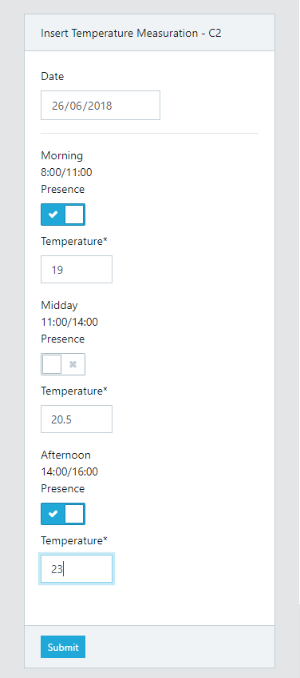

SCREEN 10: Detailed Screen for temperature insertion on the current date (26/06/2018).

Subsequently, the JEG can check the temperature graph by going to the Daily Reports and selecting date and class:

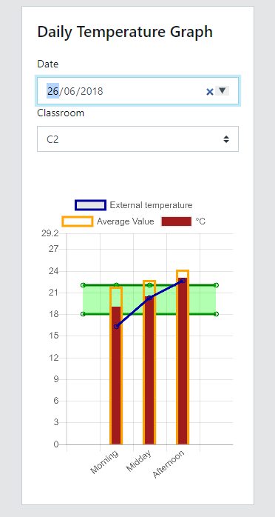

SCREEN 11: Detailed Screen for temperature graph
obtained by entering data on the current day.

The graph shows the following values:
• in red the three temperature values ​​entered
• the wellness zone in green
• in orange the average values ​​for each interval
• in blue the outdoor temperature for each interval in the afternoon band you can see a value that is outside the wellness area, this will cause the ignition of a thermal ghost relative to the data entry date and then a decrease of the total score of 10 points.3

INSERTION OFTHERMAL/ELECTRICAL VALUES

The JEG inserts the consumption values ​​for the thermal sensor on the current date:

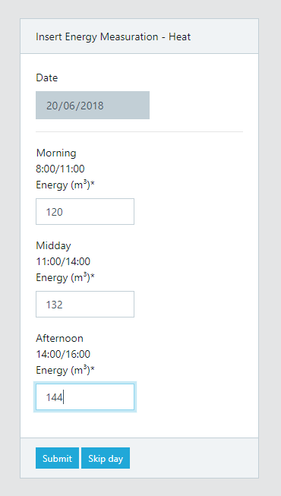
SCREEN 12: Detailed Screen for thermal values insertion.

The corresponding graph can be viewed in the Daily Report by selecting the date and the type of sensor:
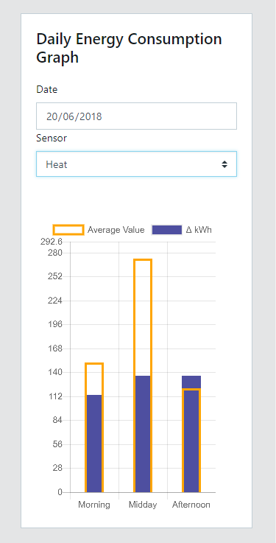
SCREEN 13: Detailed Screen for thermal graph
obtained by entering data on the current day.

The graph shows the consumption values ​​in terms of delta for each interval (blue bars) and the average values ​​of the deltas for the same intervals in orange. In this case we can observe a value higher than the average in the afternoon band. This will cause the ignition of a new energy ghost on the measurement date and a decrease of 10 points.

