TRAINING PROGRAME DEVELOPED AND DELIVERED FOR CAPACITY RAISING OF SENIOR ENERGY GUARDIANS TOWARDS ENERGY EFFICIENT MEASURES:

Countinious energy guardian training programme

Edited by PP4 KSSENA with support by PP2 CertiMaC



|  |  |
| --- | --- |
| Output O.T3.1.  28.06.2019 |  |

Edited by PP4 KSSENA with support by PP2 CertiMaC

1. Preamble

The main objective of the ENERGY@SCHOOL project is to increase the capacity of the public sector, focused on local authorities, to implement “Energy Smart Schools”, promoting the implementation of advanced technologies for energy efficiency in existing schools. The approach is based on fostering behavioural change, building awareness and a general culture of energy conservation by means of creating and implementing training programs for various relevant stakeholders active within the educational process (educationists, building managers, maintenance workers and pupils). The educational activities (on energy saving technologies, economics of reducing energy consumption, environmental benefits, etc.) will be supported by the use of smart building ICT, allowing for the participants to discover how to monitor and target energy efficiency in practice (control the indoor climate with optimal temperature control, improve air quality and thermal comfort – microclimate parameters, optimal luminescence, etc.)

This report will attempt to present the structure and contents of the proposed training program, primarily adapted to Senior Energy Guardians.

Basic outline of the training programme

The training programme is developed with the intent of facilitating the reduction of energy costs in schools to allow reinvestment in more energy efficiency measures or simply leaving schools and local authorities with more funds to carry out their primary activity – education. The basis of the training programme will be presented within the Energy Guardians Smart School Management Plan (EGSMP) and will rely on results of work packages T1 Analysis phase and definition of Energy Guardians Smart-school Management Plans and T2 Definition of Smart School Strategies and pilot applications.

This will include an upgraded Decision-support Toolbox for Energy Guardians, energy audits on a sample of representative selected schools, a developed system for targeted monitoring of energy consumption carried out within 8 pilot actions and software applications (both desktop and mobile) as part of the developed energy monitoring systems.

The focus of the trainings will foster a marketable and relevant skill set from the pre-investment phases of energy renovation activities, to advanced monitoring solutions and behavioural impact on building users. The main target groups of the training activities for senior EGs will include local authorities (municipal representatives), personnel in charge of operation and maintenance in schools in addition to educated (postgraduate students, research students) persons from the local environment with no gainful employment.

1. The European Qualifications Framework for lifelong learning (EQF) – where did the EQF come from?

The EQF is a common European reference framework which links countries’ qualifications systems together, acting as a translation device to make qualifications more readable and understandable across different countries and systems in Europe. It has two principal aims: to promote citizens’ mobility between countries and to facilitate their lifelong learning.

The Recommendation formally entered into force in April 2008. It sets 2010 as the recommended target date for countries to relate their national qualifications systems to the EQF, and 2012 for countries to ensure that individual qualification certificates bear a reference to the appropriate EQF level. The EQF will relate different countries’ national qualifications systems and frameworks together around a common European reference – its eight reference levels. The levels span the full scale of qualifications, from basic (Level 1, for example school leaving certificates) to advanced (Level 8, for example Doctorates) levels.

As an instrument for the promotion of lifelong learning, the EQF encompasses all levels of qualifications acquired in general, vocational as well as academic education and training. Additionally, the framework addresses qualifications acquired in initial and continuing education and training.

The **eight reference levels are described in terms of learning outcomes**. The EQF recognises that Europe’s education and training systems are so diverse that a shift to learning outcomes is necessary to make comparison and cooperation between countries and institutions possible**. In the EQF a Learning Outcome is defined as a statement of what a learner knows, understands and is able to do on completion of a learning process. The EQF therefore emphasises the results of learning rather than focusing on inputs such as length of study. Learning outcomes are specified in three categories – as KNOWLEDGE, SKILLS and COMPETENCE.** This signals that qualifications – in different combinations – capture a broad scope of learning outcomes, including theoretical knowledge, practical and technical skills, and social competences where the ability to work with others will be crucial.

The development of the European Qualifications Framework started in 2004 in response to requests from the Member States, the social partners and other stakeholders for a common reference to increase the transparency of qualifications. The Commission, with the support of an EQF Expert Group, produced a blueprint proposing an 8-level framework based on learning outcomes aiming to facilitate the transparency and portability of qualifications and to support lifelong learning.

1. Descriptors defining levels in the European Qualifications Framework (EQF)

Each of the 8 levels is defined by a set of descriptors indicating the LEARNING OUTCOMES relevant to qualifications at that level in any system of qualifications.

|  |  |
| --- | --- |
|  | ***Knowledge*** |
|  | *In the context of EQF, knowledge is described as theoretical and/or factual* |
| **Level 1**  The learning outcomes relevant to Level 1 are | Basic general knowledge |
| **Level 2**  The learning outcomes relevant to Level 2 are | Basic factual knowledge of a field of work or study |
| **Level 3**  The learning outcomes relevant to Level 3 are | Knowledge of facts, principles, processes and general concepts, in a field of work or study |
| **Level 4**  **The learning outcomes relevant to Level 4 are** | **Factual and theoretical knowledge in broad contexts within a field of work or study** |
| **Level 5**  The learning outcomes relevant to Level 5 are | Comprehensive, specialised, factual and theoretical knowledge within a field of work or study and an awareness of the boundaries of that knowledge |
| **Level 6**  The learning outcomes relevant to Level 6 are | Advanced knowledge of a field of work or study, involving a critical understanding of theories and principles |
| **Level 7**  The learning outcomes relevant to Level 7 are | Highly specialised knowledge, some of which is at the forefront of knowledge in a field of work or study, as the basis for original thinking and/or research  Critical awareness of knowledge issues in a field and at the interface between different fields |
| **Level 8**  The learning outcomes relevant to Level 8 are | Knowledge at the most advanced frontier of a field of work or study and at the interface between fields |

|  |  |
| --- | --- |
| ***Skills*** | ***Responsibility and autonomy*** |
| *In the context of EQF, skills are described as cognitive (involving the use of logical, intuitive and creative thinking) and practical (involving manual dexterity and the use of methods, materials, tools and instruments).* | *In the context of the EQF responsibility and autonomy is described as the ability of the learner to apply knowledge and skills autonomously and with responsibility.* |
| Basic skills required to carry out simple tasks | Work or study under direct supervision in a structured context |
| Basic cognitive and practical skills required to use relevant information in order to carry out tasks and to solve routine problems using simple rules and tools | Work or study under supervision with some autonomy |
| A range of cognitive and practical skills required to accomplish tasks and solve problems by selecting and applying basic methods, tools, materials and information | Take responsibility for completion of tasks in work or study; adapt own behaviour to circumstances in solving problems |
| **A range of cognitive and practical skills required to generate solutions to specific problems in a field of work or study** | **Exercise self-management within the guidelines of work or study contexts that are usually predictable, but are subject to change; supervise the routine work of others, taking some responsibility for the evaluation and improvement of work or study activities** |
| A comprehensive range of cognitive and practical skills required to develop creative solutions to abstract problems | Exercise management and supervision in contexts of work or study activities where there is unpredictable change; review and develop performance of self and others |
| Advanced skills, demonstrating mastery and innovation, required to solve complex and unpredictable problems in a specialised field of work or study | Manage complex technical or professional activities or projects, taking responsibility for decision-making in unpredictable work or study contexts; take responsibility for managing professional development of individuals and groups |
| Specialised problem-solving skills required in research and/or innovation in order to develop new knowledge and procedures and to integrate knowledge from different fields | Manage and transform work or study contexts that are complex, unpredictable and require new strategic approaches; take responsibility for contributing to professional knowledge and practice and/or for reviewing the strategic performance of teams |
| The most advanced and specialised skills and techniques, including synthesis and evaluation, required to solve critical problems in research and/or innovation and to extend and redefine existing knowledge or professional practice | Demonstrate substantial authority, innovation, autonomy, scholarly and professional integrity and sustained commitment to the development of new ideas or processes at the forefront of work or study contexts including research |

1. Definitions

* **QUALIFICATION** means a formal outcome of an assessment and validation process which is obtained when a competent body determines that an individual has achieved learning outcomes to given standards;
* **NATIONAL QUALIFICATIONS FRAMEWORK** means an instrument for the classification of qualifications according to a set of criteria for specified levels of learning achieved, which aims to integrate and coordinate national qualifications subsystems and improve the transparency, access, progression and quality of qualifications in relation to the labour market and civil society;
* **SECTOR** means a grouping of professional activities on the basis of their main economic function, product, service or technology;
* **LEARNING OUTCOMES** means statements of what a learner knows, understands and is able to do on completion of a learning process, which are defined in terms of knowledge, skills and competence;
* **KNOWLEDGE** means the outcome of the assimilation of information through learning. Knowledge is the body of facts, principles, theories and practices that is related to a field of work or study. In the context of the European Qualifications Framework, knowledge is described as theoretical and/or factual;
* **SKILLS** mean the ability to apply knowledge and use know-how to complete tasks and solve problems. In the context of the European Qualifications Framework, skills are described as cognitive (involving the use of logical, intuitive and creative thinking) or practical (involving manual dexterity and the use of methods, materials, tools and instruments);
* **COMPETENCE** means the proven ability to use knowledge, skills and personal, social and/or methodological abilities, in work or study situations and in professional and personal development. In the context of the European Qualifications Framework, competence is described in terms of responsibility and autonomy.

1. Common Principles for Quality Assurance of Vocational Education and Trainings in the context of the European Qualifications Framework

When implementing the European Qualifications Framework, quality assurance – which is necessary to ensure accountability and the improvement of higher education and vocational education and training – should be carried out in accordance with the following principles:

– Quality assurance policies and procedures should underpin all levels of the European Qualifications Framework.

– Quality assurance should be an integral part of the internal management of education and training institutions.

– Quality assurance should include regular evaluation of institutions, their programmes or their quality assurance systems by external monitoring bodies or agencies.

– External monitoring bodies or agencies carrying out quality assurance should be subject to regular review.

– Quality assurance should include context, input, process and output dimensions, while giving emphasis to outputs and learning outcomes.

– Quality assurance systems should include the following elements:

* clear and measurable objectives and standards;
* guidelines for implementation, including stakeholder involvement;
* appropriate resources;
* consistent evaluation methods, associating self-assessment and external review;
* feedback mechanisms and procedures for improvement;
* widely accessible evaluation results.

– Quality assurance initiatives at international, national and regional level should be coordinated in order to ensure overview, coherence, synergy and system-wide analysis.

– Quality assurance should be a cooperative process across education and training levels and systems, involving all relevant stakeholders, within Member States and across the Community.

– Quality assurance orientations at Community level may provide reference points for evaluations and peer learning.

1. Continuous energy guardian training programme

In the project we have developed 2 levels of training programme first is Vocational and second is Continuous training programme and as the name suggested, the second one is intended for all that have participated in first training and would like to upgrade the knowledge they gained in the first part of the training.

Each task is represented by the following symbol 

The activities include hints and suggestions which are found under the following symbol: 

For task requiring the access to computer the following symbol will apply:

The continuous energy guardian training programme is set up from 3 trainings units with 3 developed tasks supported with developed excel tool. The programme is designed in the way that the theory is mainly processed in the classrooms with couple of hours as self-study, supported with various tasks designed as case studies. Depending of the content and its difficulty there are recommended hours, with the intend to work closely with the expert to acquire knowledge and learn how to transfer it on actual problems.

The practical continuation of the Vocational Energy Guardian Training Program (VEGTP) is focused on understanding of the process of preliminary analysis of core areas relevant to energy efficiency in schools. For this purpose, practical examples are carried out on two theoretical buildings (School_A, and School_B) that provide basic input parameters with which the analysis is carried out.

The description of essential parameters on energy consumption, potential energy savings, costs, investments and others shall be referenced by training participants in the process of carrying out tasks and assignments described in relevant parts of the theoretical training programme.

The description of initial theoretical building models are provided in each individual training unit. The content provided within the training programme is and cannot be exhaustive, therefore it is recommended that participants under the coordination of the moderator/expert of the training course document their examples or even add additional theoretical building models on which others can further experiment and learn.

With the intent to make the training programme adaptable and replicable across member states, the project partners developed a learning tool for the preliminary analysis of energy renovation from the technical, environmental and financial perspectives. From the wide array of available software tools, it was decided that a ground-up approach that focuses primarily on the understanding of the learning content by training participants rather than professional functionality and optimization is utilized. Before continuing with the training activities familiarize yourself with functionality and content available within the developed tool. It is distributed in an unlocked version in order to allow re-use, editing and upgrade capabilities to all interested parties.

|  |  |  |  |  |
| --- | --- | --- | --- | --- |
| **CONTINUOUS ENERGY GUARDIAN TRAINING PROGRAME** | | | | |
| **Training Unit** | **Title of the TU** | **Duration in Hours** | **Learning Objectives**  **(based on EQF descriptors)** | **Didactic Methodologies**  **(and duration for each)** |
| **1** | **BUILDING PHYSICS** | **50** | Theoretical knowledge  Cognitive and practical skills  Ability of taking some responsibility for the evaluation and improvement | Classroom - 5 h  Self-study – 10 h  Case Studies – 35 h |
| **2** | **ENERGY MANAGEMENT SYSTEM** | **50** | Theoretical knowledge  Cognitive and practical skills  Ability of taking some responsibility for the evaluation and improvement  The ability to guide and direct others | Classroom - 7 h  Self-study – 10 h  Case Studies – 33 h |
| **3** | **ECONOMICS OF ENERGY SAVINGS** | **50** | Theoretical knowledge  Cognitive and practical skills  Ability of taking some responsibility for the evaluation and improvement | Classroom - 8 h  Self-study – 8 h  Case Studies – 34 h |
| **TOTAL COURSE DURATION** | | **150** |

* 1. Continuous energy guardian training programme in line with European qualification framework

During the project, partners have tested the second part of trainings with different content and durations based on their target group which were school staff, teachers, maintenance workers, energy managers and others. The aim of the Common versions of the Trainings is for setting the basis for a structured training that can be customized and transferred outside the project boundaries and participants, a training that can be of full reference for any other school and Municipality that is willing to implement the role of Energy Guardians in their environment.

For these reasons, it has been decided to implement the tests/experimentations done and it has been defined that the **EQF Level to be aimed by tailored training is achieved LEVEL 4.**

All the training contents developed during the project have therefore been fine-tuned and organised in a training formally structured according to the EQF rules. Following the training, any European school and Municipality will ensure to train very-skilled Senior Energy Guardians.

The learning outcomes relevant to Level 4 are:

**Knowledge -** *In the context of EQF, knowledge is described as theoretical and/or factual*

Factual and theoretical knowledge in broad contexts within a field of work or study.

**Skills -** *In the context of EQF, skills are described as cognitive (involving the use of logical, intuitive and creative thinking) and practical (involving manual dexterity and the use of methods, materials, tools and instruments).*

A range of cognitive and practical skills required to generate solutions to specific problems in a field of work or study.

**Competence -** *In the context of EQF, competence is described in terms of responsibility and autonomy.*

**E**xercise self-management within the guidelines of work or study contexts that are usually predictable, but are subject to change, supervise the routine work of others, taking some responsibility for the evaluation and improvement of work or study activities.

* 1. Energy management system in five main sections

In prepared content we have covered energy management system in the 5 main sections. Each specific area is addressed with a developed thematical task, that is found within each training unit. You can do them yourself or with the help of the energy expert.

|  |
| --- |
| SETTING UP ENERGY MANAGEMENT STRUCTURES |

1. Setting out an energy manager or energy management team

|  |
| --- |
| DATA ACQUISITION AND EVALUATION |

1. Collecting data of energy consumption

* Correct reading of building energy invoices
* Analysis of energy consumption (heat, power and water)
* Processing energy data

1. Performing energy audit

* Preliminary energy audit
* Detailed list of energy consumptions per user
* Detailed review of the building and its operating system
* Perform a thermographic inspection
* Perform a microclimate inspection
* Calculation of energy consumptions and costs
* Detailed energy audit
* Preliminary energy audit
* **Develop an energy use computer model with building physics** 

|  |
| --- |
| PLANNING AND PRIORITIZATION |

1. Preparation of an action plan

* **Establish an EMP** 
* Action plan for energy efficiency measures
* Action plan of exploitation of renewable energy sources
* **Determine economic feasibility of refurbishment measures** 
* Technical documents

|  |
| --- |
| IMPLEMENTATITON OF PROJECT AND ACTIONS |

1. Implementation of energy measures

* Implementation of organizational and low-cost measures
* Implementation of investment measures

|  |
| --- |
| MONITORING AND REPORTING |

* Energy bookkeeping
* Preparation of monthly or annual report
* **Establishing EMIS** 
* Working with software application
* Monitor and analyse data from smart meters

1. Prepared training units in Continuous training programe

|  |  |
| --- | --- |
| **TRAINING UNIT n.4 – BUILDING PHYSICS** | |
| Duration: 50 hours | |
| LEARNING OUTCOMES:  • Independent performance of energy audits on the building  • Recognition of the opportunities to implement measures to improve energy efficiency or use of the renewable energy resources | |
| CONTENTS | |
| * Building physics * TASK: Develop an energy use computer model with building physics | |
| KNOWLEDGE | COMPETENCES |
| * Understanding building physics characteristic * Understanding building operational system * Recognizing measures to improve energy efficiency | * Self-management in the preparation of building physics * Ability to recognize the possibilities of placement RES and RUE measures on the building * Capability to develop building physics model with computer model |

|  |  |
| --- | --- |
| **TRAINING UNIT n.5 – ENERGY MANAGEMENT SYSTEM** | |
| Duration: 50 hours | |
| LEARNING OUTCOMES:  • Independent operation with energy management system  • Independent in preparation of action plan for the building | |
| CONTENTS | |
| * Energy management system * TASK: Establish an EMP | |
| KNOWLEDGE | COMPETENCES |
| * Knowledge to understand operation of energy management system * Determining energy baseline, developing an overview of energy consumption and defining benchmark energy consumption of the building | * Self-management in the operation of energy management system * Ability to guide and direct others in line with energy management action plan to achieve greater savings * Capability to establish an EMP in building |

|  |  |
| --- | --- |
| **RAINING UNIT n.6 – ECONOMICS OF ENERGY SAVINGS** | |
| Duration: 50 hours | |
| LEARNING OUTCOMES:  • Independent calculation of energy efficient savings based on cost effectiveness, durability and reliability  • Ability to recognize and calculate financial possibilities of energy efficiency measures | |
| CONTENTS | |
| * Economics of energy savings * TASK: Determine economic feasibility of refurbishment measures | |
| KNOWLEDGE | COMPETENCES |
| * knowledge to recognize the best option for financing EE measures * determining economic feasibility of refurbishment measures | * Self-management within the guidelines of energy efficiency field * Ability to recognize the possibilities of placement RES and RUE measures on the building * Capability to determine economic feasibility of refurbishment measures |

1. Skills assessment

The prepared basic training programme was developed in the way to meet the criteria of EQF. That means that it is set up from theoretical part that encourage participants to use logical, intuitive and creative thinking and also from practical part to learn how to use manuals, tools and methods on the actual problems.

Each partner has the opportunity to adapt the basic training to their needs and prepare the training programme most suitable for their target groups. After the implemented training in all school we have asked representors of SEG to assess the knowledge, skills and competences that they have gained throughout the training programme within Energy@school project.

|  |
| --- |
| ITALY – PP1 |
| Working on the Energy@school project gave me the opportunity to discover the existence of a real community that works constantly to develop initiatives for energy, environmental and climate sustainability. The topic is carried out by the institutions, which however, as happened in energy @ school, make the local authorities working together. In this way the foundations are laid for the future where children will become aware men. The Energy@school project was the tool and not the goal for greater awareness of energy, environmental and climate sustainability. |
| POLAND – PP3 |
| SEG's developed their knowledge about energy saving and energy efficiency. They extended their knowledge in the field of energy production from municipal waste incinerators and biogas plants.  They gained new skills:   * the ability to convince others to a pro-ecological attitude * the ability to make logical and interesting arguments about energy saving * the ability to save thermal energy through appropriate ventilation of classroom * the ability to better inter-school communication within the project * increased awareness of the impact of human activities on the environment |
| CROATIA – PP5 |
| Mahično, Gorana Simić Vinski - I have gained a lot of knowledge about heating system in my school and about energy saving in general. I was very motivated to work on this project especially when LED lights and thermostatic valves were installed. The installation of energy monitoring system helped me to see exactly where the energy is lost and how it can be saved.  Rečica, Blaženka Mravunac - We have also learned a lot about planned and continuous work on energy savings. How to Calculate the Cost-Effectiveness of Energy-Saving Investment How to make more people think about energy savings. Small steps and joint action can save your money. Consumption applications have greatly helped to detect high energy consumption, and if measures can be taken and large consumption can be removed. We have seen examples of good energy savings in other schools, cities in Croatia and Europe that we could follow.  Švarča, Snježana Protulipac – It was my first EU project and I learned a lot about Interreg and support of European Union to environment protection. |
| HUNGARY – PP7 |
| They have a broader knowledge of building physics and how to conduct energy audits. They learned how to track the components of the power management process, how to create an energy management program using EMIS. They got to know energy meters and smart meters and their use. They have general knowledge of the economic concepts of project investment, energy saving and financial analysis (ROI, NPV, IRR). In the practical examples, an energy analysis was carried out with the CEGE training tool (Excel) provided to the participating schools. The JEG team's enthusiasm motivated them to perform daily tasks in the simulation game. |
| HUNGARY – PP8 |
| Most of the new knowledge and experience has been gained due to the importance of the energetic characteristics of buildings, energy upgrades, their types and possibilities. |
| GERMANY – PP9 |
| I already had good skills and competences in climate protection before the Energy@school project trainings, but was able to benefit, for example, from the communication of the school's energy data recording.  Skills and competences gained: Carry out measurements carefully, Evaluate and visualize measured values, Reflection of measured values and personal work, Presenting and arguing professionally environmental awareness and Planning of projects at the school.  Recognition that a continuous improvement process must be implemented at the school. |
| SLOVENIA – PP12 |
| SEG´s have learn about measures to reduce energy use, which include both measures on technologies and systems, as well as changing everyday inefficient habits and practices. Measures to improve energy efficiency have also been an excellent opportunity for practical learning and transfer of knowledge to others. In addition, they have realized the measurement of the use of electricity on the basis of automatic measurements (reading using the smart metering system). |



TRAINING UNIT 4

Building physics

1. BUILDING PHYSICS

Building physics is the science of how energy interacts with the materials within a building envelope. It covers the fields of heat transfer, moisture transfer and air flows and also consider lighting, building systems and construction technology. This means that building physics can include other areas such as energy efficiency, indoor air quality, mould in buildings and ventilation systems.

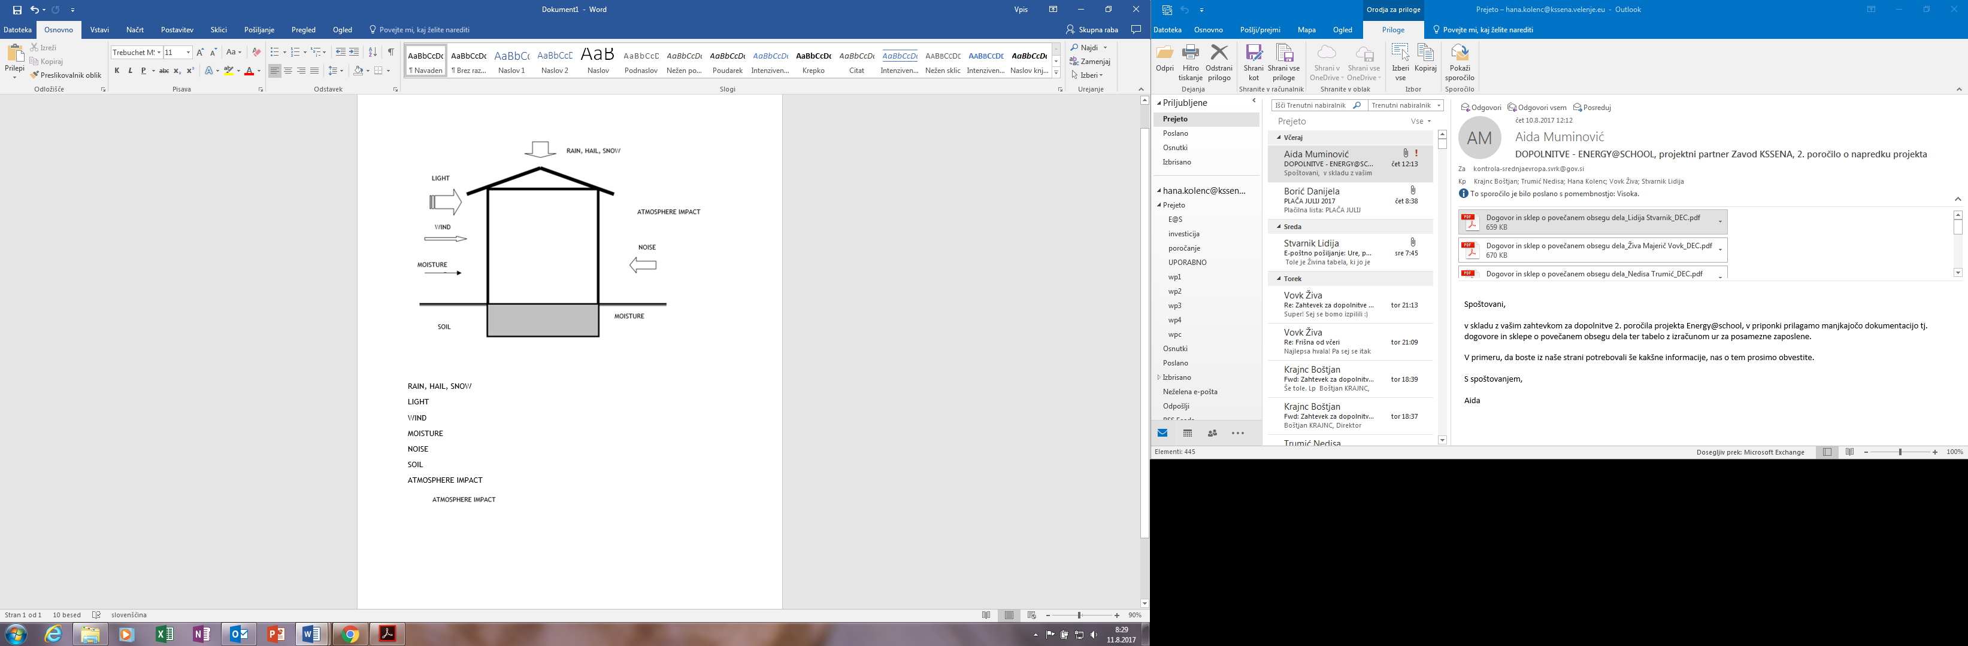

Figure 1: Influence of atmosphere impact on a building[1]

Building physics plays a key role in the design of energy efficient buildings. It is not always considered during the design of a building, yet it influences the energy use and thermal climate of a building over its entire life. Disregarding these principles can result in superfluous operational costs and environmental impacts.

* 1. Heat

One of the aspects that building physics covers is the study of heat transfer through a building’s envelope. The idea with energy efficient homes is to reduce the amount of energy needed to operate the building. Achieving this is done by increasing the amount of insulation within the walls, tightening the building envelope and optimising the ventilation system so that less energy is required to maintain a constant temperature inside the building. This idea applies for both warm and cool climates. This increases the level of comfort in the building since people are very sensitive to even small changes in temperature. A poorly insulated building can be a very uncomfortable. However, thermal comfort is not only determined by temperature differences, it is also important to consider moisture levels, air pressures, air movement and material choices and other factors that play a role with the thermal comfort of the indoor environment. If a building is not designed properly, the risk for moisture and ventilation problems increases as the energy efficiency decreases. Only an understanding of heat, air and moisture transfer theories along with knowledge of the material properties in the construction can counter these effects.

* 1. Air

Ventilation, whether it is natural or mechanical, provides air from the outdoors into buildings. Poor ventilation can lead to indoor air quality problems that can lead to health problems. Poorly designed ventilation systems can also be energy intensive and give a poor indoor environment. If the ventilation system is not balanced properly, condensation can occur on the windows, in the walls due to leaks in the building envelope, and odours can be detected from neighbouring apartments. This can also lead to other problems like mould growth and high dust levels. If these problems continue without remediation, health problems may surface in the occupants of the building.

* 1. Moisture

Moisture problems are one of the main topics today in building physics. It is a complex problem requiring a holistic approach in order to grasp the true effects of this problem. Moisture can occur in a building through a number of different paths. There are three methods of transportation that allow the water to come into contact with the materials, convection, diffusion and capillary action. Convection occurs when air moves the water particles. Diffusion is the phenomena of where the water concentration wants to be at equilibrium. Capillary action mostly occurs underground where the water travels into materials with small pore spaces. Whichever method the water takes, there is a risk during the entire construction process that materials will become wet. Before the physical construction work begins, materials can be delivered wet. They can become wet after delivery because of improper storage, storage on the ground or exposure to the climate during construction. It is important to protect the materials during every phase of construction. After the building is finished, it is still at risk from both the indoor and outdoor environments. There is an increased risk for moisture problems to occur once the moisture level of the environment reaches 75%. Ventilation control becomes even more important in removing excess moisture in the air, moisture that is attributed to building materials, people sweating, showering, cooking foods, etc.

TASK: Develop an energy use computer model with building physics

There are many different computer models for calculating building physics available on line and are based on similar calculation procedures. So, it is suggested that with a help of energy manager you prepare the building physics calculation of a building in software programme that is usually used in your country.

Most of the available tools are designed to calculate heat flows in buildings and moisture flows through materials. These programs are usually very complex and take into account the position of the building (to calculate solar gains or the amount of shading from other buildings or trees), the types of materials used, the type of ventilation system, the amount and type of heating required, the physical dimensions of the building, the effect of the local climate on the energy usage, etc.

So here we will represent the key steps towards establishing building physics based on our national software programme, which is the same that we are using for calculating energy efficiency certificates. We will explain the process on “School_A”.

1. **Theoretical analytic model School_A**

Building School_A was constructed in 1959. The total net surface area of heated spaces amounts to 730,41 m2 and includesseveral classrooms, cabinets, corridors, offices, a secretariat, staff chambers, a library, gym and boiler room. Additional parameters on building size are available for further reference in Table below.

|  |  |  |
| --- | --- | --- |
| Net surface area of heated spaces | 730,41 | m2 |
| Gross volume of the building | 2.880,36 | m3 |
| Nett volume of the building | 2.271,39 | m3 |



Main steps that will be represented in this process are:

|  |  |
| --- | --- |
| iNTRODUCTION | |
|  | READ CHAPTER “*Theoretical* analytic model School_A” |
| **Collect and insert the input data in the programme** | |
|  | Location data |
|  | Type or purpose of building |
|  | Define the zones |
|  | Wall structure and materials used |
|  | Specific transmission heat loses |
| **discussion (Time estimate: 15min, 10min)** | |
|  | THE RESULTS OBTAINED BY THE CALCULATION OF BUILDING PHYSICS |

|  |  |
| --- | --- |
|  | READ CHAPTER “THEORETICAL analytic model School_a“ |

For the calculation with building physic programmes you need to obtain the necessary input data by making location visit or get the information’s from existing architectural and construction documents. Some of the necessary data are represented in the chapter Theoretical analytic model School_A.

1. General data

|  |  |
| --- | --- |
|  | Location data |

Based on given location data of building, the program can determine the climate data such as temperature deficit, heating and cooling degree days, period of heating/cooling season, solar irradiance, average outdoor temperature etc.

|  |  |
| --- | --- |
| **City** | Velenje |
| **Cadastral municipality** | Velenje |
| **Parcel number** | 2539 |
| **Location coordinates of the building** | X(N)=135061 |
| Y(E)=509281 |

|  |  |
| --- | --- |
|  | Type or purpose of building |

It is important to define the type and purpose of the building because there are different properties for different type of a building predefined in the programme (dwelling, house, public building, industrial building, etc.)

1. Building data

|  |  |
| --- | --- |
|  | Define the zones |

The zones in building are defined based on:

* heated/cooled rooms (if the basement floor or some rooms in the building are not heated or cooled you don’t consider them in the calculation),
* how are the rooms heated/cooled (if one room is heated different than the other rooms or if there are different energy sources we have to define different zone),
* what is an average indoor temperature (if one room have a different average indoor temperature than the other rooms, we have to define different zone).

In the table below are three examples of different heated/cooled rooms in the building

|  |  |
| --- | --- |
| Heated or cooled rooms (red line) | How to define zone |
|  | * First floor * Second floor |
|  | * First floor * Second floor * Attic |
|  | * Second floor * Attic |

Zone length and width: have to be defined for each conditioned zone (heated or cooled) and are measured from exterior walls, see the layout below:

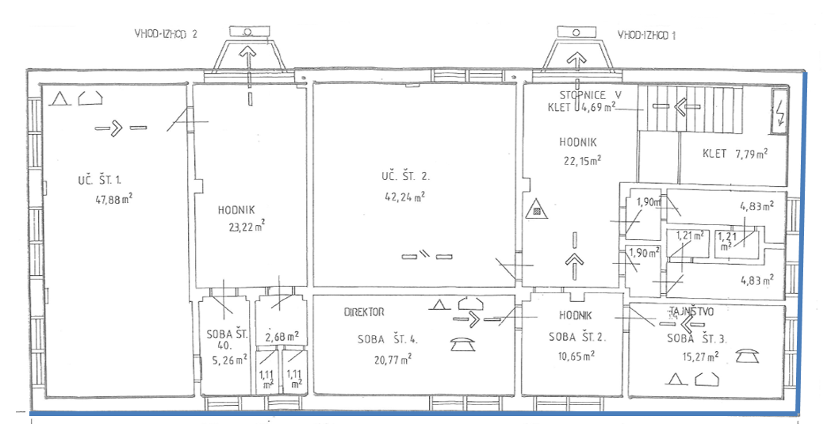

*Note: in this case the entire floor is considered as one zone*

Conditioned floor area (m2) is the total floor area of enclosed conditioned space on all floors of a building, as measured at the floor level of the interior surfaces of exterior walls enclosing the conditioned space

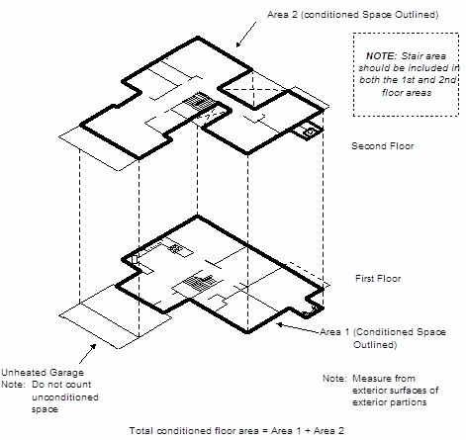

Heated volume (m3) is the total volume of the define zone (including the width of exterior walls, width of ground floor and roof floor).

Net heated volume - m3 is the heated or cooled volume of the air, inside the building (not including the exterior and interior walls, ground slab and roof). It can also be calculated approximately with the formula: 0.8 * heated volume.

Floor height, if you have more than one floor that are different heights, you have to define the height for each floor.

In our case the entire building is heated so we have defined only one zone:

|  |  |
| --- | --- |
| **Zone length** | 24,95 |
| **Zone width** | 10,90 |
| **Conditioned floor area** | 730,41 m2 |
| **Heated volume** | 2.880,36 m3 |
| **Net heated volume** | 2.271,39 m3 |
| **Floor height** | 3,1 m |
| **Number of floors** | 3 |

|  |  |
| --- | --- |
|  | Wall structure and materials used |

After defining the zone of building you have to determine all different types of walls/slabs structure that surround the heated/cooled rooms. Here are three examples of differently defined zones:

|  |  |
| --- | --- |
| Zone (red line) | Walls/slabs of which layers needs to be defined |
|  | * Exterior wall * Foundation slab * Ceiling towards the attic |
|  | * Exterior wall * Foundation slab * Roof |
|  | * Exterior wall * Slab towards unheated basement * Roof |

Here are the layers of walls/slabs that are defining the zone in this case:

1. Layers of exterior wall

|  |  |
| --- | --- |
|  | 1. Mineral plaster layer 2. Brick wall 3. Finishing mineral plaster layer |

The programmes usually have a set of materials with characteristics already prepared, so it is necessary to choose the material and enter the thickness. Based on inserted data the program calculated the characteristics that are represented in the table below:

|  |  |  |  |  |  |  |
| --- | --- | --- | --- | --- | --- | --- |
| **Layer** | **Material** | **Thickness - cm** | **Density – kg/m3** | **Specific heat – J/kgK** | **Thermal conductivity – W/mK** | **Thermal resistance – m2K/W** |
| 1. | Mineral plaster layer | 3,000 | 1.600 | 1.050 | 0,810 | 0,037 |
| 2. | Brick wall | 39,000 | 1.600 | 920 | 0,640 | 0,690 |
| 3. | Finishing mineral plaster layer | 3,000 | 1.850 | 1.050 | 0,700 | 0,043 |

*Note: The data in are automatically calculated based on inserted layers.*

1. Layers of ground slab

|  |  |
| --- | --- |
|  | 1. Ceramic tiles 2. Cement screed 3. Expanded polyester (styrofoam) 4. Multipleplate bitumenic hydroizolation 5. Concrete 6. Gravel |

|  |  |  |  |  |  |  |
| --- | --- | --- | --- | --- | --- | --- |
| **Layer** | **Material** | **Thickness - cm** | **Density – kg/m3** | **Specific heat – J/kgK** | **Thermal conductivity – W/mK** | **Thermal resistance – m2K/W** |
| 1. | Ceramic tiles | 2,000 | 2.300 | 920 | 1,280 | 0,016 |
| 2. | Cement screed 2200 | 5,000 | 2.200 | 1.050 | 1,400 | 0,36 |
| 3. | Expanded polyester (styrofoam) | 3,000 | 28 | 1.500 | 0,046 | 0,652 |
| 4. | Multipleplate bitumenic hydroizolation 1200 | 0,020 | 1.200 | 1.460 | 0,190 | 0,001 |
| 5. | Concrete 2400 | 15,000 | 2.400 | 960 | 2,040 | 0,074 |
| 6. | Gravel | 25,000 | 1.750 | 840 | 1,500 | 0,167 |

1. Layers of flat roof

|  |  |
| --- | --- |
|  | 1. Finishing mineral plaster layer 2. Concrete 3. Extruded polystyrene 4. Bituminous cardboard 5. Bituminous cardboard |

|  |  |  |  |  |  |  |
| --- | --- | --- | --- | --- | --- | --- |
| **Layer** | **Material** | **Thickness - cm** | **Density – kg/m3** | **Specific heat – J/kgK** | **Thermal conductivity – W/mK** | **Thermal resistance – m2K/W** |
| 1. | Finishing mineral plaster layer | 1,000 | 1.500 | 920 | 1,280 | 0,014 |
| 2. | Concrete | 15,000 | 2.500 | 960 | 1,400 | 0,064 |
| 3. | Extruded polystyrene | 5,000 | 150 | 1.000 | 0,046 | 0,833 |
| 4. | Bituminous cardboard | 1,000 | 1.100 | 1.460 | 0,190 | 0,053 |
| 5. | Bituminous cardboard | 0,500 | 1.100 | 1.460 | 1,700 | 0,029 |

1. Layers of slope roof

|  |  |
| --- | --- |
|  | 1. Finishing mineral plaster layer 2. Wood 3. Vapor barrier 4. Mineral wool 5. Wood 6. Profiled roof panel |

|  |  |  |  |  |  |  |
| --- | --- | --- | --- | --- | --- | --- |
| **Layer** | **Material** | **Thickness - cm** | **Density – kg/m3** | **Specific heat – J/kgK** | **Thermal conductivity – W/mK** | **Thermal resistance – m2K/W** |
| 1. | Finishing mineral plaster layer | 3,000 | 1.000 | 920 | 0,470 | 0,064 |
| 2. | Wood | 2,5000 | 600 | 2.090 | 0,140 | 0,179 |
| 3. | Vapor barrier | 0,053 | 225 | 960 | 0,190 | 0,003 |
| 4. | Mineral wool | 15,000 | 140 | 1.030 | 0,040 | 3,750 |
| 5. | Wood | 2,500 | 600 | 2.090 | 0,140 | 0,179 |
| 6. | Profiled roof panel | 2,500 | 100 | 150 | 0,035 | 0,714 |

|  |  |
| --- | --- |
|  | Specific transmission heat loses |

Based on defined orientation, incline and surface of all facades, the programme calculates the transmission heat loses which are heat loses through external surfaces.

They are divided into two sections, non-transparent and transparent surfaces:

|  |  |  |  |  |  |  |
| --- | --- | --- | --- | --- | --- | --- |
| **NON-TRANSPARENT SURFACES** | | | | | |  |
| **Type** | **Orientation** | **Incline °** | **Surface – m2** | **Thermal transmittance U – W/Km2** | **Heat loss** | **Umax - W/Km2** |
| External wall | North | 90 **°** | 239,35 | 1,164 | 278,60 | 0,28 |
| External wall | East | 90 **°** | 72,28 | 1,164 | 84,13 | 0,28 |
| External wall | South | 90 **°** | 241,65 | 1,164 | 281,28 | 0,28 |
| External wall | West | 90 **°** | 75,54 | 1,164 | 87,93 | 0,28 |
| Roof | / | 0 **°** | 234,94 | 0,882 | 207,22 | 0,20 |
| Roof | East | 15 **°** | 42,60 | 0,199 | 8,48 | 0,20 |

*Note: when calculating the surface, you have to deduct the surface of windows/door that are on that facade.*

|  |  |  |  |  |  |  |
| --- | --- | --- | --- | --- | --- | --- |
| **Type** | **Orientation** | **Incline °** | **Surface – m2** | **Thermal transmittance U – W/Km2** | **Heat loss** | **Umax - W/Km2** |
| Door | North | 90 **°** | 14,26 | 1,600 | 22,82 | 1,60 |
| Door | West | 90 **°** | 2,10 | 3,000 | 6,30 | 1,60 |

|  |  |  |  |  |  |  |  |  |  |
| --- | --- | --- | --- | --- | --- | --- | --- | --- | --- |
| **TRANSPARENT SURFACES** | | | | | | | | |  |
| **Type** | **Material** | **Layers** | **Shadings** | **Orientation** | **Incline °** | **Surface – m2** | **Thermal transmittance U – W/Km2** | **Heat loss** | **Umax - W/Km2** |
| Door | Wood | / | / | West | 90 **°** | 7,63 | 5,500 | 41,96 | 1,30 |
| Window | PVC | 2 | External blinds | North | 90 **°** | 53,82 | 1,200 | 64,58 | 1,30 |
| Window | PVC | 2 | External blinds | South | 90 **°** | 65,78 | 1,200 | 78,94 | 1,30 |
| Window | PVC | 2 | External blinds | East | 90 **°** | 55,26 | 1,200 | 66,31 | 1,30 |
| Window | PVC | 2 | External blinds | West | 90 **°** | 53,82 | 1,200 | 64,58 | 1,30 |

*Note: Umax-values are taken from standards SIST EN ISO 6946 and SIST EN ISO 10211.*

**LOSSES THROUGH FUNDAMENTAL SLAB AND BELOW GRAND WALLS**

|  |  |  |  |  |  |
| --- | --- | --- | --- | --- | --- |
| **Type** | **Surface - m2** | **Perimeter of slab - m** | **Thermal transmittance U - W/Km2** | **Heat loss W/K** | **Umax - W/Km2** |
| Ground floor | 271,97 | 91,70 | 0,334 | 63,45 | 0,35 |

*Note: perimeter is necessary for calculation of linear thermal bridges.*

* Consideration of thermal bridges - the thermal transmittance of thermal bridges should be calculated using either the detailed method (in accordance with the corresponding standards SIST EN ISO 13789, SIST EN ISO 14683 or SIST EN ISO 10211) or simplified method (in accordance with the corresponding standard SIST EN ISO 14683).
* Ventilation heat losses - the heat losses caused by ventilation depend on the type of ventilation system in building (natural or mechanical).
* Heat gains – are caused by heating demand, solar radiation which enters the building, as well as internal heat gains from occupants, lighting, equipment and technical systems.

1. Data about system

For collection of data about operating system of the building you can use the template presented in first part of *Training materials Task 3: Detailed review of the building and its operating system.*

* Data about heating – it is important to define energy carrier, power and energy conversion of boiler, boiler control (internal or external temperature sensor), heating regime (the higher the temperature the greater are the losses), indoor heaters – radiators and heating regulation (local – thermostatic valves or central).
* Heating distribution system – it is important to define length and width because based on that the programme calculates the length of distribution system and can determine the heat losses that occurred through distribution system.

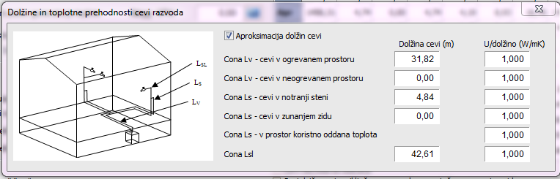

* LSL – connection line
* LS - vertical line
* LV - horizontal line
* Data about cooling: energy carrier, way of cooling (split or multi split)
* Data about hot sanitary water: way of preparation (local or central in combination with heating) energy carrier, number of days (schools are usually operating five days per week) and type of a building
* Lightings: number of lights, power of lights – W and its working hours.
* Data about the use of renewable energy sources: solar photovoltaic, solar thermal – hot water systems, heat pumps, geothermal and wind energy sources.

|  |  |
| --- | --- |
|  | The results obtained by the calculation of building physics |

|  |  |
| --- | --- |
| Input heat energy | Qf,h,skupni =120.941,75 kWh |
| Annual needed heat energy | QNH = 98.121 kWh/a |
| Annual needed heat energy per unit of conditioned floor area | QNH/A = 134,34 kWh/m2a |

*Note: heat energy need is thermal energy (without taking into account system losses and conversions from one energy type to another).*

|  |  |
| --- | --- |
| Annual CO2 emissions | 42.173,35 kg |
| Annual CO2 emissions per unit of conditioned floor area | 65,9 kg/m2a |

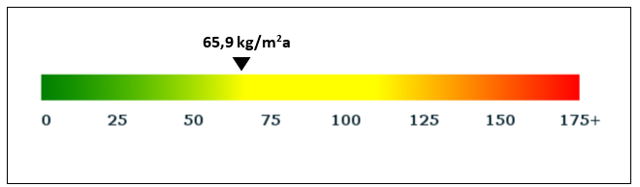

**Heat losses and gains**

One of the results that are calculated are transmission and ventilation heat loses and on the other hand internal heat gains and gains from solar radiation.

*Note: You can read more about heat gains and losses in the D.T3.2.1 Training materials to deliver VEGTP training programme to SEG, chapter 1.3.ENERGY EFFICIENCY BASICS*

Here we have represented only the main results that you get from the programme of building physics. Based on these results the energy expert can evaluate the energy efficiency of the building and prepare the list of potential measures to be implemented in building to improve its efficiency.

After the list of potential measures is prepared the energy manager re-make a calculation of building physics and inserts the data of potential measures. The obtained results from the second calculation shows how energy efficient the building will be after the implementation of potential measures.



TRAINING UNIT 5

energy management system

1. ENERGY MANAGEMENT

Energy management is the process of monitoring energy consumption, collecting and organizing the data, identifying opportunities to save energy and analysing their impact, taking targeted action towards implementing technological and organizational measures that address these opportunities and monitoring the progress in terms of achieved energy savings.

Energy management is the key aspect of addressing energy usage systematically and enables:

Reduce operating expenditure (OPEX) of the organization and increase the amount of funds available for other programs.

Reduce the carbon footprint and attributed environmental damage, avoid or reduce carbon associated taxes and duties and promote a sustainable, green, eco-friendly image of the organization.

Reduce the risk of increasing energy prices or supply shortages to impact your work by reducing demand and making energy costs (operation and maintenance) predictable.

An Energy Management Program is constituted by:

* Energy audits (identify and evaluate opportunities)
* Policy and strategy (define your long-term goals and energy saving strategy)
* Project development and implementation (implement improvement opportunities)
* Training and awareness (support desired behaviour/proper use of systems)
* Implement an Energy Management Information System (EMIS)

For details on carrying out energy audits please *see section 5. “ENERGY AUDIT”* of this report. Frequently implemented energy saving measures are documented in the *Deliverable D.T1.1.2 Joint inventory of energy-saving and RES technologies with best cost-effective bundle of measures for schools*

* 1. ENERGY MANAGEMENT INFORMATION SYSTEMS (EMIS)

An EMIS is one of the key elements of a comprehensive energy management program. It provides relevant information to key individuals and departments that enables them to improve energy performance.

In larger organizations, it is often integrated with other already existent IT equipment available, like human resource systems, business modelling systems, supply chain systems, etc.

It is estimated that a well-designed EMIS can achieve savings from 5 up to 10 % in overall energy consumption.

The purpose of EMIS systems and other comparable ICT systems is multifold, including the provision of accurate information, ease of data storage and comparison, support to decision makers, elaboration of more accurate energy use and expense projection for the future and the ease of manipulating input parameters and observing/comparing different scenarios. An EMIS is the foundation of a comprehensive Energy Management Program (EMP).

* sensors
* energy meters
* hardware and software
* management commitment allocation of responsibility
* procedures
* training
* regular audits
* storage of data in a usable format
* the calculation of energy use targets
* comparison of actual consumption
* early detection of poor performance
* support for decision making
* effective energy reporting

The actual structure of an EMIS depends on a variety of factors with the price of energy (relative to other cost for operation and maintenance), location and building usage specifics, technical equipment and processes installed (including potential meters and instruments), requirements for data analysis and existing management systems being the most important. The term EMIS in itself is comprised from wide prospect of tools and services to manage the energy use in both private and public buildings. Generally, EMIS systems could be classified into those providing tools with a Whole-building energy Focus and those with tools with a System-level focus.

* + 1. Benchmarking and Monthly Utility Bill Analysis

Also known as energy accounting, utility tracking and billing reconciliation, the benchmarking and monthly utility Bill Analysis is the most basic form of ICT supporting an Energy Management System, is the most affordable to establish and operate.

It is based on inputting energy use data from invoices on a monthly interval, either manually (either by the buildings energy manager on the level of the organization, the responsible public authority or by any available personnel within the organization) or semi-automatically (software for scanning energy invoices or reading electronic invoices)

The acquisition of data is obtained on the level of the entire building from utility meters or if unavailable for example the delivery notes or other commercial documents for supplied energy carriers like heating oil.

It is primary applications include the reconciliation of utility bills, tracking of energy use and associated costs as well as comparisons of energy use with respect to other buildings of similar purpose and general use.

It is useful for benchmarking, past performance examination, future trends projection and determination of various economic and environmental impact metrics. Frequently it features access to climate data (including HDD and CDD) with respect to the buildings location. The tool has significant drawback, among which the most important are the dependence on personnel to oversee the input of data into the system and usually a complete lack of validation and crosschecking of the pertinence of inputted data, making error identification troublesome. It is also retrospective and cannot be used to identify issues on building systems in any acceptable time period (faulty building fixtures or shading elements, leakage from systems, non-appropriate regulation, etc.)

* + 1. Basic and advanced Energy Information Systems

Likewise, Energy Information Systems (also known as Continuous energy monitoring and analysis systems) also operate on acquiring data on the level of the entire building, but may offer additional submetering (basic) and system level monitoring (advanced) capabilities. Data is collected automatically on an time interval ranging from quarter hour to hourly samples and is designed for continuous use. The basic system allows for total building or portfolio energy monitoring, data visualization for aiding the identification of worthwhile energy conservation measures (those that offer substantial improvement in building operational efficiency), while an advanced EIS also introduces automated interval data analysis.

These types of systems offer a more comprehensive overview of energy use within a building and it`s systems, but still lack the capability of real-time identification of system errors and optimization opportunities (depends on the scope of submetering and system-level monitoring in place). For an all-inclusive access to system monitoring and control, it`s necessary to expand standard type of EIS with additional tools with a system-level focus.

* + 1. Tools with a system-level focus

Generally, these tools could be categorized as Supervisory control and data acquisition (SCADA) and are represented by building automation systems (BAS), fault detection and diagnostic systems as well as automated system optimization. The typical data scope is focused on systems and components, system submetering and system-level metering with standardly applied time intervals for data collection with 15 minutes or less.

Building automation systems allow a wide variety of functions including the control of microclimate parameter setpoints like indoor temperature (and air quality), light, humidity, as well as alarming and notification about „out-of-range“ operations.

Fault detection and diagnostic system optimization expand the functional capacity with the automated identification of faults on the buildings system and finally, the automated modification of control parameters to optimize the system according to predefined parameters (efficiency, energy use, energy costs, etc.). The main drawback of these advanced systems is the initial instalment costs and the additional energy required to power them.

* 1. ENERGY METERS

Energy meters are devices for measuring the amount of energy consumed by a building (residence, business, public, etc.) or a device. Data on energy consumption ensures a reliable and transparent billing system for both energy suppliers and end users. The approach to measurement varies substantially between different types of meters according to the energy they measure, the specific application and connectivity, however energy meters of different types can accommodate for the measurement of both electrical energy and heat (or cold).

The basic classification of measuring instrument in general defines three categories that are mechanical, electrical and electronic. Other classifications include the basis of the measurement output (**Absolute or Primary Instruments** - give the magnitude of quantity under measurement in terms of physical constants of the instrument and **Secondary instruments** - the quantity being measured can only be determined by the output indicated by the instrument), on the effects of electric current or voltage upon which their operation depend (magnetic. chemical, electrostatic, electromagnetic/induction), nature of operation (indicating, recording and integrating instruments), type of current that can be measured (DC, AC, both DC and AC) and the applied method (direct measuring and comparison instruments).

This training program will forego the in-depth review of classification of measuring instruments and will focus on energy measurement applications of widespread use in the partner countries.

* 1. METERING OF ELECTRICAL ENERGY

Commercial use of electricity expanded at the end of the 19th century with rapid progression of electrical engineering, paving the way to the second industrial revolution. Similar to then existing gas meters, it was necessary to properly bill costumer for the cost of energy, instead of a flat-rate based on installed number of lamps.

Today, meters for monitoring electricity use can be categorized by different characteristic or applications, including the type of metering points (grid, secondary transmission, primary and local distribution), type of display (analog or digital), technology characteristics (single phase, 3 phases, HT – high tension/voltage vs. low tension).

Electrical energy meters continuously measure the voltage and current to provide energy used (typically in kilowatt-hours). The major types of meters are electromechanical and electronic energy meters.

* + 1. Electromechanical meters

Electromechanical meters, specifically the induction watt-hour meter is the most commonly used type of electricity meter. It operates by counting revolutions of an electrically conductive (non-magnetic) metal disc, which rotates at a speed proportional to the amplitude of energy passing through the meter. Some energy is consumed by the voltage coil (relatively constant, small amount – not registered on the meter) and the current coil (registered on the meter).

One revolution of the disc represent a specific amount of energy, therefore the measurement is based on watt-hours per revolution, which is commonly denoted with the meters Kh value (Kh 3.6 corresponds to 3.6 watt-hours per revolution). Kh value varies significantly between countries. Some common values include 1.8, 3.6, 7.2, 10.0, 14.4, 28.8 and so on. Most meters list the Kh value in front of the meter.

* + 1. Electronic energy meters

Electronic energy meters are either analog or digital. Electronic analog energy meters use voltage dividers and current transformers to obtain (analog) values of voltage and current, which are converted to digitized samples by a digital converter. Samples are then converted into frequency signals by means of a frequency converter, which are fed to a counter that display the amount of used energy. The value is displayed analogously.

Digital energy meters on the other hand display the energy readings on a digital display, either LCD or LED. Newer versions provide a wide scope of additional functionality, including the recording of additional parameters such as instantaneous/maximum rate of usage demands, power factors, reactive power and amount of energy used during on-peak/off-peak hours as well as the capability of transferring the readings to remote locations (remote meter reading for energy utilities). Digital energy meters are also known as static energy meter, as there are no moving parts in the device. A typical energy meter is constructed by instrument transformers, analog to digital converters, and microcontroller. The present value of currents and voltages are sampled by instrument transformer, the input voltage or current are then compared with a reference value (pre-programed) which is converted into digital form, processed with appropriate operations in a microcontroller and shown on the LCD or LED display.

* 1. METERING OF THERMAL ENERGY (heat and cold)

Measuring thermal energy is based on monitoring the stream of the energy medium (for example H2O) and its corresponding temperature. Because of this, meters are always constructed with three major components – a flow sensor, a temperature sensor pair and an energy calculator.

The flow sensor measures the quantity of the energy medium, the temperature sensors detect the difference in temperature between the flow and return and the calculator is used to quantify the energy consumed using the inputs of measured temperature and volume.

There are three main categories of energy meters with respect to the assembly of major components. These are combined, complete and hybrid meters.

Combined (also known as split meters) heat meters have three major components (or sub-assemblies) which are separable in a sense that they can be individually calibrated/checked for coherence and independently assembled into a heat meter by the user. The individual components can be replaced separately. Split meters are flexible as they can be assembled from a large variety of different flow and temperature sensor combination, which enables the user to adapt the form of measurement for a specific situation.

Complete and hybrid meters (also known as compact meters) combine the three major components as a ﬁxed whole and generally do not have sub-assemblies which can be separated. The meter is calibrated as a unit and must also be replaced in the event of meter replacement. This is the most common and cost-effective type of meter in use today.

There are several interfaces and protocols that can be applied in energy meters to read and extract data, which range from standard optical interfaces, to M-bus, GPRS and wireless interface communications.

* 1. SMART METERS

Smart meters are devices that measure energy, natural gas or water consumption of a building and are connected to the internet. They allow for the monitoring of energy consumption on a continuous basis and in real-time. Smart meters are available with home displays or mobile applications that allow consumers to better understand their energy usage, track their costs and carbon emissions, which can also encourage rational behaviour in terms of energy use.

Smart meters are able to send information about energy use straight to the suppliers to simplify and progress accurate billing.

TASK: Establish an EMP

1. Theoretical analytic model School_B

Building School_B was constructed in 1977 and has undergone partial energy renovation in 2012. The building has 2 stories that are made up from classrooms, cabinets, corridors, the lobby, offices, a secretariat, staff chambers, a library, gym with associated wardrobes and a boiler room available at a combined surface of 4.644,17 m2. School_B uses district heating energy, supplied from the city grid to heats its premises. Outside of the heating season, heat pumps 2 kW are used to heat the sanitary water.

The building is equipped by various types of appliances from IT devices such as computer, copy machines, projectors and so on to dishwashers, refrigerators and other appliances, but exact shares of electrical energy consumption is not known.

The building owner/manager of the building has not encouraged energy saving initiatives among employees, students and visitors of the facility. Therefore, the awareness on the topic and mechanisms for supporting desired (with energy efficiency in mind) behaviour among key target groups is at a very poor level. This implies that substantial reserves are available through the engagement of building users into basic as well as targeted action organizational measures, for which we project a very short payback period.

The average annual energy use data for this particular building is based on monthly energy invoices for the period from 2014 – 2016.

Heating (space heating plus sanitary hot water) accounted for 70,3% of total consumed energy and 51,6% of the costs, while the costs for electrical energy represented 37 % of the total.

Total average energy consumption (based on calculated consumptions in years 2014 – 2016) was 405,628 MWh, which resulted in 60.694,3 € of total operational expenditures, including the costs of water supply. There was detailed energy audit developed for this building in 2017. Which envisages the organizational measures, as well as following investments: Energy efficient lighting (LED) and motion sensors; thermal envelope of the building and attic insulation, installation of thermostatic valves and thermostatic heads on heating bodies. The detailed energy audit which was carried out on this building indicates that by implementing the energy renovation measures listed in table 1, the building manager would be able to save a total of 9. 936,00 EUR in annual costs.



Table: Overview and foreseen impact of energy renovation measures

|  |  |  |  |
| --- | --- | --- | --- |
| **Renovation measure** | **Energy use reduction**  **[kWh]** | **Cost reduction**  **[EUR]** | **Investment**  **[EUR]** |
| Organizational measures | 19.848 | 2.175 € | 2.000 € |
| Energy efficient lighting (LED) and motion sensors | 24.422 | 3.892 € | 34.035 € |
| Thermal envelope and attic insulation | 26.553 | 2.477 € | 47.035 € |
| Installation of thermostatic valves and thermostatic heads | 14.922 | 1.392 € | 5.187 |
| Total | ***85.745*** | ***9.936,00 €*** | ***88.257,00 €*** |

Table: Building size and geometry

|  |  |  |
| --- | --- | --- |
| Net surface area of heated spaces | **4.644,17** | m2 |
| Gross volume of the building | **19.051,96** | m3 |
| Nett volume of the building | **15.400,69** | m3 |

Table: Overview of average annual energy consumption

|  |  |  |  |
| --- | --- | --- | --- |
|  | Total energy consumption [kWh] | Costs [EUR] | Energy number [kWh/m2a] |
| Heat | 288.371 | 43.255,7 € | / |
| Electricity | 116.257 | 17.438,6 € | / |
| SUM | 405.628 | 60.694,3 € | 87,31 |



Figure: Annual use of energy for heating and electricity



**Task 8 Establish an EMP**

|  |  |
| --- | --- |
| iNTRODUCTION (Time estimate: 2x10 min) | |
|  | READ CHAPTER ““*Theoretical* analytic model School_B” |
|  | Create a list of POTENTIAL investment measures |
| **Develop an energy use profile (**Time estimate: 1x20min, 5x10 min**)** | |
|  | INPUT PARAMETERS |
|  | DETERMINE ENERGY BASELINE |
|  | develop an overview of energy consumption by source |
|  | BENCHMARK ENERGY CONSUMPTION OF BUILDING |
|  | CHECK STATEMENT |
|  | GHG ANALYSIS |
| **discussion (Time estimate: 15min, 10min)** | |
|  | Q&A |
|  | FEEDBACK FROM TRAINING PARTICIPANTS |

|  |  |
| --- | --- |
|  | READ CHAPTER ““THEORETICAL ANALYTIC MODEL SCHOOL_B” |

Read through the description provided in the indicated text of the story and attempt to obtain an approximate image of key factors that define energy use, such as the state/energy carrier of the heating system, efficiency of the distribution systems and status of regulation/ management of requirements in accordance to the actual requirements of building users. Recognize promising investment measure potentials from the technical, environmental and economic perspectives.

|  |  |
| --- | --- |
|  | Create a list of POTENTIAL investment measures |

According to the description reviewed within the previous tasks, identify critical fixtures and components that with respect to their impact on the reduction of energy use and economic sustainability. Based on limited oversight, state 1-3 renovation measures that should in your opinion be considered a priority. Share opinions between the members of the working group. A preliminary checklist might look something like the following:

Table: Preliminary checklist

|  |  |  |  |
| --- | --- | --- | --- |
|  | **Up to date** | **Minor adaptation** | **Major adaptation** |
| **Heating system** | **✓** |  |  |
| **Hot water preparation** | **✓** |  |  |
| **Building fixtures** |  |  | **✓** |
| **Thermal envelope** |  |  | **✓** |
| **HVAC systems** |  | **✓** |  |
| **Shading elements** | **✓** |  |  |

|  |  |
| --- | --- |
|  | INPUT PARAMETERS |

Open the CEGE training programme tool and continue to sheet titled “***Energy analysis****”.* Your screen will look like this:

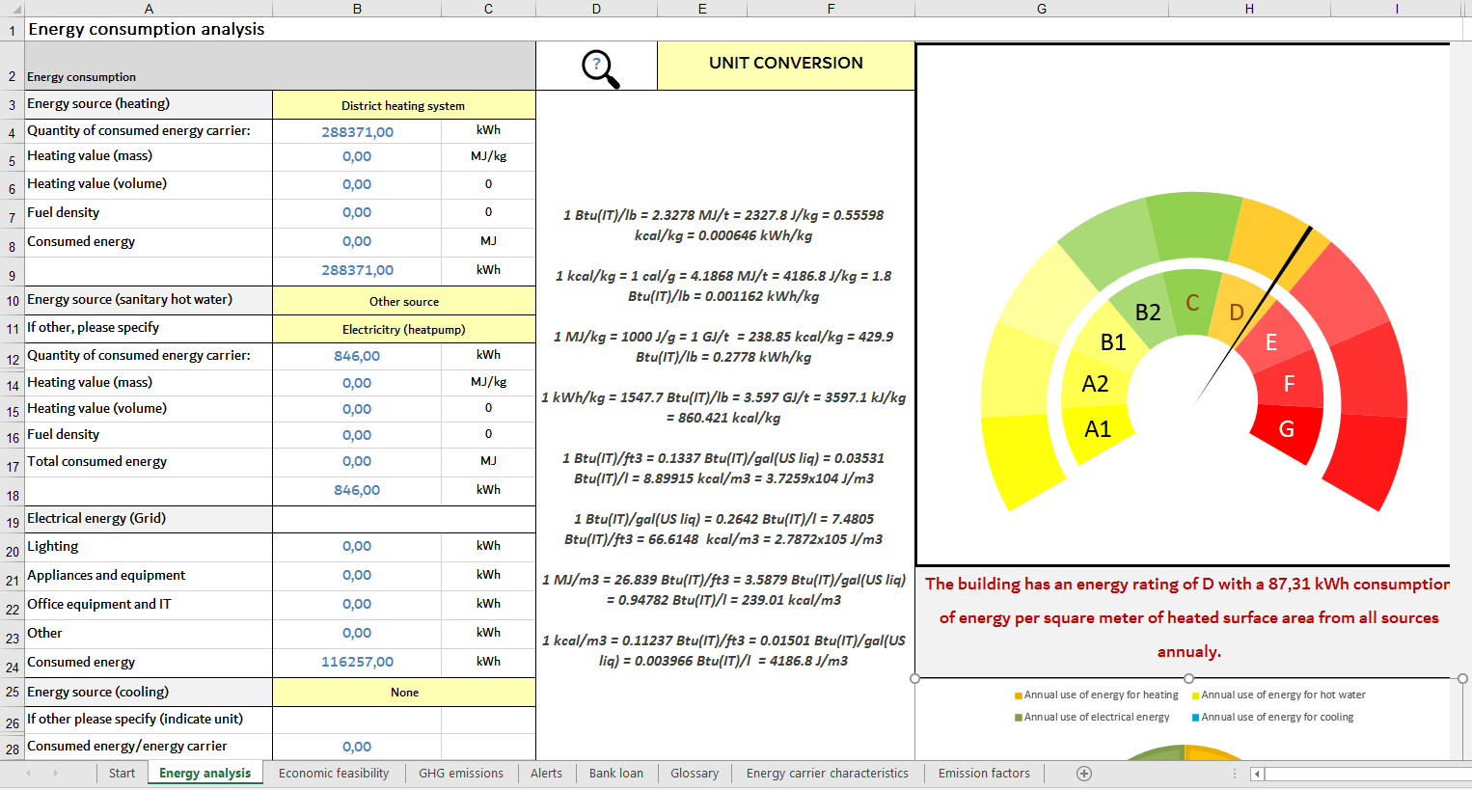

Figure: Energy analysis dashboard parameter input overview

|  |  |  |
| --- | --- | --- |
|  | The black arrows in the image indicate the location of the sheet (bottom-left) and the input fields for the energy consumption factors (top-right). The predefined drop-down lists are marked with red arrows in the image. | |
|  |  |

The lists open up if you click on the cell and if you click once again on the arrow on the right side of the cell the drop-down list will appear:

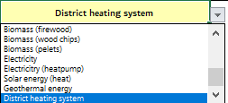

Figure: List of pre-defined energy carriers

Starting from the top-left, the first section collects data on the primary fuel for space heating. The description of School_B indicates that the building required **28.8371 kWh** of heat energy from district heating system in order to meet requirements for heating. Input the value into cell **B4**.

The correctly filled out table looks as follows:



Figure: Energy source for heating calculation

***Note:*** *The measurement units indicated to the side of the calculation values marked in yellow in the figure above are applied to the calculation automatically with the* ***VLOOKUP*** *function, that draws data based on pre-defined conditionalities from the sheet “Energy carrier characteristics”.*

Click on cells from B5 to B8 to observe the applied formula. The heating values for mass and volumes are also drawn from this sheet and expressed as MJ/kg and MJ/l respectively. Generally, the only mandatory inputs within this section is the quantity of consumed energy carrier and the energy source chosen from a predefined list in cell **B3** and **B4.** Based on whether the primary energy carrier is expressed in l, Nm3 or kg, the applied computation provides a result in cell **B9** (in kWh).

The next section is used to input data about the energy source and consumption of energy (electric, gaseous, liquid energy carriers or otherwise) and applies the exact same logic for computation. The main distinction between the former and later is the addition of a conditional field list, that queries whether the source used for the preparation of hot sanitary water is the same (“Same source”) or different (“Other source”) to the energy carrier/source providing energy for heating (previous example). If the first option is chosen, that we can still see the calculated values within the “*Energy sources (SHW)*” section, however the cumulative value indicated in cell B18 is not added to the “Summary” section (cell **B39). The value is however used for determining the share of energy consumption by purpose and by source. Furthermore, the value is subtracted from the total energy from light fuel oil in the section of “**Energy consumption by source**” in case that the same energy carrier is used to supply the central heating and hot water preparation.**



Figure: Energy source for sanitary hot water preparation



Figure: Energy source – Electricity from grid consumption by purpose

|  |  |
| --- | --- |
|  | DETERMINE ENERGY BASELINE |



Figure: Summary of energy baseline

|  |  |
| --- | --- |
|  | DEVELOP AN OVERVIEW OF ENERGY CONSUMPTION BY SOURCE |



Figure: Overview of energy consumption by source

|  |  |
| --- | --- |
|  | BENCHMARK ENERGY CONSUMPTION OF BUILDING |

Schools (elementary schools, grammar schools, vocational high-schools, etc.) generally have higher energy consumption than for e.g. offices and are typically found in the range between the top value of energy rating C all the way to F and even G energy rating buildings. The energy ratings applied within this tool are presented in table 6 below:

Table 6: Energy rating categories as applied by the training tool

|  |  |  |  |
| --- | --- | --- | --- |
| **No.** | **Rating** | **From [kWh/m2a]** | **To [kWh/m2a]** |
| **1** | **A1** | **0** | **10** |
| **2** | **A2** | **10** | **15** |
| **3** | **B1** | **15** | **25** |
| **4** | **B2** | **25** | **35** |
| **5** | **C** | **35** | **60** |
| **6** | **D** | **60** | **105** |
| **7** | **E** | **105** | **150** |
| **8** | **F** | **150** | **210** |
| **9** | **G** | **210** | **300+** |

The values illustrate the latest official classification of energy rating classes in Slovenia and may not apply to other partner countries. In order to change the energy rating classes please drag the object right of the gauge for energy rating as indicated in the figure below:

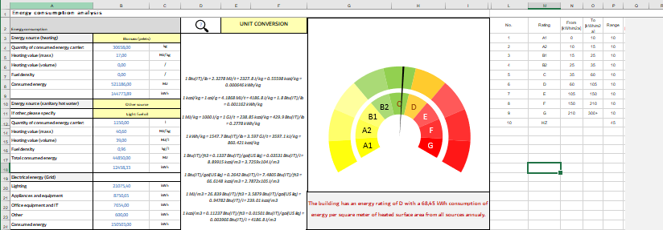

Figure: Access to energy rating classes

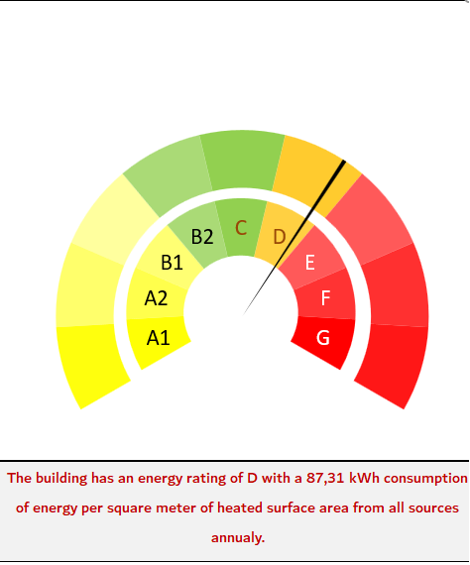

Figure: Energy rating gauge

The energy rating gauge indicates that School_B was classified as a building with an D class energy rating, reaching 87.31 kWh of provided energy for each m2 in the reference year.

|  |  |
| --- | --- |
|  | CHECK STATEMENT |

Check the validity of following statements. Are they valid/relevant to the energy analysis carried out for building School_B.

*Note: Each partner should prepare statements that are relevant to their building.*

* Heating (space heating plus sanitary hot water) accounted for 70% of total consumed energy while the rest was electrical energy. The total costs represent a 48% share of energy costs for heating, while electricity accounts for 36%. Water and utilities represent a 16% share of all financial assets for the operation of the building.
* School_B is highly energy efficient.
* …

|  |  |
| --- | --- |
|  | GHG ANALYSIS |

Using the following examples of computation carried out within the training tool, develop your own analytical tool for evaluating green house gas emission (or their CO2 equivalents) on the provided template within sheet “GHG emissions”. Data is drawn from the Covenant of Mayors periodical revision, whose tables are included in sheet “Emission factors”. Follow the example and work individually. Consult the hosting expert in the case of experiencing difficulties.

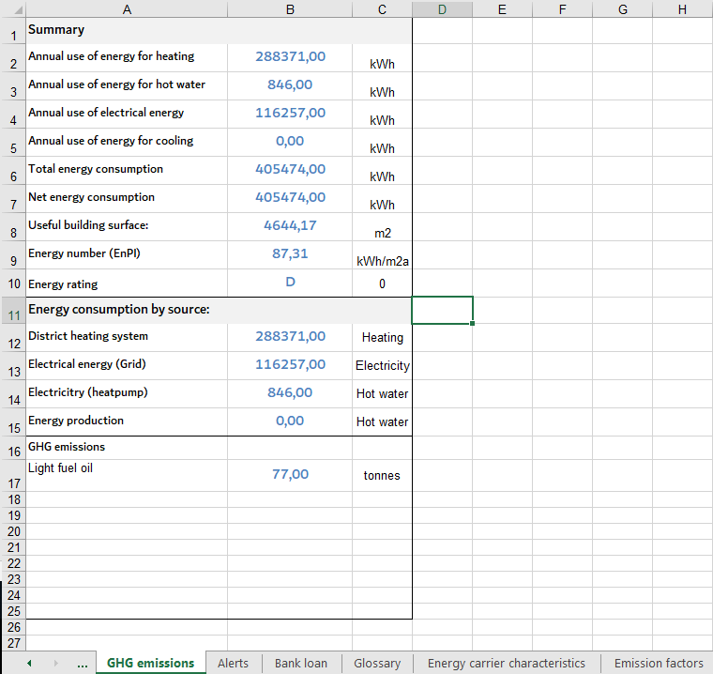

|  |  |
| --- | --- |
|  | DISCUSSION AND SUMMARY |

Reflect on the implemented assignments and present the content within an open discussion between working group participants. The moderator/energy expert of the training session may touch upon additional considerations that were not taken into account within the scope of this task and think about how and/or were within the existing training tool this could be implemented.

* Energy tariffs for electricity. What are they and how they should be taken into account within the tool?
* Could we reduce the energy bill by optimizing the operation times of certain appliances? How to indicate this within the training tool?
* Consider the wider benefits of energy renovation and suggest ways to attempt to express their energy/GHG emission mitigation potential (health improvements for building occupants due to better microclimate and indoor air quality, improved cognitive ability-improved learning and productivity, environmental protection-reduction of GHG emission and pollution, etc.)
* Q&A

|  |  |
| --- | --- |
|  | FEEDBACK FROM TRAINING PARTICIPANTS |

Share your experience on the experience with the training programme to the moderator host of the training session and the rest of the working group. The organizing partner may use the opportunity to present the project participants with a simple questionnaire (preferably in an online format, such as Google forms) in order to document their feedback and gather comments to be used in the follow-up to the implemented training sessions.



TRAINING UNIT 6

economics of energy savings

1. ECONOMICS OF ENERGY SAVINGS

Carrying out investment in energy efficiency, be it in technical measures, organizational measures or services aside from improving the work space environment (improving productivity, reducing health concerns) of its user substantially reduces operating and maintenance costs.

This translates to lower expenses and improved cash flow, making more funds available for other activities and/or investments. This can also help to create new employment opportunities.

The selection of energy efficiency measures should always be implemented on the basis of cost effectiveness, durability and reliability of achieving savings on a continuous basis.

The cost (capital expenditure - CAPEX) of energy efficiency measures or contracted services present the cost, while achieved energy savings present the return on that investment. Savings achieved by introducing measures to increase energy efficiency can be either in the form of direct energy savings, indirect energy savings, capital savings (for smaller systems) and maintenance savings.

**Direct energy savings**

Investing in energy efficiency measures means that less energy will be required to provide the same operational functionality compared to the existing technology. This includes measure of replacing inefficient systems with more efficient ones (a LED requires less electricity to provide the same amount of light as opposed to standard light bulbs or even CFL’s, a high efficiency condensation boiler uses less gas to provide the same amount of thermal energy), installing equipment that uses less expensive fuels (natural gas for heating sanitary hot water as opposed to electricity or heating oil), introducing systems that can reduce the required energy load of a building (for example, occupancy sensors reduce the amount of required electricity by optimizing the supply of light, introducing windows with high efficiency and/or shading elements reduce the heating – thermal losses and cooling load – solar gains of a building), optimizing the size and operation of a system in accordance to the provided service (downsizing piping systems, reducing light levels to those actually required), improving system operation (hydraulic balancing of heating systems, optimized regulation of pumps reduces the run time) and reducing peak electricity demand (thermal storage, instalment of capacitors improves the power factor, etc.)

**Indirect energy savings**

Introducing technologies or services can provide savings greater that those initially foreseen, because reducing energy consumption in one system can often lead to indirect energy savings in other systems due to interactive effects. For example, the cooling requirements of a building include the heat generated by electrical appliances, lighting systems and so on. By introducing energy efficiency measures (using efficient lighting, efficient appliances, efficient windows for reducing solar heat gains, optimizing the ventilation systems) in some areas will result in the reduced cooling or heating load of the building respectively.

**Capital Cost Savings**

It can be true, that buildings incorporating advance design can cost the same or less than conventional buildings. For example, by using more efficient lighting systems, curtain wall systems, taking advantage of natural light (and shade) reduce the size and cost of required systems. The higher initial CAPEX of advanced, more efficient systems can be offset by their smaller size and scope.

**Maintenance Savings**

Introducing energy efficiency measures means that building systems can operate with reduced run times, resulting in lower maintenance cost because of extend life span of used equipment. For example, switching from standard light bulbs with LED’s which have an estimated life span of 50000 hours means that within that time period, no expenditure will be required for works on the lighting systems.

FINANCIAL CONCEPTS FOR EVALUATING ENERGY EFFICIENCY MEASURES

The four most commonly used concepts to evaluate the economic feasibility of specific investment measures in energy efficiency are:

* Simple payback
* Return on Investment (ROI)
* Net Present Value (NPV)
* Internal Rate of Return (IRR).

These concepts increase the quality of investment decision by making long-term forecast based on known and estimated investment factors.

**Simple Payback**

Simple payback is the most commonly used indicator that measures the time it takes for the energy savings to payback the initial cost of the investment measure. We calculate the time period it takes to recover our initial investment by dividing the initial investment by the estimated energy saving. It disregards a wide variety of factors that influence the long-term sustainability of investment project

(life span of the equipment, does not allow comparison of the option with other investments, payback does not take account for the time value of credit), therefore it represents an estimation and is used only alongside other factors.

It is calculated by simply dividing the CAPEX of the investment by the estimated energy savings in a given period (usually on an annual basis):

$$Payback period= {Investment measure cost}/{Estimated energy savings [years]}$$

**Return on Investment (ROI)**

ROI also considers the effective life cycle of the investment measure. It is calculated by

dividing the total value of energy savings achieved within the life of the project exceeding the initial investment by the initial investment times 100 (because it is expressed in %):

$$ROI=({Value of energy savings -Estimated investment cost)}/{Estimated energy savings [\%]}$$

This equation provides a return on investment for the life cycle of the project. An annual return on investment can be calculated by dividing the total ROI by the number of years of the life of the investment measure. For example, the calculated ROI is 40 % (meaning that within the life of the investment measure, the total initial investment plus 40 % was recovered) for an investment with a life of 10 years, then the annual ROI would amount to 4 %.

ROI like the simple payback method, also does not take into account the time value of money and the benefits or pitfalls (for inflation) of compound interest and as such cannot be used to compare different investment measure. In addition, if the majority of cash flows occur towards the end of the investment life, rather than in a steady stream, ROI can overstate the attractiveness of a particular investment measure.

**Net Present Value (NPV)**

The best overall method for evaluating investment measure is the NPV. It measures the increase in value of the investment based on the organizations required rate of return. Unlike the simple payback and ROI, it considers the life span of the equipment (amortisation), risks associated to the investment and when the actual energy savings will be achieved. It is calculated by dividing after tax cash flows of each periods at time *t* discounted by some rate *r*. The sum of all these discounted cash flows is then offset by the initial investment, which equals the current NPV

$$NPV=\sum{\frac{CF (after tax) }{{(1+r)}^{t}}-{CF}_{0}(initial investment) }$$

or simplified:

$NPV=Initial invesment+Sum of present value of estimated energy savings \left(total life\right)$

If the sum of the present values of expected annual energy savings are greater than the initial energy investment, the NPV of the project will be positive and should be undertaken. The risk of the project is taken into account by selecting an appropriate discount rate for the investment.

The Internal Rate of Return (IRR)

IRR is similar to the NPV, the main difference being that instead of choosing a specific discount rate in accordance to the risk of the investment measure, the concept utilizes a repetitive approach to determine the discount rate that will cause the NPV of a particular project to equal zero (sort of a brake even point).

IRR is calculated by trial and error by varying the discount rate in the NPV formula until the NPV is equal to 0, using the following equation (expanded version of the basic equation for NPV):

$$NPV=-{CF}_{0}+\sum{\frac{CF (after tax) }{{(1+IRR)}^{t}} }$$

where again, CF0 represents the initial investment cost, CF is cash flow after tax and t is the time of each period when the investment is discounted.

IRR is used to evaluate the profitability and to make direct comparisons to alternative of energy efficiency investments. This method of analysis includes the time value of money, timing of cash flows and total project length (investment life).

TASK: Determine economic feasibility of refurbishment measures

Within this task the focus will be on acquiring practical experience for determining the economic feasibility of potential energy renovation measures to be applied in schools. The preliminary economic analysis will be carried out by a step-by-step approach on examples of theoretical buildings/situations that may be encountered.

Assignment list and training session overview:

|  |  |
| --- | --- |
| Introduction (Time estimate: 3x6 min) | |
|  | Determine the economic feasibility of the investment by applying the simple payback method |
|  | observe and discuss the proposed length of the estimated payback period |
|  | Determine the economic feasibility of the investment by applying the Net Present Value method. Assume that the discount rate is 4 % |
| **CEGE training programme tool** (Time estimate: 5x10 min) | |
|  | Determine economic feasibility by including subsidies (grants/non-refundable). Assume that the investor is eligible for a one-time subsidy from the national energy fund in the amount of 10.000,00 EUR. |
|  | Determine economic feasibility by taking into account loan financing. Assume that 70% of financing will be carried out through a lending institution, that will provide a fixed interest rate of 3% over the 20 years. |
|  | Determine economic feasibility by including an annual projected inflation rate of 1.7 %. |
|  | Determine IRR after estimated payback period |
|  | experiment with different input parameters |
| **discussion** (Time estimate: 15min, 10min) | |
|  | Q&A |
|  | FEEDBACK FROM TRAINING PARTICIPANTS |

|  |  |
| --- | --- |
|  | Determine the economic feasibility of the investment by applying the simple payback method |

The payback period is the most basic and common, financial gauge for energy renovation investment. It is defined as the time, in years, required for an investment’s cumulative cash flow (including the initial outlay) to reach zero. In the example of Building School_B, the total investment for proposed renovation measures ammounts to 88.257,00€. The combined energy savings may reduce annual costs for an estimated 9.936,00 €. Table below demonstrates the expected cash flow from the investment over 15 years. On a cumulative basis, cash flow is negative until reaching zero in the year 9, so this investment has a 9-year payback.

Table: Payback period calculation 1





|  |  |
| --- | --- |
|  | OBSERVE AND DISCUSS THE PROPOSED LENGTH OF THE ESTIMATED PAYBACK PERIOD |

In the previous example we demonstrated that the initial investment would be recovered in 9 years. In this task, re-evaluate the economic feasibility of the investment project by applying the simple payback method for the situation where the building owner/investor would decide to not include energy renovation measures on the lighting system into the investment.

As illustrated by the example above, simple payback period method indicates that the excluded investment into energy renovation of inefficient lighting systems provided great investment value relative to the overall expenditure. Simple payback (dividing individual investment with their counterpart values for reduced energy costs) shows that while the investment into the thermal envelope can be recovered in 11,6 years, the investment into efficient lighting systems is repaid in 9,3. The exclusion of the investment measure would clearly be a mistake. The overall payback period for the second example is 11 years.

|  |  |
| --- | --- |
|  | DETERMINE THE ECONOMIC FEASIBILITY OF THE INVESTMENT BY APPLYING THE NET PRESENT VALUE METHOD. ASSUME THAT THE DISCOUNT RATE IS 4 % |

Net present value (NPV) is a financial measure of investment value that explicitly accounts for the time value of money in terms of lost opportunity.

|  |  |
| --- | --- |
|  | Definition “*The time value of money is the concept that money available at the present time is worth more than the identical sum in the future due to its potential earning capacity. This core principle of finance holds that, provided money can earn interest, any amount of money is worth more the sooner it is received.”*  Source: Investopedia (<https://www.investopedia.com> ) |
|  |  |

Same as in the previous example of the simple payback method approach, NPV is also calculated from the stream of cash flows that are a direct result of the investment. However, NPV computes cash flows that are adjusted to factor in the time value of money, placing greater priority on short-term cash flows and less value on more distant ones in the future. As mentioned in the training manual the discount rate is an interest rate used to adjust a future cash flow to its present value, which normally corresponds to year 0 (year on which investment was carried out).

Same as in the previous example of the simple payback method approach, NPV is also calculated from the stream of cash flows that are a direct result of the investment. However, NPV computes cash flows that are adjusted to factor in the time value of money, placing greater priority on short-term cash flows and less value on more distant ones in the future. As mentioned in the training manual the discount rate is an interest rate used to adjust a future cash flow to its present value, which normally corresponds to year 0 (year on which investment was carried out).

For example we apply a ***4 %*** discount rate to the economic feasibility calculation. The ***present value (PV)*** of an ***individual cash flow (CF)*** that will be received one year from today, where r is the discount rate is expressed as follows:

$$PRESENT VALUE \left(PV\right)=CASH FLOW\left(CF\right)*\frac{1}{\left(1+r\right)}$$

We apply the discount rate to the expected cash flow in year 1:

$$PRESENT VALUE \left(PV\right)=9936,00 €*\frac{1}{\left(1+0.04\right)}$$

The present value of the projected energy savings that we will received at the end of year one is now only worth ***9.553,84 €.*** The monetary value of energy savings for each subsequent year is then further adjusted (discounted) with reference to the value in the previous year.

Generally, for any cash flow received in year **t** (where t represents the elapsed time in years), the present value is the product of the future cash flow and the present value factor as illustrated below, for year 3(t=3):

$$PRESENT VALUE \left(PV\right)=9936,00 €*\frac{1}{{\left(1+0.04\right)}^{3}}$$

The discount rate has a strong direct effect on the NPV. We observe the extent to which the adjustment of future cash flows with the defined discount rate negatively effects the economic feasibility study. Frequently, the cost of capital in terms of the rate of return that must be met in order to cover the interest on outstanding debt (loans and/or bonds) is the basis when considering the minimum value of the discount rate.

|  |  |
| --- | --- |
|  | DETERMINE ECONOMIC FEASIBILITY BY INCLUDING SUBSIDIES (GRANTS/NON-REFUNDABLE). ASSUME THAT THE INVESTOR IS ELIGIBLE FOR A ONE-TIME SUBSIDY FROM THE NATIONAL ENERGY FUND IN THE AMOUNT OF 10.000,00 EUR. |

IT tools focusing on spreadsheet software make analysis of projected future cash flows and the NPV much easier to compute. Built-in NPV functions in spreadsheet software can make the evaluation even easier, however for the purpose of the tutorial, the tool will be applying a standard approach to calculation, focusing on easy to understand functions with the purpose to support further uses and upgrades from the side of software users. Open the CEGE training programme tool and continue to sheet titled “***Economic feasibility****”.*

The “Energy cost” section provides basic information on total annual expenditure on energy expressed in EUR. As stated in the glossary area, the energy costs are by default calculated based on the energy consumption inputted on the list "Energy analysis" list taking a fixed tariff of 0,15 EUR for energy prices per kWh.



Figure: Energy costs section of the CEGE analysis training tool

In the example of the economic analysis of energy renovation on School_B, the description text states (see section “Theoretical analytic model School_B”) that heating (space heating plus sanitary hot water) accounted for **71 %** of total consumed energy and **51%** of the costs, while the costs for electrical energy represented **37 %** of the total.

The values of costs for different energy uses/sources (heat, electrical energy) are in this example computed from the total energy expenditure in cell B7, which amounted to **52.380,00 EUR** in the reference year. For e.g. Cost of energy for heating is calculated with the simple formula **=0,51*B7**, representative of 51 %from the total expenditure on energy.

Ideally, the energy costs should be derived from actual consumption of energy carries, or better yet, cross-referenced/compared between one another, depending on the availability of data on energy baselines. This would allow for establishing a more comprehensive model by linking energy, emission and economic flows and deriving valuable data for benchmarking and setting goals. According to the text, hot water is prepared from natural gas from the same supply source (the gas grid) so no additional costs are keyed into cell **B2**. The provided description doesn`t provide any information about separate costs for cooling therefore the value used is **0**.

In this example, the preliminary analysis doesn`t take into account the division between for e.g. electrical energy used to power the heating system in relation to the electricity required to supply appliances and the lighting system. The “*Preliminary economic analysis*” section presents information on the investment such as projected annual savings and the expected total cost of the investment in energy renovation measures, applied already in the previous tasks on the simple payback period and NPV calculations.



Figure: Energy costs section of the CEGE analysis training tool

Input the pre-defined annual energy savings value of **17.656 €** into cell **B9.** Cells **B11** and **B12** indicate the total cost of the investment with and without including potential subsidies (positive cash flow that reduces the total amount of the investment from the perspective of the building owner. Input the total cost of the investment as indicated in the description into cell **B11.** Input **20 years** for the projected payback period of the investment into cell **B13.** Taking into account that the total amount of required capital (213.495 EUR) including a 10.000 EUR one-time subsidy, is provided from building owners own sources not through loan instruments and the discount rate of 4 %, the analytic tool should provide the following results.



Figure: Energy costs section of the CEGE analysis training tool

The proposed renovation investment measures are economically viable, as the NPV after the estimated payback period of 15 years amounts to 22.270 EUR. The Internal Rate of Return (IRR) is higher than the assumed discount rate and amounts to 7,4 % at the end of the projected payback period. The investment is repaid in 11 years, so the expected payback period can be re-adjusted to 15 years in order to provide a better visual overview of charts and tables.

|  |  |
| --- | --- |
|  | DETERMINE ECONOMIC FEASIBILITY BY TAKING INTO ACCOUNT LOAN FINANCING. ASSUME THAT 70% OF FINANCING WILL BE CARRIED OUT THROUGH A LENDING INSTITUTION, THAT WILL PROVIDE A FIXED INTEREST RATE OF 3% OVER THE 20 YEARS. |

In practice, energy renovation is seldom carried out strictly by the investment of building owner`s own capital/equity, which is especially true for public organizations that are usually very limited in terms of flexibility and availability of cash flow. In addition, in many countries within Central Europe, rigid administrative procedures are prohibitive in terms of allowing beneficiaries (public organizations) substantial control over their funding and so it is unlikely that a school per se, could carry out energy renovation to any notable extent with own capital exclusively. Therefore, this exercise introduces credit financing into the analysis of economic feasibility. Taking into consideration the parameters administered in previous examples we consult the financing section (cell range A14:C21) within the tool:

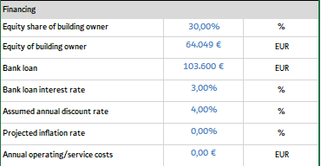

Figure: Financing section of the CEGE analysis training tool

Input the equity share of building owner in cell B15, which is the share of the buildings owner stake in the investment with own equity taking into account the total cost of the investment minus subsidies. The total equity/capital of the building owner in the energy renovation investment (monetary value) is automatically calculated in cell B16. The calculation of the bank loan value is carried out on a separate sheet titled “*Bank loan”* and cross referenced back to the main interface of the calculation tool. Input bank loan interest rate, which is the projected annual interest rate of the bank loan in in cell B18. It can be observe in the results section, that the investment is not economically feasible.



Figure: Financing section of the CEGE analysis training tool

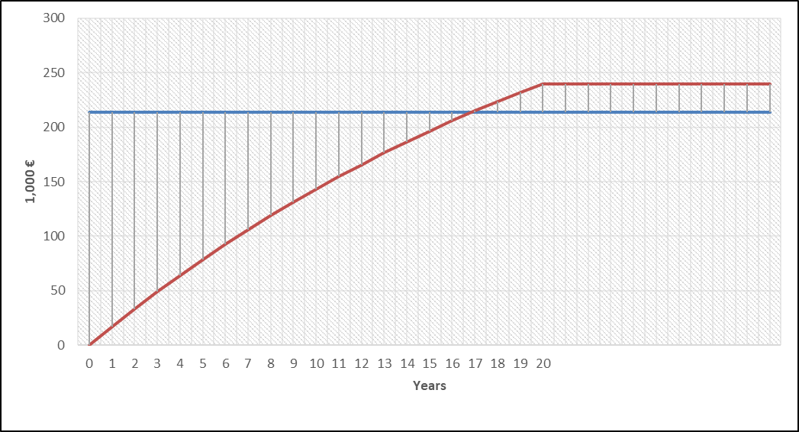

Figure: Visual representation of the investment payback within a period of 20 years

|  |  |
| --- | --- |
|  | DETERMINE ECONOMIC FEASIBILITY BY INCLUDING AN ANNUAL PROJECTED INFLATION RATE. ASSUME A FIXED ANNUAL INFLATION RATE OF 1.7 %. |

|  |
| --- |
| Definition “*Inflation is the rate at which the general level of prices for goods and services is rising and, consequently, the purchasing power of currency is falling. Central banks attempt to limit inflation (target inflation is just below 2%)— and avoid deflation — in order to keep the economy running smoothly.”*  Source: Investopedia (<https://www.investopedia.com> ) |
|  |

Price increases effect all positive and negative cash flows as the value of the monetary unit itself is debased. As explained in the glossary section of the analytic tool, for the purpose of the training exercise carried out within the project, the projected inflation rate is applied to the avoided costs for energy over the investment course to account for the foreseen future **rise of energy cost** (so it`s is considered positive in this particular example).

Taking into consideration the parameters administered in previous examples we consult the financing section (cell range A14:C21) within the tool:

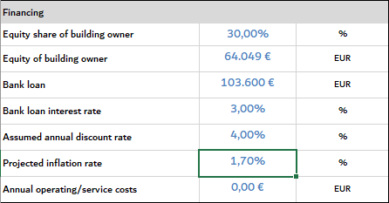

Figure: Financing section of the CEGE analysis training tool

Input the projected inflation rate to cell B20 of the financing section as demonstrated in the figure above. Following the logic of the impact of inflation on energy prices, the projected inflation rate is applied to the row titled “*Avoided energy costs per year (nominal)” prior to the adjustment to the discount rate (cell range E38:E59) with the following function for year 1:*

**=IF(A40<>"";ROUND(($B$9*(1+$B$20)^A40)/1000;2);"")**

For additional assistance with applied functions consult the CEGE training programme tool presentation and overview available in the annex of this document. Please see consult the figure on the following page.

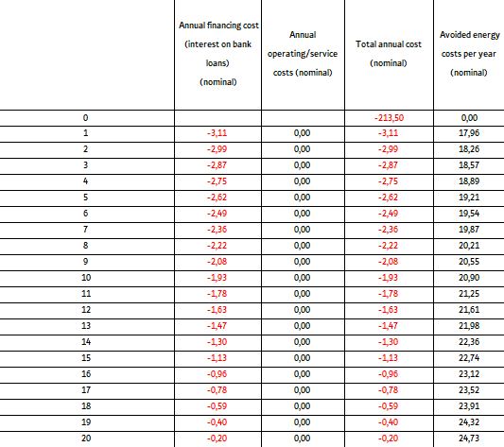

Figure: Financing section of the CEGE analysis training tool, applying the inflation rate

The applied inflation rate results in the increased priced for energy on a fixed basis, applied annually to the nominal positive cash flow as a result of reduced energy consumption, resulting in (in this example) increased energy savings/increased revenue, whereby in the year of the investment once the payback is concluded, the projected energy savings already amounted to 21,98 thousand EUR instead of the original vale of 17,66 thousand EUR.

|  |  |
| --- | --- |
|  | DETERMINE IRR AFTER ESTIMATED PAYBACK PERIOD |

The internal rate of return (IRR) is an alternative cash-flow analysis tool closely related to NPV. IRR is a percentage figure that describes the yield or return on an investment over a multiyear period. For a given series of cash flows, the IRR is the discount rate that results in an NPV of zero.

When used as the threshold for an acceptable IRR, the discount rate is often referred to as the **hurdle rate**. As with NPV, it may be appropriate to apply a hurdle rate greater than the cost of capital to prospective investments that are especially risky—or one below the cost of capital to investments of low risk. Energy-efficiency projects that rely on proven technologies are often in the latter category. As with the selection of a discount rate, it is important to consult with financial experts within the organization in order to determine an appropriate hurdle rate.

The IRR is calculated from the sum of nominal net cash flows on an annual basis in cells 039 to O59 with the following formula within the analysis tool:

**=IRR($F$39:F39;0,1)**

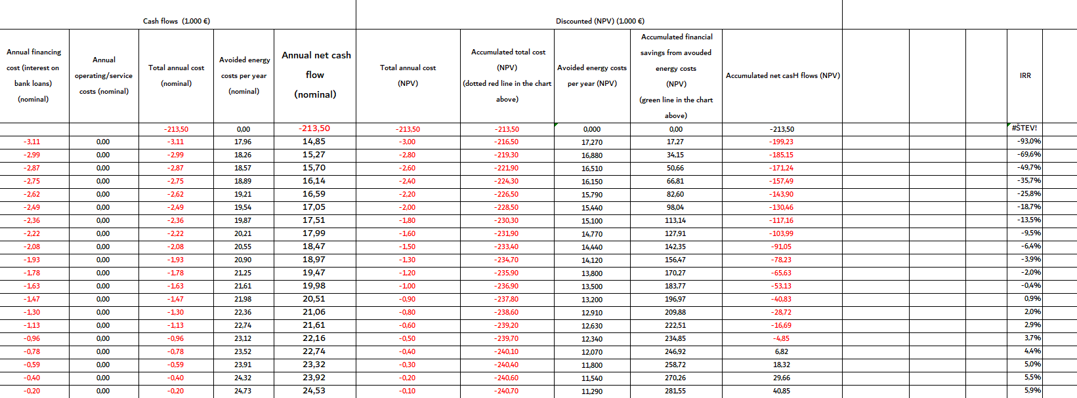

Figure: Example of IRR computation in the analytic tool. Calculation of IRR for each year(above)

Figure: Example of calculation of IRR for year 5 (below).

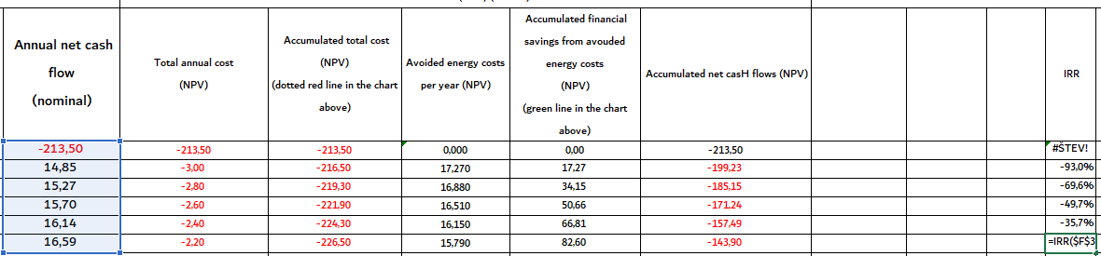



Taking into consideration the parameters administered in previous examples we consult the result section (cell range A22:C28) of the tool:



Figure: Result section of the CEGE analysis training tool

We observe that the NPV is 21.400,74 EUR and IRR amounts to 7,41 % after the foreseen investment payback period is concluded. In the dynamic result prompt of the tool (cell range A29:F36) illustrated below, we conclude that the IRR exceeds 0 % in year 9 since investment implementation.



Figure: Dynamic result prompt in CEGE analysis training tool

|  |  |
| --- | --- |
|  | EXPERIMENT WITH DIFFERENT INPUT PARAMETERS |

Input different parameters into the relevant cells as described in previous tasks and discuss the results with the host of the training session. Explore the dashboard and consult the glossary for additional information. Make up additional energy renovation theoretical models or consult existing data from energy audits in the public domain.

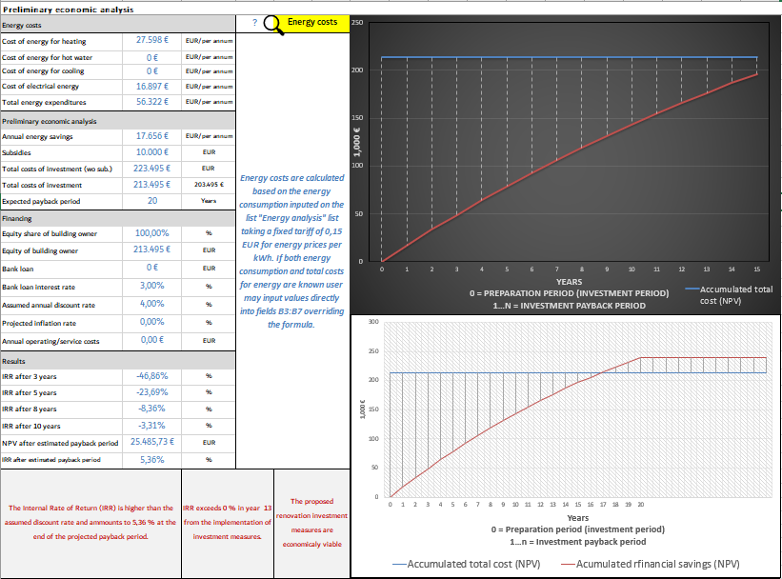

Figure: Dynamic result prompt in CEGE analysis training tool

The training tool is structured to facilitate hands-on experience and provide a valuable learning experience to the participant of the training program. Feel encouraged to freely navigate, revise, upgrade, improve or otherwise complement the tool. Suggest and share ideas to other training participants in the working group.

|  |  |
| --- | --- |
|  | DISCUSSION AND SUMMARY |

Reflect on the implemented assignments and presented content within an open discussion between working group participants. The moderator/energy expert of the training session may touch upon additional considerations that were not taken into account within the scope of this task and think about how and/or were within the existing training tool this could be implemented.

* Could we reduce the energy bill by optimizing the operation times of certain appliances? How to indicate this within the training tool?
* What is an ESCO and what is ESCO financing? How/where to include within the tool
* What are green bonds?
* Consider the wider benefits of energy renovation and suggest ways to attempt to express their monetary value (health improvements for building occupants due to better microclimate and indoor air quality, improved cognitive ability-improved learning and productivity, environmental protection-reduction of GHG emission and pollution, etc.)
* Q&A

|  |  |
| --- | --- |
|  | FEEDBACK FROM TRAINING PARTICIPANTS |

Share your experience on the experience with the training program to the moderator host of the training session and the rest of the working group. The organizing partner may use the opportunity to present the project participants with a simple questionnaire (preferably in an online format, such as Google forms) in order to document their feedback and gather comments to be used in the follow-up to the implemented training sessions.

TASK: Define the scope and establish an EMIS

The activities associated to task ˝Define the scope and establish an EMIS˝ were carried out during the technical workshops where the energy monitoring systems were presented. Project partners have chosen to pursuit pilot investment into monitoring equipment that is relevant to their specific case therefore the comparability between different approaches would not allow for a comprehensive generalization of the topic of establishing an Energy Monitoring System within the scope of this training manual. Instead, this task was implemented in live interaction on the national/local level. For additional information about pilot investment and the outcomes of the technical workshops please consult your national contact point.

**Annex: CEGE training programme tool presentation and overview**

**Additional sources and literature:**

<https://esosregister.com/wp-content/uploads/2016/01/DECC_Guide_to_Implementing_Energy_Savings_Opportunities1.pdf>

<https://ec.europa.eu/energy/sites/ener/files/documents/20130619-energy_performance_certificates_in_buildings.pdf>

<https://www.eurima.org/uploads/ModuleXtender/Publications/51/Economics_of_Deep_Renovation_Ecofys_IX_Study_Design_FINAL_01_02_2011_Web_VERSION.pdf>

1. http://mpinter.ifs.hr/student/data/gf-knjiga.pdf