TRAINING PROGRAME DEVELOPED AND DELIVERED FOR CAPACITY RAISING OF SENIOR ENERGY GUARDIANS TOWARDS ENERGY EFFICIENT MEASURES:

Vocational energy guardian training programme

Edited by PP4 KSSENA with support by PP2 CertiMaC



|  |  |
| --- | --- |
| Output O.T3.1.  28.06.2019 |  |

Edited by PP4 KSSENA with support by PP2 CertiMaC

1. Preamble

The main objective of the ENERGY@SCHOOL project is to increase the capacity of the public sector, focused on local authorities, to implement “Energy Smart Schools”, promoting the implementation of advanced technologies for energy efficiency in existing schools. The approach is based on fostering behavioural change, building awareness and a general culture of energy conservation by means of creating and implementing training programs for various relevant stakeholders active within the educational process (educationists, building managers, maintenance workers and pupils). The educational activities (on energy saving technologies, economics of reducing energy consumption, environmental benefits, etc.) will be supported by the use of smart building ICT, allowing for the participants to discover how to monitor and target energy efficiency in practice (control the indoor climate with optimal temperature control, improve air quality and thermal comfort – microclimate parameters, optimal luminescence, etc.)

This report will attempt to present the structure and contents of the proposed training program, primarily adapted to Senior Energy Guardians.

Basic outline of the training programme

The training programme is developed with the intent of facilitating the reduction of energy costs in schools to allow reinvestment in more energy efficiency measures or simply leaving schools and local authorities with more funds to carry out their primary activity – education. The basis of the training programme will be presented within the Energy Guardians Smart School Management Plan (EGSMP) and will rely on results of work packages T1 Analysis phase and definition of Energy Guardians Smart-school Management Plans and T2 Definition of Smart School Strategies and pilot applications.

This will include an upgraded Decision-support Toolbox for Energy Guardians, energy audits on a sample of representative selected schools, a developed system for targeted monitoring of energy consumption carried out within 8 pilot actions and software applications (both desktop and mobile) as part of the developed energy monitoring systems.

The focus of the trainings will foster a marketable and relevant skill set from the pre-investment phases of energy renovation activities, to advanced monitoring solutions and behavioural impact on building users. The main target groups of the training activities for senior EGs will include local authorities (municipal representatives), personnel in charge of operation and maintenance in schools in addition to educated (postgraduate students, research students) persons from the local environment with no gainful employment.

1. The European Qualifications Framework for lifelong learning (EQF) – where did the EQF come from?

The EQF is a common European reference framework which links countries’ qualifications systems together, acting as a translation device to make qualifications more readable and understandable across different countries and systems in Europe. It has two principal aims: to promote citizens’ mobility between countries and to facilitate their lifelong learning.

The Recommendation formally entered into force in April 2008. It sets 2010 as the recommended target date for countries to relate their national qualifications systems to the EQF, and 2012 for countries to ensure that individual qualification certificates bear a reference to the appropriate EQF level. The EQF will relate different countries’ national qualifications systems and frameworks together around a common European reference – its eight reference levels. The levels span the full scale of qualifications, from basic (Level 1, for example school leaving certificates) to advanced (Level 8, for example Doctorates) levels.

As an instrument for the promotion of lifelong learning, the EQF encompasses all levels of qualifications acquired in general, vocational as well as academic education and training. Additionally, the framework addresses qualifications acquired in initial and continuing education and training.

The **eight reference levels are described in terms of learning outcomes**. The EQF recognises that Europe’s education and training systems are so diverse that a shift to learning outcomes is necessary to make comparison and cooperation between countries and institutions possible**. In the EQF a Learning Outcome is defined as a statement of what a learner knows, understands and is able to do on completion of a learning process. The EQF therefore emphasises the results of learning rather than focusing on inputs such as length of study. Learning outcomes are specified in three categories – as KNOWLEDGE, SKILLS and COMPETENCE.** This signals that qualifications – in different combinations – capture a broad scope of learning outcomes, including theoretical knowledge, practical and technical skills, and social competences where the ability to work with others will be crucial.

The development of the European Qualifications Framework started in 2004 in response to requests from the Member States, the social partners and other stakeholders for a common reference to increase the transparency of qualifications. The Commission, with the support of an EQF Expert Group, produced a blueprint proposing an 8-level framework based on learning outcomes aiming to facilitate the transparency and portability of qualifications and to support lifelong learning.

1. Descriptors defining levels in the European Qualifications Framework (EQF)

Each of the 8 levels is defined by a set of descriptors indicating the LEARNING OUTCOMES relevant to qualifications at that level in any system of qualifications.

|  |  |
| --- | --- |
|  | ***Knowledge*** |
|  | *In the context of EQF, knowledge is described as theoretical and/or factual* |
| **Level 1**  The learning outcomes relevant to Level 1 are | Basic general knowledge |
| **Level 2**  The learning outcomes relevant to Level 2 are | Basic factual knowledge of a field of work or study |
| **Level 3**  The learning outcomes relevant to Level 3 are | Knowledge of facts, principles, processes and general concepts, in a field of work or study |
| **Level 4**  **The learning outcomes relevant to Level 4 are** | **Factual and theoretical knowledge in broad contexts within a field of work or study** |
| **Level 5**  The learning outcomes relevant to Level 5 are | Comprehensive, specialised, factual and theoretical knowledge within a field of work or study and an awareness of the boundaries of that knowledge |
| **Level 6**  The learning outcomes relevant to Level 6 are | Advanced knowledge of a field of work or study, involving a critical understanding of theories and principles |
| **Level 7**  The learning outcomes relevant to Level 7 are | Highly specialised knowledge, some of which is at the forefront of knowledge in a field of work or study, as the basis for original thinking and/or research  Critical awareness of knowledge issues in a field and at the interface between different fields |
| **Level 8**  The learning outcomes relevant to Level 8 are | Knowledge at the most advanced frontier of a field of work or study and at the interface between fields |

|  |  |
| --- | --- |
| ***Skills*** | ***Responsibility and autonomy*** |
| *In the context of EQF, skills are described as cognitive (involving the use of logical, intuitive and creative thinking) and practical (involving manual dexterity and the use of methods, materials, tools and instruments).* | *In the context of the EQF responsibility and autonomy is described as the ability of the learner to apply knowledge and skills autonomously and with responsibility.* |
| Basic skills required to carry out simple tasks | Work or study under direct supervision in a structured context |
| Basic cognitive and practical skills required to use relevant information in order to carry out tasks and to solve routine problems using simple rules and tools | Work or study under supervision with some autonomy |
| A range of cognitive and practical skills required to accomplish tasks and solve problems by selecting and applying basic methods, tools, materials and information | Take responsibility for completion of tasks in work or study; adapt own behaviour to circumstances in solving problems |
| **A range of cognitive and practical skills required to generate solutions to specific problems in a field of work or study** | **Exercise self-management within the guidelines of work or study contexts that are usually predictable, but are subject to change; supervise the routine work of others, taking some responsibility for the evaluation and improvement of work or study activities** |
| A comprehensive range of cognitive and practical skills required to develop creative solutions to abstract problems | Exercise management and supervision in contexts of work or study activities where there is unpredictable change; review and develop performance of self and others |
| Advanced skills, demonstrating mastery and innovation, required to solve complex and unpredictable problems in a specialised field of work or study | Manage complex technical or professional activities or projects, taking responsibility for decision-making in unpredictable work or study contexts; take responsibility for managing professional development of individuals and groups |
| Specialised problem-solving skills required in research and/or innovation in order to develop new knowledge and procedures and to integrate knowledge from different fields | Manage and transform work or study contexts that are complex, unpredictable and require new strategic approaches; take responsibility for contributing to professional knowledge and practice and/or for reviewing the strategic performance of teams |
| The most advanced and specialised skills and techniques, including synthesis and evaluation, required to solve critical problems in research and/or innovation and to extend and redefine existing knowledge or professional practice | Demonstrate substantial authority, innovation, autonomy, scholarly and professional integrity and sustained commitment to the development of new ideas or processes at the forefront of work or study contexts including research |

1. Definitions

* **QUALIFICATION** means a formal outcome of an assessment and validation process which is obtained when a competent body determines that an individual has achieved learning outcomes to given standards;
* **NATIONAL QUALIFICATIONS FRAMEWORK** means an instrument for the classification of qualifications according to a set of criteria for specified levels of learning achieved, which aims to integrate and coordinate national qualifications subsystems and improve the transparency, access, progression and quality of qualifications in relation to the labour market and civil society;
* **SECTOR** means a grouping of professional activities on the basis of their main economic function, product, service or technology;
* **LEARNING OUTCOMES** means statements of what a learner knows, understands and is able to do on completion of a learning process, which are defined in terms of knowledge, skills and competence;
* **KNOWLEDGE** means the outcome of the assimilation of information through learning. Knowledge is the body of facts, principles, theories and practices that is related to a field of work or study. In the context of the European Qualifications Framework, knowledge is described as theoretical and/or factual;
* **SKILLS** mean the ability to apply knowledge and use know-how to complete tasks and solve problems. In the context of the European Qualifications Framework, skills are described as cognitive (involving the use of logical, intuitive and creative thinking) or practical (involving manual dexterity and the use of methods, materials, tools and instruments);
* **COMPETENCE** means the proven ability to use knowledge, skills and personal, social and/or methodological abilities, in work or study situations and in professional and personal development. In the context of the European Qualifications Framework, competence is described in terms of responsibility and autonomy.

1. Common Principles for Quality Assurance of Vocational Education and Trainings in the context of the European Qualifications Framework

When implementing the European Qualifications Framework, quality assurance – which is necessary to ensure accountability and the improvement of higher education and vocational education and training – should be carried out in accordance with the following principles:

– Quality assurance policies and procedures should underpin all levels of the European Qualifications Framework.

– Quality assurance should be an integral part of the internal management of education and training institutions.

– Quality assurance should include regular evaluation of institutions, their programmes or their quality assurance systems by external monitoring bodies or agencies.

– External monitoring bodies or agencies carrying out quality assurance should be subject to regular review.

– Quality assurance should include context, input, process and output dimensions, while giving emphasis to outputs and learning outcomes.

– Quality assurance systems should include the following elements:

* clear and measurable objectives and standards;
* guidelines for implementation, including stakeholder involvement;
* appropriate resources;
* consistent evaluation methods, associating self-assessment and external review;
* feedback mechanisms and procedures for improvement;
* widely accessible evaluation results.

– Quality assurance initiatives at international, national and regional level should be coordinated in order to ensure overview, coherence, synergy and system-wide analysis.

– Quality assurance should be a cooperative process across education and training levels and systems, involving all relevant stakeholders, within Member States and across the Community.

– Quality assurance orientations at Community level may provide reference points for evaluations and peer learning.

1. Vocational energy guardian training Programme

The Vocational energy guardian training programme is intended for relevant stakeholders active within the educational process (teachers, building maintenance, municipality employees and pupils) and all that are interested in building awareness in the field of energy efficiency and implementing energy monitoring system in their building.

In the project we have developed 2 levels of training programme first is Vocational and second is Continuous training programme and as the name suggested, the second one is intended for all that have participated in first training and would like to increase the knowledge gained in the first part of the training.

Each task is represented by the following symbol 

The activities include hints and suggestions which are found under the following symbol: 

For task requiring the access to computer the following symbol will apply:

The Vocational energy guardian training programme is set up from 3 Training units with 7 developed tasks. The programme is designed in the way that the theory is mainly processed in the classrooms with couple of hours on E-learning courses and self-study, supported with various tasks. Depending of the content and its difficulty there are recommended hours, with the intend to work closely with the expert to acquire knowledge and learn how to transfer it on actual problems.

|  |  |  |  |  |
| --- | --- | --- | --- | --- |
| **VOCATIONAL ENERGY GUARDIAN TRAININGS PROGRAME** | | | | |
| **Training Unit** | **Title of the TU** | **Duration in Hours** | **Learning Objectives**  **(based on EQF descriptors)** | **Didactic Methodologies**  **(and duration for each)** |
| **1** | **ENERGY EFFICIENCY BASICS** | **32** | Theoretical knowledge | Classroom - 20 h  E-learning – 4 h  Self-study – 8 h |
| **2** | **RATIONAL USE OF ENERGY and ENERGY CONSUMPTION IN SCHOOL** | **50** | Theoretical knowledge  Cognitive and practical skills  Ability of taking some responsibility for the evaluation and improvement | Classroom - 10 h  E-learning – 2 h  Training on the job – 16 h  Self-study – 5 h  Case Studies – 17 h |
| **3** | **ENERGY AUDITS - BASICS** | **68** | Theoretical knowledge  Cognitive and practical skills  Ability of taking some responsibility for the evaluation and improvement | Classroom - 25 h  E-learning – 5 h  Training on the job – 15 h  Self-study – 8 h  Case Studies – 15 h |
| **TOTAL COURSE DURATION** | | **150** |

* 1. Vocational energy guardian training programme in line with European qualification framework

During the project, partners have tested the trainings with different content and durations based on their target group which were Senior energy guardians from school staff and teachers. The aim of the Common versions of the Trainings is therefore to set the basis for a structured training that can be customized and transferred outside the project boundaries and participants, a training that can be of full reference for any other school and Municipality that is willing to implement the role of Energy Guardians in their environment.

For these reasons, it has been decided to implement the tests/experimentations done and it has been defined that the **EQF Level to be aimed by tailored training is achieved LEVEL 4.**

All the training contents developed during the project have therefore been fine-tuned and organised in a training formally structured according to the EQF rules. Following the training, any European school and Municipality will ensure to train very-skilled Senior Energy Guardians.

The learning outcomes relevant to Level 4 are:

**Knowledge -** *In the context of EQF, knowledge is described as theoretical and/or factual*

Factual and theoretical knowledge in broad contexts within a field of work or study.

**Skills -** *In the context of EQF, skills are described as cognitive (involving the use of logical, intuitive and creative thinking) and practical (involving manual dexterity and the use of methods, materials, tools and instruments).*

A range of cognitive and practical skills required to generate solutions to specific problems in a field of work or study.

**Competence -** *In the context of EQF, competence is described in terms of responsibility and autonomy.*

**E**xercise self-management within the guidelines of work or study contexts that are usually predictable, but are subject to change, supervise the routine work of others, taking some responsibility for the evaluation and improvement of work or study activities

* 1. Energy management system in five main sections

In prepared content we have covered energy management system in the 5 main sections. Each specific area is addressed with a developed thematical task, that is found within each training unit. You can do them yourself or with the help of the energy expert.

|  |
| --- |
| SETTING UP ENERGY MANAGEMENT STRUCTURES |

1. Setting out an energy manager or energy management team

|  |
| --- |
| DATA ACQUISITION AND EVALUATION |

1. Collecting data of energy consumption

* **Correct reading of building energy invoices** 
* Analysis of energy consumption (heat, power and water)
* Processing energy data

1. Performing energy audit

* Preliminary energy audit
* **Detailed list of energy consumptions per user** 
* **Detailed review of the building and its operating system** 
* **Perform a thermographic inspection** 
* **Perform a microclimate inspection** 
* **Calculation of energy consumptions and costs** 
* Detailed energy audit
* Preliminary energy audit
* Develop an energy use computer model with building physics

|  |
| --- |
| PLANNING AND PRIORITIZATION |

1. Preparation of an action plan

* Establish an EMP
* Action plan for energy efficiency measures
* Action plan of exploitation of renewable energy sources
* Financial and economic analysis
* Technical documents

|  |
| --- |
| IMPLEMENTATITON OF PROJECT AND ACTIONS |

1. Implementation of energy measures

* **Implementation of organizational and low-cost measures** 
* Implementation of investment measures

|  |
| --- |
| MONITORING AND REPORTING |

* Energy bookkeeping
* Preparation of monthly or annual report
* Establishing EMIS
* Working with software application
* Monitor and analyse data from smart meters

1. Prepared training units in Vocational training programe

|  |  |
| --- | --- |
| **TRAINING UNIT n.1 – ENERGY EFFICIENCY BASICS** | |
| Duration: 32 hours | |
| LEARNING OUTCOMES:  • To acquire a basic knowledge to better understand the energy monitoring framework  • Extended prior knowledge and the foundation for further understanding | |
| CONTENTS | |
| * Forms of energy; primary, secondary, final and useful * Basics of energy efficiency; explanation of professional terminology * Renewable energy resources * Explanation of rational use of energy | |
| KNOWLEDGE | COMPETENCES |
| * Basics knowledge to better understand energy efficiency and its terminology * Renewable energy sources and the rational use of energy | * Self-management within the guidelines of energy efficiency field * Ability to recognize the possibilities of placement RES and RUE measures on the building |

|  |  |
| --- | --- |
| **TRAINING UNIT n.2 – RATIONAL USE OF ENERGY and ENERGY CONSUMPTION IN SCHOOL** | |
| Duration: 50 hours | |
| LEARNING OUTCOMES:  Acquiring a range of diverse cognitive and practical skills needed to generate solutions to specific problems.  • self-management with acquired knowledge in the field of energy monitoring  • dissemination of acquired knowledge to raise awareness amongst colleagues  • supporting and guiding others in the field of energy management | |
| CONTENTS | |
| * Energy consumption in school * Guidelines for efficient behaviour   + HVAC system – heating   + HVAC system – ventilation   + HVAC system – air conditioning   + Lighting and motion sensors   + Power consumption of appliances and electronics   + Rational use of sanitary hot water   + Effect of solar heat gains and how to minimize them * TASK: CORRECT READING OF BUILDINGS ENERGY INVOICES * TASK: DETAILED LIST OF ENERGY CONSUMPTION * TASK: EASY TO APPLY ENERGY SAVING MEASURES | |
| KNOWLEDGE | COMPETENCES |
| * Monitoring energy consumption in building * Low cost energy efficient measures to lower energy consumption | * Independent in preparation of energy consumption lists and recognizing possibilities to implement EE measures * Independent monitoring of energy consumption * Independent in implementing low cost energy saving measures in the building |

|  |  |
| --- | --- |
| **TRAINING UNIT n.3 – ENERGY AUDITS - BASICS** | |
| Duration: 68 hours | |
| LEARNING OUTCOMES:  Acquiring a range of diverse cognitive and practical skills needed to generate solutions to specific problems  • self-management and identification of potential problems that could arise in the energy management of the building  • recognition of potential improvements in the energy management system of the building  • support and guiding others in raising awareness and improving energy efficiency in their building | |
| CONTENTS | |
| * Energy audit * Thermographic inspection * Microclimate parameters and indoor air quality * Energy performance certificate - EPC * TASK: DETAILED REVIEW OF THE BUILDING AND ITS OPERATING SYSTEM * TASK: CALCULATION OF ENERGY CONSUMPTION AND COSTS * TASK: PERFORM A THERMOGRAPHIC INSPECTION * TASK: PERFORM MICROCLIMATE INSPECTION | |
| KNOWLEDGE | COMPETENCES |
| * General knowledge about Energy audits * Thermographic inspection * Microclimate inspection * Types of energy measures * Energy performance certificate - EPC | * Independent in preparation of detailed list of the building and its operating system * With the help of expert performing thermographic and microclimate inspection * Independent in making simple calculation of energy performance indicators |

1. Skills assessment

The prepared basic training programme was developed in the way to meet the criteria of EQF. That means that it is set up from theoretical part that encourage participants to use logical, intuitive and creative thinking and also from practical part to learn how to use manuals, tools and methods on the actual problems.

Each partner has the opportunity to adapt the basic training to their needs and prepare the training programme most suitable for their target groups. After the implemented training in all school we have asked representors of SEG to assess the knowledge, skills and competences that they have gained throughout the training programme within Energy@school project.

|  |
| --- |
| ITALY – PP1 |
| Working on the Energy@school project gave me the opportunity to discover the existence of a real community that works constantly to develop initiatives for energy, environmental and climate sustainability. The topic is carried out by the institutions, which however, as happened in energy @ school, make the local authorities working together. In this way the foundations are laid for the future where children will become aware men. The Energy@school project was the tool and not the goal for greater awareness of energy, environmental and climate sustainability. |
| POLAND – PP3 |
| SEG's developed their knowledge about energy saving and energy efficiency. They extended their knowledge in the field of energy production from municipal waste incinerators and biogas plants.  They gained new skills:   * the ability to convince others to a pro-ecological attitude * the ability to make logical and interesting arguments about energy saving * the ability to save thermal energy through appropriate ventilation of classroom * the ability to better inter-school communication within the project * increased awareness of the impact of human activities on the environment |
| CROATIA – PP5 |
| Mahično, Gorana Simić Vinski - I have gained a lot of knowledge about heating system in my school and about energy saving in general. I was very motivated to work on this project especially when LED lights and thermostatic valves were installed. The installation of energy monitoring system helped me to see exactly where the energy is lost and how it can be saved.  Rečica, Blaženka Mravunac - We have also learned a lot about planned and continuous work on energy savings. How to Calculate the Cost-Effectiveness of Energy-Saving Investment How to make more people think about energy savings. Small steps and joint action can save your money. Consumption applications have greatly helped to detect high energy consumption and if measures can be taken and large consumption can be removed. We have seen examples of good energy savings in other schools, cities in Croatia and Europe that we could follow.  Švarča, Snježana Protulipac – It was my first EU project and I learned a lot about Interreg and support of European Union to environment protection. |
| HUNGARY – PP7 |
| They have gained a broader knowledge of building physics and how to conduct energy audits. They learned how to track the components of the power management process, how to create an energy management program using EMIS. They got to know energy meters and smart meters and their use. They have general knowledge of the economic concepts of project investment, energy saving and financial analysis (ROI, NPV, IRR). In the practical examples, an energy analysis was carried out with the CEGE training tool (Excel) provided to the participating schools. The JEG team's enthusiasm motivated them to perform daily tasks in the simulation game. |
| HUNGARY – PP8 |
| Most of the new knowledge and skills has been gained due to the importance of the energetic characteristics of buildings, energy upgrades, their types and possibilities. |
| GERMANY – PP9 |
| I already had good skills and competences in climate protection before the Energy@school project trainings, but was able to benefit, for example, from the communication of the school's energy data recording.  Skills and competences gained: Carry out measurements carefully, Evaluate and visualize measured values, Reflection of measured values and personal work, Presenting and arguing professionally environmental awareness and Planning of projects at the school.  Recognition that a continuous improvement process must be implemented at the school. |
| SLOVENIA – PP12 |
| SEG´s have learn about measures to reduce energy use, which include both measures on technologies and systems, as well as changing everyday inefficient habits and practices. Measures to improve energy efficiency have also been an excellent opportunity for practical learning and transfer of knowledge to others. In addition, they have realized the measurement of the use of electricity on the basis of automatic measurements (reading using the smart metering system). |



TRAINING UNIT 1

ENERGY EFFICIENCY BASICS

1. GENERAL ABOUT ENERGY
   1. ENERGY

Energy is defined as the ability of an object to do work. It exists in many forms (heat, light, motion, electrical, chemical, nuclear, gravitational) and cannot be created nor destroyed, merely converted from one form to another, each time with a loss. Although this energy does not disappear, some amount of the initial energy turns into forms that are not viable for further use.

Energy can be measured with specialized devices and instruments. The quantity measuring unit is Joule but we also use its derivatives kJ, MJ, PJ. In everyday life is more commonly used unit Ws - watt second, 1J is equal to 1Ws and its derivatives Wh, kWh, MWh.

Energy can be divided into various ways - by source, by effects, by carrier, etc.

In daily life, we share energy according to the source:

* solar energy,
* electricity,
* wind energy,
* energy of water,
* geothermal energy,
* spring energy,
* light energy,
* heat energy,
* chemical energy and
* nuclear energy.
  1. FORMS OF ENERGY

To distinguish between various levels of energy losses, we use the following terms:

* primary,
* secondary,
* final and
* useful energy.

Primary energy refers to all-natural resources used for energy production, such as fossil fuels (natural gas, coal, oil shale, catran sand), nuclear fuels (uranium, thorium) and renewable energy sources (sun, wind, water, biomass, geothermal energy). Apart from the energy of the tide and nuclear energy, all sources of energy on Earth are of solar origin, because they represent stored solar energy. Secondary energy is the result of the primary energy conversion process and includes coal products (coke, briquettes), crude oil products (gasoline, fuel oil and fuel for jet engines), gas products, electricity and heating. Final energy is the energy available to the consumer at the point of use, while useful energy is the energy that the consumer actually uses as heat, light or electricity.

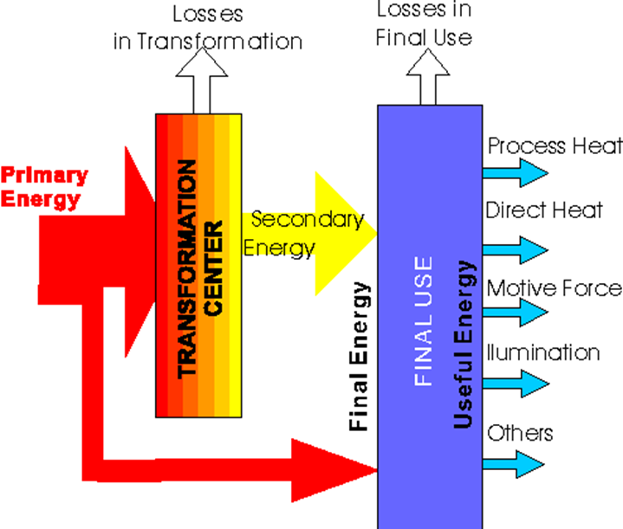

Figure 1: Schematic representation of primary, secondary, final and useful energy fluxes with indication of losses[[1]](#footnote-2)

By the time the energy (regardless of type/carrier) is brought to the level of the final user, it has already taken many forms and endured substantial losses.

Example for electricity

Initially, the process begins with the creation of the electricity through some method. For example, the burning of [coal](http://energyeducation.ca/encyclopedia/Coal) in a [power plant](http://energyeducation.ca/encyclopedia/Coal-fired_power_plant) takes the [chemical energy](http://energyeducation.ca/encyclopedia/Chemical_energy) stored in the coal and releases it through combustion, creating heat that produces [steam](http://energyeducation.ca/encyclopedia/Steam). From here, the steam moves [turbines](http://energyeducation.ca/encyclopedia/Turbine) that are attached through a shaft to a generator which converts mechanical energy to electricity. A typical coal fired electrical plant is around 38 % efficient, so approximately 1/3 of the initial energy content of the fuel is transformed into a useable form of energy while the rest is lost. Further losses occur during the transport of this electricity. In the [transmission](http://energyeducation.ca/encyclopedia/Electrical_transmission) and [distribution](http://energyeducation.ca/encyclopedia/Distribution_grid) of electricity in the United States, the EIA estimates that about 6% of the electricity is lost in these processes. Finally, the electricity reaches its destination. This electricity could reach an incandescent [light bulb](http://energyeducation.ca/encyclopedia/Light_bulb) wherein a thin [wire](http://energyeducation.ca/encyclopedia/Wire) is heated until it glows, with a significant amount of energy being lost as heat. The resulting light contains only about 2 % of the energy content of the coal used to produce it.

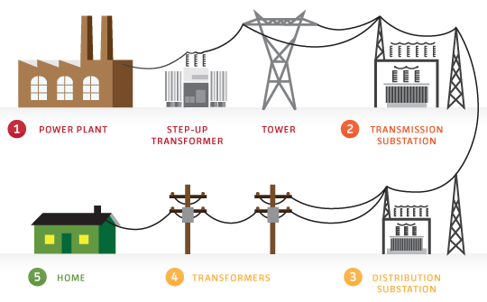

Figure 2: Energy from its production to its final use[[2]](#footnote-3)

* 1. ENERGY EFFICIENCY BASICS

Within the following chapter the basic terminology of energy efficiency is represented. It is important to become familiar with the basic terms for better understanding of this training material.

**Energy efficiency**

Energy efficiency means using the minimum amount of energy for heating, cooling, equipment or lighting that is required to maintain comfort conditions in a building. The most important factor that impact energy efficiency is the building envelope. This includes all the building elements between the interior and the exterior of the building such as: walls, windows, doors, roof and foundation. Efficient energy use is crucial in the fight against climate change and in the development of a sustainable and low carbon society.

**End use energy**

End use energy also called total final consumption or baseline energy consumption is the [energy](http://energyeducation.ca/encyclopedia/Energy) directly consumed by the user.

**Kilowatt (kW)**

This is a measure of demand for power. The rate at which electricity is used during a defined period (usually metered over 15-minute intervals). Utility customers generally are billed on a monthly basis; therefore, the kW demand for a given month would be the 15-minute period in which the most power is consumed. Customers may be charged a fee (demand charge) based on the peak amount of electricity used during the billing cycle. (Residential customers are generally not levied a demand charge.)

**Kilowatt-hour (kWh)**

This is a measure of consumption. It is the amount of electricity that is used over some period, typically a one-month period for billing purposes. Customers are charged a rate per kWh of electricity used.

**Temperature deficit/surplus**

Temperature deficit is defined as total of differences in temperature between the interior of the building (by agreement in country) and outside air, of all heating days. The duration of heating is limited to the time when the outdoor temperature is lower than agreed temperature in country. Therefore, for the certain place, we take the average outdoor temperature during the heating season and subtract it from the agreed interior temperature and multiply it by number of heating days.

**Thermal transmittance**

Thermal transmittance, also known as [U-value](https://en.wikipedia.org/wiki/R-value_(insulation)#U-factor.2FU-value), is the rate of heat transfer (in [watts](https://en.wikipedia.org/wiki/Watt)) through one square metre of a structure, divided by the difference in temperature across the structure. It is expressed in watts per square metre kelvin, or W/m²K. Well-insulated parts of a building have a low thermal transmittance whereas poorly insulated parts of a building have a high thermal transmittance. Losses due to [thermal radiation](https://en.wikipedia.org/wiki/Thermal_radiation), [thermal convection](https://en.wikipedia.org/wiki/Thermal_convection) and [thermal conduction](https://en.wikipedia.org/wiki/Thermal_conduction) are taken into account in the U-value.

**Heat loss**

The transmission heat loss occurs, because of heat transfer through the building envelope, depending of surface and thermal transmittance of each element and climatic conditions described by temperature deficit. Based on known surfaces of individual elements like floor, walls, ceilings, windows, doors and their thermal transmittance we can therefore determine the required annual energy for heating for individual places in country. It is expressed in kilowatt hour - kWh.

**Energy conversion efficiency**

Determining the quality of devices for converting energy base on the energy conversion efficiency of the device. The energy conversion efficiency of the device is determined by measurement in laboratories or test facilities. The values obtained are expressed in % and are referring to the conditions obtained during the test. The energy conversion efficiency of the device tells us how much of the input of primary energy in the form of a fuel is converted into final energy (under the standard conditions of the test). Values are always less than 100 %, because fuel cannot be fully utilized, as part of the energy is lost through flue gases and moisture in it and other part by surface radiating of the boiler to the surrounding area, and the remainder remains in incomplete burning residues.

For orientation, you can see the energy conversion efficiency of combustion plants according to the construction and type of energy carrier in table below:

|  |  |  |  |  |
| --- | --- | --- | --- | --- |
| Energy carrier | Construction |  |  | Energy conversion efficiency |
| Solid fuels | Old versions |  |  | 65 do 72 % |
| Combined boilers for liquid fuel |  |  | 70 do 75 % |
| Modern special boilers |  |  | 80 do 90% |
| Wood biomass boilers  -              pellets  -              chips |  |  | up to 93%  85 do 90% |
| Liquid fuels | Combined boilers for solid fuels  Special boilers |  |  | 68 do 75 %  90 do 95% |
| Gasoline | Special boilers  Condensing boilers |  |  | do 98%  over 100% |

Table 1: Energy conversion efficiency

**Heating value**

The heating value is the amount of heat produced by combustion a unit quantity of a fuel. The difference between energy carriers is shown in table below and it is based on amount of heat that they contain:

|  |  |  |
| --- | --- | --- |
| Energy carrier | Density  kg/m3 | Heating value-Hi |
| Light heating oil | 830 | 10,0 kWh/l |
| Natural gas | 0,7 | 9,44 kWh/m3 |
| Liquified natural gas | 2,02 | 12,8 kWh/kg |
| Lignite | 550 | 3,1 kWh/kg |
| Wood | 570 | 4,2 kWh/kg |

Table 2: Heating values

**Emission factors**

An **emissions factor** is a representative value that attempts to relate the quantity of a pollutant released to the atmosphere with an activity associated with the release of that pollutant. These factors are usually expressed as the weight of pollutant divided by a unit weight, volume, distance, or duration of the activity emitting the pollutant (kilograms of particulate emitted per megawatt of used gas). Such factors facilitate estimation of emissions from various sources of air pollution. In most cases, these factors are simply averages of all available data of acceptable quality, and are generally assumed to be representative of long-term averages for all facilities in the source category.

Emission factors are summarized from *Deliverable D.T1.6.1. Energy guardians smart-school management plan.*

|  |  |
| --- | --- |
| Energy carriers | tCO2/MWh |
| Natural Gas | 0,202 |
| Natural Gas Liquid | 0,231 |
| Heating Oil | 0,267 |
| Lignite | 0,364 |

Table 3: Emission factors for fossil fuel combustion

|  |  |
| --- | --- |
| Energy carriers | tCO2/MWh |
| Wind Power | 0 |
| Hydroelectric Power | 0 |
| Photovoltaics | 0 |
| Biogas | 0,197 |
| Wood | 0,007 |
| Geothermal | 0 |
| Solar thermal | 0 |

Table 4: Emission factors for local electricity or thermal production renewable energy sources

|  |  |  |  |  |  |  |
| --- | --- | --- | --- | --- | --- | --- |
|  | IPCC tCO2/MWh | | | | | |
| Country | 2005 | 2006 | 2007 | 2008 | 2009 | 2010 |
| Austria | 0,226 | 0,212 | 0,202 | 0,206 | 0,200 | 0,204 |
| Germany | 0,619 | 0,621 | 0,645 | 0,626 | 0,609 | 0,616 |
| Hungary | 0,563 | 0,551 | 0,606 | 0,593 | 0,516 | 0,539 |
| Italy | 0,491 | 0,494 | 0,493 | 0,484 | 0,453 | 0,467 |
| Poland | 1,262 | 1,243 | 1,188 | 1,123 | 1,141 | 1,165 |
| Slovenia | 0,536 | 0,536 | 0,539 | 0,561 | 0,613 | 0,582 |

Table 5: Emission factors for electricity by country involved in the ENERGY@SCHOOL

Principles of heat transfer

Heat is energy in transit. Spontaneously, heat flows from a hotter body to a colder one. Heat transfer tells us:

* how heat is transferred,
* at what rate heat is transferred and
* the temperature distribution inside the body.

There are several modes of heat transfer: conduction is an energy transfer across a system boundary due to a temperature difference by the mechanism of inter-molecular interactions. Furthermore, convection is an energy transfer across a system boundary due to a temperature difference by the combined mechanisms of intermolecular interactions and bulk transport. Convection can be natural (induced by natural forces: wind etc.), forced (induced by external means) or it changes phases (boiled/condensated). Besides conduction and convection, radiation heat transfer involves the transfer of heat by electromagnetic radiation that arises due to the temperature of the body. While conduction needs matter, but does not require any bulk motion of matter, convection needs fluid matter and bulk motion of matter. However, radiation does not need matter.

Energy Use Intensity - EUI

Energy Use Intensity (EUI) indicator provides the means to equalize the way that energy use is compared between various types of buildings and evaluate the means of reducing overall energy consumption. It is calculated by dividing the total gross energy (expressed in kilowatt-hours) consumed in a one-year period by the total gross square conditioned floor area of the building.

EUI can vary significantly depending on building type. Its measurement unit is kWh/m2a. Hospitals usually have high EUI, due to high energy demand of interior lighting and hospital equipment. Food service facilities also tend to have very high energy usage. In contrast, a school may have smaller EUI's due to smaller amount of time average spent in the building. Climate can have a significant effect on EUI, due to the variations in heating and cooling costs between different areas of the country. For this reason, EUI values may be broken up into region to provide a more accurate comparison of selected structures. By adjusting the EUI, there is a possible comparison between buildings in a different type of climate.

Ventilation requirements

Within a building, all enclosed spaces that are normally used by human must be continuously ventilated during occupied hours with outdoor air, using either natural or mechanical ventilation. Natural ventilation may be provided for spaces which are all normally occupied and are within a specific distance from an operable wall or roof opening through which outdoor air can flow. Airflow through the openings must come directly from the outdoor. Air may not flow through any intermediate spaces such as other occupied spaces, unconditioned spaces, corridors or atriums. High windows need to have a control mechanism accessible from the floor.

Mechanical outdoor ventilation must be provided for all spaces normally occupied that are not naturally ventilated. Buildings usually require that a space conditioning system provides outdoor air equal to or exceeding the ventilation rates required for each of the spaces that it serves. In the space, the required ventilation can be provided either directly through supply air or indirectly through transfer of air from an adjacent space. The designer may specify higher outside air ventilation rates based on the owner’s preference or specific ventilation needs associated with the space. However, specifying more ventilation air than the minimum allowable ventilation rates increases energy consumption and electrical peak demand and increases the costs of operating the HVAC equipment. Therefore, the designer should have a compelling reason to specify higher ventilation air rates than the calculated minimum outside air requirements.

Thermal comfort of building users

Adopting a revised model of thermal comfort puts us one step further toward increasing energy-efficiency in building. Thermal comfort is a condition of mind that expresses satisfaction with the thermal environment. Due to its subjectivity, thermal comfort is different for every individual. It is maintained when the heat generated by the human metabolism is allowed to dissipate at a rate that maintains thermal equilibrium in the body. Any heat gain or loss beyond this generates substantial discomfort. Essentially, to maintain thermal comfort, all heating losses (transmission and ventilation losses) must be equal to temperature gains (heating demand, solar and internal gains) which is also known as heat balance of a building (figure 3).

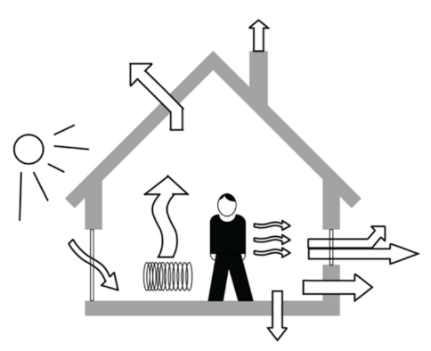

Figure 3: heat balance of a building[[3]](#footnote-4)

There are six primary thermal comfort variables:

* ambient temperature (air temperature),
* radiant temperature (the temperature of the surfaces around us),
* relative humidity (measurement of the water vapor in an air-water mixture),
* air motion (the rate at which air moves around and touches skin),
* metabolic rate (amount of energy expended) and
* clothing insulation (materials used to retain or remove body heat).

Knowing these six variables is essential to making informed decisions when planning and designing a building air conditioning system.

Understanding thermal comfort is important to architecture, since it not only lays the foundation for building design, but also affects the field of sustainable design. Contemporary models of thermal comfort recommend that a narrow temperature range be applied equally across all building types, climatic zones, and populations. This method casts the building occupants as passive recipients of thermal applications, leading to thermal comfort standards that require energy-intensive environmental control strategies.

HVAC systems

HVAC stands for heating, ventilation, and air conditioning. HVAC equipment perform heating and/or cooling for residential, commercial or industrial buildings. The HVAC system may also be responsible for providing fresh outdoor air to dilute interior airborne contaminants such as odors from occupants, volatile organic compounds (VOC’s) emitted from interior furnishings, chemicals used for cleaning, etc. A properly designed system will provide a comfortable indoor environment year round when properly maintained.

In computing and especially in enterprise data centers, HVAC systems control the ambient environment (temperature, humidity, air flow, and air filtering) and must be planned for and operated along with other data center components.

External factors influencing energy use

Degree days are measures of how cold or warm a location is. The more extreme the outside temperature, the higher the number of degree days. A high number of degree days generally results in higher levels of energy use for space heating or cooling. They are a specialist type of weather data, calculated from readings of outside air temperature. Heating degree days and cooling degree days are used extensively in calculations relating to building energy consumption.

People study degree day patterns to assess the climate and the heating and cooling needs for different regions of the country during the seasons of the year. There are three main types of degree days: heating degree days, cooling degree days, and growing degree days.

* Heating degree days are a measure of how much (in degrees), and for how long (in days), the outside air temperature was below a certain level.  They are commonly used in calculations relating to the energy consumption required to heat buildings.
* Cooling degree days are a measure of how much (in degrees), and for how long (in days), the outside air temperature was above a certain level.  They are commonly used in calculations relating to the energy consumption required to cool buildings.
* Growing degree days are calculated in the same way as cooling degree days, but the base temperatures used are based upon the temperatures above which certain plant or insect growth occurs. Different plants have a different base temperature above which they will start to grow, and their growth will typically be roughly proportional to the amount by which that base temperature is exceeded.  This is very similar to the way in which building cooling is proportional to the amount by which the building base temperature is exceeded.

Solar irradiance

Solar radiation is radiant energy emitted by the sun, particularly electromagnetic energy. About half of the radiation is in the visible short-wave part of the electromagnetic spectrum. The other half is mostly in the near-infrared part, with some in the ultraviolet part of the spectrum. Solar irradiance is the power per unit area (W/m2) received from the Sun in the form of electromagnetic radiation in the wavelength range of the measuring instrument. Irradiance is measured perpendicular to the incoming sunlight. Insolation is the power received on Earth per unit area on a horizontal surface (W/m2). In construction, insolation is an important consideration when designing a building for a particular site.

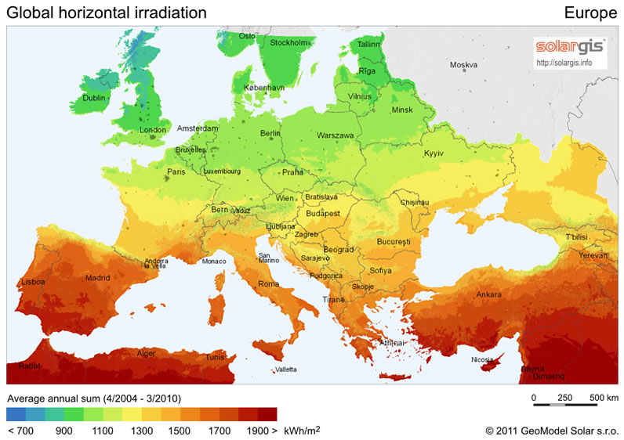

Figure 4: Global annual horizontal irradiation in Europe[[4]](#footnote-5)

Figure 4 presents global average annual horizontal irradiation in Europe in kWh/m2. As seen, countries in southern Europe receive more solar irradiance than countries in northern Europe.

You can use the link below to determine the potential of solar radiation for your country or place.

<http://re.jrc.ec.europa.eu/pvgis/index.htm>

1. **RENEWABLE ENERGY SOURCES – RES**

Renewable energy is energy that is generated from natural resources that are continuously replenished. This energy cannot be exhausted and is constantly renewed. The most important ones are:

* wind,
* sun,
* water,
* geothermal energy and
* biomass which is partially a renewable energy source.

The EU`s Renewable energy directive sets a binding target of 20 % final energy consumption from renewable sources by 2020. To achieve this, EU countries have committed to reach their own national renewable targets. By using more RES to meet its energy needs, the EU lowers its dependence on imported fossil fuels and make its energy production more sustainable. In the graph below you can see the share of renewable energy in final energy consumption for each country participating in the project. By the year of 2015 Germany achieved a 14,6 %, Croatia 29 %, Italy 17,5 %, Hungary 14,5 %, Austria 33 %, Poland 11,8 % and Slovenia 22 % share of renewable energy.

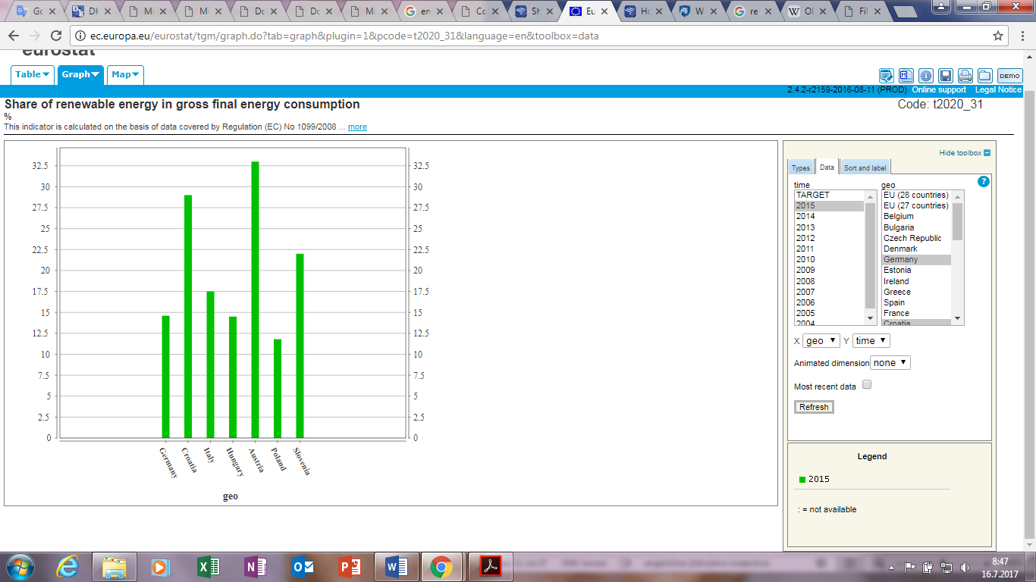

Graph 1: Share of renewable energy in gross final energy consumption (%)

It is important to use local renewable energy because they are pure sources that have very little influence on the environment. In the graphs below you can see the share of energy from renewable sources for electricity for each country participating in the project.

|  |  |
| --- | --- |
| Graph 2: Share of renewable sources in Germany | Graph 3: Share of renewable sources in Croatia |
| Graph 4: Share of renewable sources in Italy | Graph 5: Share of renewable sources in Hungary |
| Graph 6: Share of renewable sources in Austria | Graph 7: Share of renewable sources in Poland |
| Graph 8: Share of renewable sources in Slovenia | |

Renewable energy sources commonly used for building applications include solar, wind, geothermal and biomass. Before selecting an appropriate renewable energy technology to apply to an existing building retrofit project, it is important to first consider a number of factors. Examples of these factors include:

* Available renewable energy source at or near the building site
* Available area for placing the renewable energy technology
* Cost of energy purchased from the electrical or thermal energy provider for the building
* Available incentives for offsetting the installation cost of the renewable energy system
* Local regulations affecting renewable energy systems
* Desire to preserve or not alter existing architectural features
* Characteristics of the energy profiles to be offset by the renewable energy installation

There are many ways of integrating the renewable energy sources. Within the following chapter, renewable energy technologies most commonly used in public buildings are represented. We divided them in the sections:

* Solar photovoltaic systems (PV)
* Solar thermal, including solar hot water (domestic water heating and space heating),
* Geothermal heat pump
* Wind turbines
* Biomass systems.
  1. Solar photovoltaic - PV

Photovoltaics is the direct conversion of light into electricity at the atomic level. Some materials exhibit a property known as the photoelectric effect that causes them to absorb photons of light and release electrons. When these free electrons are captured, an electric current results in a way that can be used as electricity.

These systems are generally fixed in a single position but can be placed on structures that tilt toward the sun that roll East to West over the course of a day.

A number of solar cells electrically connected to each other and mounted in a support structure or frame is called a photovoltaic module. Modules are designed to supply electricity at a certain voltage, such as a common 12 V system. The current produced is directly dependent on how much light strikes the module.

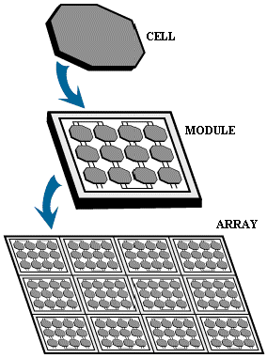

Figure 5: Solar modules[[5]](#footnote-6)

Multiple modules can be wired together to form an array. In general, the larger the area of a module or array, the more electricity will be produced. Photovoltaic modules and arrays produce direct-current (DC) electricity. They can be connected in both series and parallel electrical arrangements to produce any required voltage and current combination.

The major challenge with placing solar PV systems is ensuring appropriate place for maximum electricity production. An ideal solar installation would be situated in an unshaded, south-facing location with an optimum tilt angle, you have to keep in mind that not all sites are suitable for solar technologies.

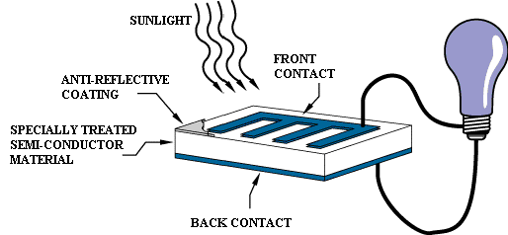

Figure 6: Working principle of a basic photovoltaic cell4

For better understanding, the diagram above illustrates the operation of a basic photovoltaic cell, also called a solar cell. Solar cells are made of the same kinds of semiconductor materials, such as silicon, used in the microelectronics industry. For solar cells, a thin semiconductor wafer is specially treated to form an electric field, positive on one side and negative on the other. When light energy strikes the solar cell, electrons are knocked loose from the atoms in the semiconductor material. If electrical conductors are attached to the positive and negative sides, forming an electrical circuit, the electrons can be captured in the form of an electric current, that is, electricity. This electricity can then be used to power a load, such as a light or a tool.

* 1. Solar thermal - Hot Water Systems

Another way of using solar energy is solar hot water systems which use a collector to absorb and transfer heat from the sun to water, which is stored in a tank until needed. These systems are categorized by the temperature at which heat is most efficiently delivered and the collector type that is best suited for that delivered temperature, including low-temperature (unglazed collectors), mid-temperature (flat-plate collectors), and high-temperature (evacuated tube collectors).

In general, solar water systems are reliable and low maintenance because they have few moving parts. The primary components of a solar water heating system are the collectors and heat transfer systems, which include a heat exchanger, pumps, hot water storage and controls. Carefully considering placing issues will help increase the efficiency and cost effectiveness of solar thermal system installations.

* 1. Heat pumps

Heat pumps use electricity to move heat from a cool space to a warm space, making the cool space cooler and the warm space warmer. During the heating season, heat pumps move heat from the cool outdoors into your warm house and during the cooling season, heat pumps move heat from your cool house into the warm outdoors. Because they move heat rather than generate heat, heat pumps can provide equivalent space conditioning at as little as one quarter of the cost of operating conventional heating or cooling appliances.

There are three types of heat pumps: air-to-air, water source, and geothermal. They collect heat from the air, water, or ground outside your home and concentrate it for use inside.

The most common type of heat pump is the air-to-air heat pump, which transfers heat between your house and the outside air. Today's heat pump can reduce your electricity use for heating by approximately 50% compared to electric resistance heating such as furnaces and baseboard heaters. High-efficiency heat pumps also dehumidify better than standard central air conditioners, resulting in less energy usage and more cooling comfort in summer months.

Geothermal (ground source or water source) heat pumps achieve higher efficiencies by transferring heat between building and the ground or a nearby water source. Although they cost more to install, geothermal heat pumps have low operating costs because they take advantage of relatively constant ground or water temperatures. They can reduce energy use by 30% - 60%, control humidity, are sturdy and reliable, and fit in a wide variety of homes. Whether a geothermal heat pump is appropriate for you will depend on the size of your lot, the subsoil and the landscape. Ground source or water source heat pumps can be used in more extreme climates than air-to-air heat pumps.

* 1. ****Wind****

Another way for incorporate the use of RES into your building is with wind turbines. Wind energy is created by uneven solar heating of the Earth’s surface. This wind flow can be harnessed by modern wind turbines to generate electricity. Wind turbines use rotating propeller-like blades to harness the energy in the wind and drive a turbine that generates electricity. Before installing a wind turbine, it must be established that the wind resource in a specific location is adequate. Wind resource is classified according to its potential to produce electricity over an annual basis. Wind resource maps can determine if an area of interest should be further explored, but wind resource at a micro level can vary significantly. Therefore, it is important to evaluate the specific area of interest before deciding to invest in wind systems.

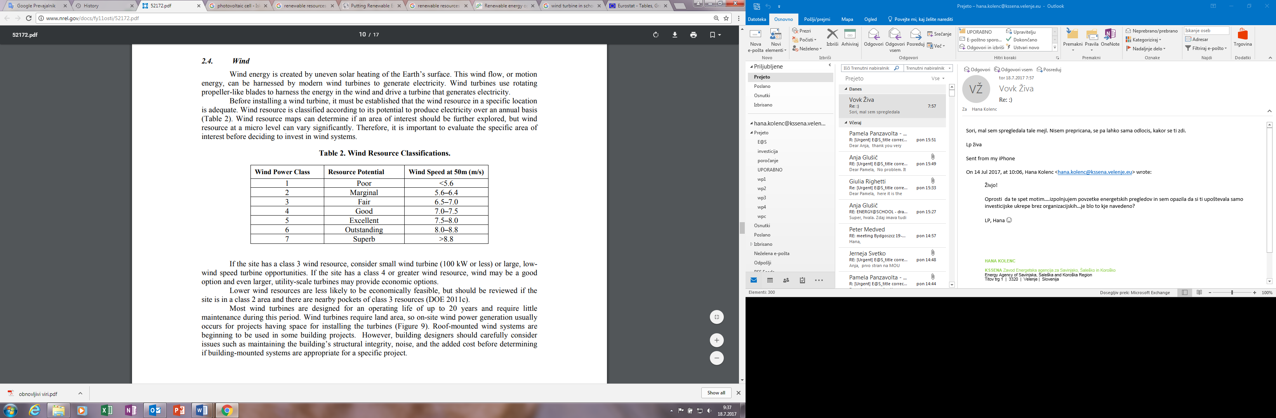

Table 6: Features of wind power classes

If the site has a class 3 wind resource, consider small wind turbine (100 kW or less). If the site has a class 4 or more, use of wind energy may be a good option and even larger, utility-scale turbines may provide economic options. Lower wind resources are less likely to be economically feasible. Most wind turbines are designed for an operating life of up to 20 years and require little maintenance during this period. Wind turbines require land area, so on-site wind power generation usually occurs for projects having space for installing the turbines. Roof-mounted wind systems are beginning to be used in some building projects. However, building designers should carefully consider issues such as maintaining the building’s structural integrity, noise and the added cost before determining if building-mounted systems are appropriate for a specific project.

* 1. Bioenergy

Bioenergy is energy derived from biomass which includes biological material such as plants, residue from agriculture and forestry, the organic component of municipal and industrial wastes. Biomass is used to produce fuels, chemicals and power. The flexibility of materials has resulted in increased use of biomass technologies.

Biomass contains stored energy from the sun. Plants absorb the sun's energy in a process called photosynthesis. When biomass is burned, the chemical energy in biomass is released as heat. Biomass can be burned directly or converted to liquid biofuels or biogas that can be burned as fuels. Examples of biomass and their uses for energy:

* wood and wood processing wastes - burned to heat buildings, to produce process heat in industry and to generate electricity,
* agricultural crops and waste materials - burned as a fuel or converted to liquid biofuels,
* food and wood waste in garbage - burned to generate electricity in power plants or converted to biogas in landfills,
* animal manure and human sewage - converted to biogas, which can be burned as a fuel.

Converting biomass to other forms of energy

Burning is only one way to release the energy in biomass. Biomass can be converted to other useable forms of energy such as methane gas or transportation fuels such as ethanol and biodiesel.

Methane gas is a component of landfill gas or biogas that forms when garbage, agricultural waste and human waste decompose in landfills or in special containers called digesters.

Crops such as corn and sugar cane are fermented to produce fuel ethanol for use in vehicles. Biodiesel, another transportation fuel, is produced from vegetable oils and animal fats.

1. RATIONAL USE OF ENERGY - RUE

Main goal of rational use of energy is to reduce energy consumption, for the same work or service. It is focused on individual and collective solutions which induce the smallest energy consumption by efficiency, savings and conservation. RUE combines energy efficient behaviour and equipment.

There are three main steps to take, when pursuing to rational use of energy:



TRAINING UNIT 2

RATIONAL USE OF ENERGY AND ENERGY CONSUMPTION IN SCHOOL

1. ENERGY CONSUMPTION IN SCHOOL

Buildings are responsible for 40 % of energy consumption and 36 % of CO2 emissions in the EU. While new buildings generally need fewer than three to five litres of heating oil per square meter per year, older buildings consume about 25 litres on average. Some buildings even require up to 60 litres.

Currently, about 35 % of the EU's buildings are over 50 years old. By improving the energy efficiency of buildings, we could reduce total EU energy consumption by 5-6 % and lower CO2 emissions by about 5 %.

In the figure below you can see the average energy use profile of schools. Of those energy users, space heating systems consume the most energy, followed by lighting with 14 % and cooling 9 %. Although the numbers vary by climate zone, the results provide generalized summary of systems and representing the opportunities for energy savings.

Graph 9: Average profile of the energy use in school

* 1. GUIDELINES FOR EFFICIENT BEHAVIOUR

The guidelines for efficient behaviour in school is the main task of Junior energy guardians. Within this chapter, the most relevant ones will be represented to educate Senior energy guardians.

* + 1. HVAC system - heating

A pleasant room climate creates an essential condition for wellbeing and health, as well as good performance at work. For this, several things have to be considered. In order to feel well, “thermal comfort” should prevail. This is a state, which is given when persons are satisfied with the air temperature, the air humidity, air movement and radiant heat in the room. One factor that can easily be influenced is the air temperature because the energy consumption of a building is mainly influences by the room temperature. One-degree higher temperature causes a 6 % higher consumption. In the table below the recommended toom temperatures are represented:

|  |  |
| --- | --- |
| **Room** | **Temperature** |
| Common room | 20° C |
| Changing room | 22 – 24° C |
| Lavatory | 22 - 24° C |
| Toilets | 15 – 17°C |
| Office spaces | 20° C |
| Workshops, service stations | 12° C |
| Stairways | 12 – 15° C |
| Garage | 5° C |

Table 7: Recommended room temperatures

1. **Correct use of thermostats**

A thermostat is a valve, that mechanically controls the temperature. Depending on the ambient temperature, the valve adjusts the flow rate so that the temperature will be constant.   
Inform the users of the building on how to correctly use the thermostat. The setting of the thermostat will determine, at which room temperature the valve will be closed. A setting to 3 will result in a room temperature of 20°C. A setting to 5 will not cause a faster heating-up of the room. On the contrary, it will result in an over-heating of the room, for the valve will be closed at a temperature of 28°C.

1. **Margin of thermostats in side rooms**

In less often used rooms like hallways, storage rooms and toilets, room temperature can be lower. The thermostats can manually be limited and locked to a setting of 1 or 2. So the building users (especially in public buildings and schools) cannot manipulate the temperature in these less often used rooms.

1. **Avoid electric heating**

Electric heating is 2 to 3 times more expensive than heat generation with a central heating system based on oil, natural gas or biomass. And the use of electricity causes more CO2 emissions than conventional energy carriers. If electric heating devices are used, it indicates that there is a problem with the heating system. If remote rooms are heated with additional electric heaters, it may be because the rooms are not getting warm enough. Try to optimize heat distribution in the building with a hydraulic balancing.

On the other hand, electric heating is reasonable in some cases, for example if you can avoid the heating of entire building. This may be the case if you have any of remote rooms that have to be warm.

Scheduled maintenance should be performed one to four times per year. Boiler inspection is essential for safe and efficient operation and may already be required by your state. A qualified technician should perform boiler maintenance. However, school building manager have to check for leaks, look for damaged or missing insulation and monitor energy efficiency.

* + 1. HVAC system - Ventilation

The users of residential and non-residential buildings need fresh air. CO2, water vapor, fine dust and odors accumulate indoors and have to be brought outside of the building. Clean and sufficient air is essential for the health and well-being of users. Ventilation systems in non-residential buildings are often planned to existing laws and norms. The air-change rate is often projected according to the size of the room (m²) or number of persons. For each person, the volume of 20-30 m³ per hour should be sufficient.

* + 1. HVAC system – Air conditioning

Regular maintenance of air conditioning systems maintains optimal cooling performance and saves energy.

Most of the maintenance recommendations apply to all types of air conditioning systems found in schools, including package systems and classroom unit ventilators. The general cooling efficiency of the air conditioning system should be checked every three to five years.

* + 1. Power consumption of appliances and electronics

Modern technical devices can often go to stand-by modus and can be easily activated with a remote control. In the stand-by modus, the functionality of the device will be limited in order to save energy. The amount of energy that is still consumed by the power supplies and sensors is called the stand-by consumption or power loss. Almost any device with an external power supply, a remote control, a display or a charging station consumes electric energy continuously. To detect the power loss, you can use a measuring instrument that shows how much energy is wasted.  
To avoid stand-by consumption use switchable power sockets.

Appliances that are old and have bad energy efficiency can transform its lost energy into heat. So replace the appliances that have the worst energy efficiency characteristics and at the same time minimize the activities on heat generating appliances that are not necessary.

* + 1. Lighting and motion sensors

A major contribution to save electric energy can be brought by the users of a building by correct and intelligent use of the lights. In some cases when lighting system is very poor it can transform lost energy into heat. In fact, only 10 to 15 % of electricity when using regular incandescent bulbs results in light, where the lion`s share of the energy is actually lost. So change the lighting systems that have the worst energy efficiency characteristics. In the table below the recommended illuminance levels are represented:

|  |  |
| --- | --- |
| **Type of room** | **Illuminance level** |
| common room | 200 lux |
| changing room | 100 lux |
| lavatory | 100 lux |
| toilets | 100 lux |
| office spaces with daylight | 300 – 500 lux |
| office spaces | 500 – 1.000 lux |
| workshops, service stations | 500 lux |
| stairways | 100 lux |
| garage | 30 – 100 lux |

Table 8: Recommended illuminance levels

A significant amount of energy can also be saved by installing light system sensors which turn the light on only when there are people in the vicinity. The most suitable rooms for installing these sensors are the lavatories, hallways and wardrobes.

* + 1. **Rational** use of sanitary hot water

Wasting hot water will cost more for the energy used to heat it, and also for the water used. It is important to always close the taps or install percussion taps which turn off automatically. To prevent heat escaping is good to insulate hot water storage tanks and distribution pipes. To avoid unnecessary energy use, restrict boiler heating to relevant times using timers.

The main share of water consumption in school buildings is caused by toilet and urinal flushing, (Graph 10) if we don’t consider the consumption in kitchen. In the case of refurbishment, water-saving taps should be installed. The installation of waterless urinals or the use of rainwater is also ecologically worthwhile. Water taps, toilets and urinals should be checked regularly for tightness. Defect parts should be replaced immediately.

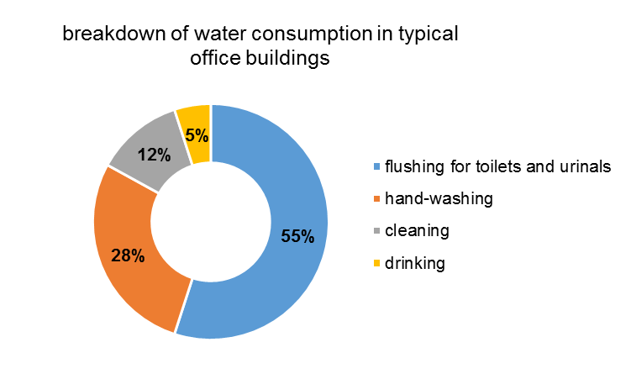

Graph 10: water consumption in typical office building

* The adequate temperature of the hot water should be 60°C at the outlet of the hot-water boiler.
* The temperature should not be lower to prevent legionnaires disease.
* Pipes for warm water and circulation should be insulated. Depending on the temperature, a loss of 20-50 watt per meter arise. The energy losses can easily be calculated in kwh:

power loss [W/m] · length [m] · operating hours per year/1000 [h/a] = xx kWh/a

If considered that hot water in school building is only needed in kitchens, it may be the best solution to decommission the central hot water-supply and equip the kitchen with electronic water heaters. Flow-type heaters are more efficient than storage heaters, for there are no storage losses. Only the required amount of hot-water is heated and the water is heated to the desired temperature accurately. Alternatively, you can also begin to turn off the hot water at the wash-basins in the toilets. Inform the building users, that not the temperature of water is crucial when washing your hands but the care. In an office building with 50 employees, roughly 500 to 1.200 Euro per year can be saved if cold water is used for washing the hands.

* + 1. Effect of solar heat gains and how to minimize them

Effect of solar heat gains occurs because of solar irradiance. In winter is desirable to warm up chilly rooms, but it is an unwelcome side effect in the summer because it can over heat the rooms. To minimize the amount of solar heat entering the window, select the correct window treatments for the windows. Blinds and shades are useful to cover the windows during the hottest part of the day. Adjustable shades can be opened slightly so light can enter between the slats but still block direct sunlight.

TASK: Easy to apply energy saving measures

Based on prepared theory in previous chapter you can use this task to implement behavioural energy measures into your school. In the table below you will find a list of prepared concrete measures that you can easily apply with the help of Junior energy guardian.

Feel free to add more measures for the area you think that have the most potential for energy savings.

* **Follow these steps to ensure energy savings in your building:**

|  |  |
| --- | --- |
| **ENERGY SAVING MEASURES** | **CHECKED** |
| **Heating** | |
| Reduce the temperature by 1°C and you may cut up to 6 % off your heating costs. |  |
| Turn heating off in unoccupied areas. |  |
| Take into account of the outside temperature and adjust heating levels accordingly. A multi programmable switch will accommodate varying requirements during the day. |  |
| Thermostats should not be influenced by sunlight, radiators or draughts. |  |
| Use thermostatic radiator valves to control the heat output from radiators. |  |
| Regularly check the thermostatic valves to ensure that they are working correctly. |  |

|  |  |
| --- | --- |
| **Ventilation** | |
| Ventilation systems should only be activated, if they are necessary for the specific usage of the room. |  |
| Doors and windows should be closed during the operation of the ventilation system. |  |
| Ventilation flaps and dampers should be closed when system is not in operation. |  |
| To heat up rooms with air heating, recirculation air operation should be used. |  |
| Sunscreens and blinds should be used timely to prevent the building to be heated up in summer. |  |
| Air condition and cooling may only be used, if room temperature is higher than 27°C |  |

|  |  |
| --- | --- |
| **Air conditioning** | |
| Clean filters and fans |  |
| Check air leaks in equipment cabinets and ducts |  |
| Check improper air damper operation |  |
| Clean dirty condenser and evaporator coils |  |
| Checkimproper refrigerant charge |  |

|  |  |
| --- | --- |
| **Lighting and motion sensors** | |
| Switch off the lights when leaving the room or daylight is sufficient |  |
| Clean lamps and reflectors regularly |  |
| Use sun-shading in a way, that no additional electric lights are necessary |  |
| Install signs and information signs “switch off the lights” in infrequently used rooms like toilets, storage rooms, kitchens |  |
| Use photo sensors, which are designed to minimize lighting system when daylight reaches bright levels. |  |
| Switch off unnecessary lights |  |
| Illuminate the rooms according to the requirements and the use of the rooms |  |
| Replace old bulbs and filament lamps with efficient lamps e.g. LED retrofit lamps. |  |

|  |  |
| --- | --- |
| **Power consumption of appliances and electronics** | |
| Use stand-by mode |  |
| Use switchable power sockets |  |
| Switch off all appliances when they are not in use |  |

|  |  |
| --- | --- |
| Rational **use of sanitary hot water** | |
| After using, close the taps or install percussion taps which turn off automatically |  |
| Use timers to restrict boiler heating to avoid unnecessary energy use |  |
| Insulate hot water storage tanks and distribution pipes to prevent heat escaping |  |
| Regularly check water taps, toilets and urinals for tightness. |  |

|  |  |
| --- | --- |
| **Effect of solar heat gains and how to minimize them** | |
| Install proper window shading to minimize the amount of solar heat |  |
| Properly use the adjustable shades, |  |

TASK: Correct reading of buildings energy invoice

Important action that can be done by every building owner is to learn how to correct read building energy invoces.

Understanding the [components of your energy invoice](http://www.energysmart.enernoc.com/get-to-know-your-electricity-bill-one-line-item-at-a-time/) is no easy task, but it is a fundamental first step to take control of your energy use and reducing costs (and to find any [potential errors](http://energysmart.enernoc.com/10-common-utility-bill-errors-infographic/) in your invoice). How you get billed is complicated and varies widely depending on your specific contract, but it is important for you to understand your tariff. Without knowing exactly how you are billed for energy, it is difficult to prioritize which energy savings measures will have the biggest impact. When you understand each component, you can see exactly what you are paying and it can help you manage your overall energy expenses.

For analysing energy consumption (heat, power and water) you have to collect data of actual consumption. The goal is to uderstand the basic trends of the buildings consumption throughout the year, to determine if energy consumption is increasing and if there are any seasonal trends. One way to do so, is to collect one to three years of energy invoices for heat, power and water.

* Obtain invoices for a building and separate them according to heating, electricity and sanitary waste water.
* **Read invoice for heating**

This is a typical invoice in Slovenia, received for heating. In this example, the natural gas is the source of heat energy:

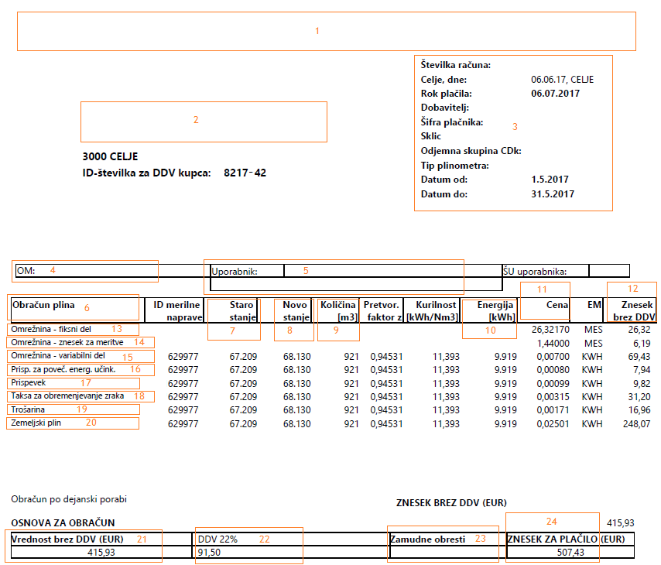

*In the first part of the invoice you can see the general data about client and distributor:*

1. The name and contact details of the company, supplying energy
2. The name and address of the person/institution receiving energy
3. General invoice data: invoice number, issue date, payment due, data of the account holder, account data of the supplier and the time period (usually whole month) when energy was supplied
4. Meter point administration number (MPAN) or supply number
5. Address, where energy is supplied to (it might be different from postal address)

*In next section, from 6 to 20, are cost of building, operating and maintaining distribution system explained and also amount and cost of supplied natural gas.*

1. Energy charges (13-20) that may be different in invoices
2. Previous status (supplied gas)
3. New status (supplied gas)
4. Amount of supplied natural gas (in cubic metres)
5. Amount of supplied energy (Quantity of supplied natural gas · Conversion factor)
6. Cost of one unit of energy charge
7. Cost of energy charges without VAT (10. x 11.)

13., 14., 15. Network access charges (acquired for covering the costs of maintaining the system for stable and efficient supply and distribution of energy)

16. Energy efficiency contribution (for increasing energy efficiency and energy savings for final customers/clients)

17. Contribution for renewable energy sources (for increasing share in renewable energy sources)

18. Fee for CO2 emissions

19. Excise duty

20. Natural gas

21. Total amount/cost of energy charges without VAT

22. VAT (value added tax)

23. Default interest (in case of client/institution not paying invoice until payment due)

24. Total amount/cost (21. + 22.)

* **Read invoice for electricity**

Despite electricity invoices varying from state to state, there are usually three costs involved in electricity. They are as follows:

* **Generators** produce the main source of electricity from renewable sources or the burning of fossil fuels. The buying of fuels, the building operations and maintenance of power plants are where costs are incurred.
* **Network** businesses own and operate the transmission and distribution systems. The building, maintenance and repairs of new and existing powerlines are where costs are incurred.
* **Retailers** are the electricity providers for homes and businesses. The connection of customers to the grid, purchase of electricity from generators and management of customer accounts are where costs are incurred.

Here is a typical invoice in Slovenia, received for electricity, from electric power distributor, which will charge you for network access and different contributions.

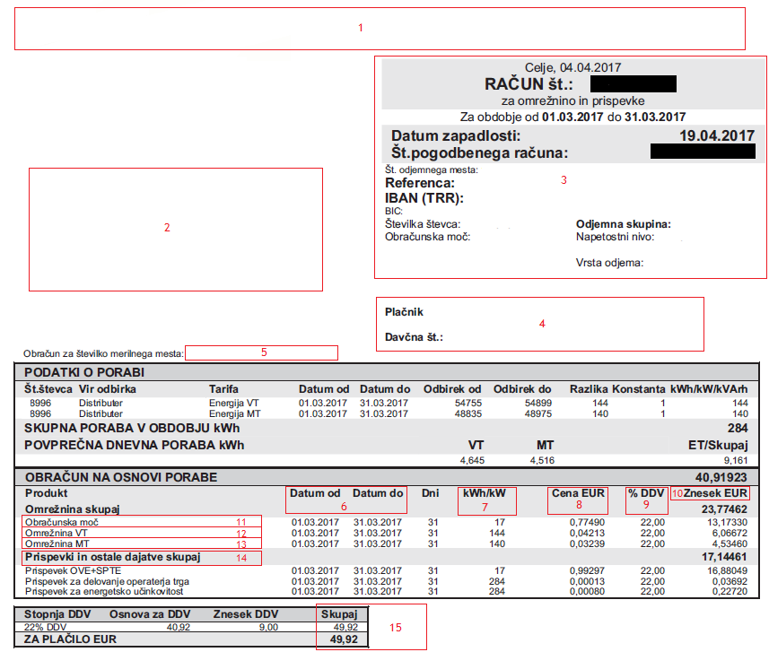

*In first part of invoice you usually find the general data about client and distributor:*

1. The name and contact details of the company, distributing electricity (transmission system operator – TSO)
2. The name and address of the person/institution receiving electricity
3. General invoice data: invoice number, issue date, payment due, data of the account holder, account data of the distribution company and the time period (usually whole month) when electricity was distributed
4. Address, where energy is supplied to (it might be different from postal address)
5. Meter point administration number (MPAN) or supply number

*In the section from 6 to 10 it is shown the amount and prices for used energy:*

1. Time period (usually whole month)
2. Power demand (kW) or used energy (kWh)
3. Cost of one unit of energy charge
4. VAT (value added tax)
5. Cost of energy charges without VAT (7. · 8.)

*The section from 11 to 15 is divided on network charges and contribution:*

1. Capacity charges/peak demand (kW)
2. High tariff for network access charges (kWh)
3. Low tariff for network access charges kWh)
4. Network access charges are acquired for covering the costs of maintaining the system for stable and efficient supply and distribution of electricity
5. Contribution for renewable energy sources (for increasing share in renewable energy sources), energy efficiency contribution (acquired for increasing energy efficiency and energy savings for final customers/clients) and contribution for transmission system operator (TSO)

*At the end of invoice is the amount you have to pay:*

1. Total amount/cost

This is a typical invoice in Slovenia, received for electricity, from electricity retailer:

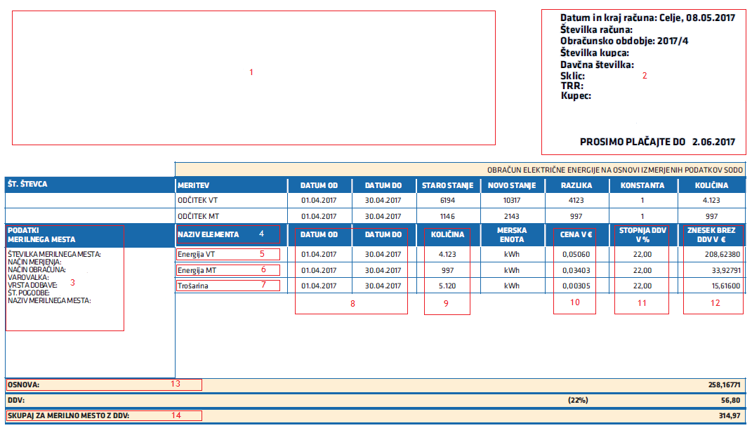

*In first part are general data of client and electricity retailer:*

1. The name and contact details of the company, supplying electricity
2. The name and address of the person/institution receiving electricity and general invoice data: invoice number, issue date, payment due, data of the account holder, account data of the company supplying energy and the time period (usually whole month) when electricity was supplied
3. Meter point administration number (MPAN) or supply number, address, where energy is supplied to (it might be different from postal address)

*In section from 5 to 7 you can find energy charge*s:

1. High tariff electricity is the price for higher tariff
2. Low tariff electricity (kWh) is the price for lower tariff
3. Excise duty, is charged for each used kWh of electricity for high or low tariff

In Slovenia, you can have two way or unified measurement. When having a two-way measurement system, you get charged based on used electricity during the day. The period of high and low tariff electricity is shown on figure below:

MONDAY TO FRIDAY

|  |  |  |
| --- | --- | --- |
| Low tariff | High tariff | Low tariff |
| 00:00 | 06:00 22:00 | 24:00 |

SATURDAY, SUNDAY AND HOLIDAY

|  |
| --- |
| Low tariff |
| 00:00 24:00 |

*In the sections from 8 to 14 it is shown the amount of used energy, the price and total amount:*

1. Time period (usually whole month)
2. Amount (in kWh) of energy charges
3. Cost of one unit of energy charge
4. VAT (value added tax)
5. Cost of energy charges without VAT (9. · 10.)
6. Total amount/cost of energy charges without VAT
7. Total amount/cost

It is also good to know about capacity charges/peak demand, because it can help you save the money. It refers to the times of day when our electricity consumption is at its highest.

There are generally two peak periods during the day - morning and evening - from 8 to 10 and again from 5 to 8, or some similar times when demand is the highest.

Saving electricity during the peak demand period is beneficial to the community and the electricity system. Just by making little changes in your energy routine, you can spread the need for energy throughout the day and lower the peak demand. And by lowering the peak demand you will lower the capacity charges which will result in lower total amount.

And also supplying electricity for an ever-increasing peak demand requires to build more electricity infrastructure such as generators and higher capacity powerlines. Ultimately customers pay to build this infrastructure through increases in the price of power, even though much of it goes unused for the remainder of the year.

TASK: Make a detail list of energy consumptions

First step toward achieving energy saving is getting to know your building, because if we learn how and where our building uses energy, we can discover potential energy saving places and consequently financial savings.

You have to make a location visit and prepare a detailed list of all energy consumptions and surfaces which contribute to heat gains and losses. The main goal of this step is to determine the major consumers. This will enable you to recognize the area or individual consumer, that you may want to focus your efforts on, to lower the consumption.

* When making a detailed list in large building with many separate room it is recommended to use the table as presented below. It is divided in 6 sections for better presentation.

In the first section, you write down general data of a building. This information will enable you to have a good orientation of building layout when you end with the location visit. The most important information in this section is window orientation, because of the solar irradiance.

|  |  |
| --- | --- |
|  | 1. Location; personal choice of room numbering 2. Building; in which building the energy audit is performed 3. Building zone; in which part of the building is the room located 4. Floor; on which floor is the room located 5. Orientation; in which directions are the windows facing 6. Room description; define the room in which you are in. |

In the second section, you describe dimensional values, for each room defined in previous section. These are important information for calculating the conditional floor area, which is needed in *TASK: Calculation of energy consumption and costs*. The volume is necessary when performing the building physics.

|  |  |
| --- | --- |
|  | 1. Height of the room (m) 2. Width of the room (m) 3. Length of the room (m) 4. Surface of the room (m2) 5. Volume of the room (m3) |

In the third section, you list all heating entities and its properties. Based on, you can estimate the necessary measures for lower the consumption and costs (e.g. all heating entities should have a thermostatic valve)

|  |  |
| --- | --- |
|  | 1. Heating entities; define what kind of heating entities are in room 2. Manufacturer of heating entities; define who is the manufacturer of heating entities so you can define its properties 3. Old/new; define if the heating entities are old or new 4. Thermostatic valve; define if there is a thermostatic valve installed 5. Number; count the heating entities in the room 6. Width of entities(cm); 7. Height of entities(cm); 8. Heating entities surface (m2); |

In the fourth section, you make a list of windows and doors properties, because these surfaces are the major contributors to temperature gains and losses. The size of windows is used when performing the building physics.

|  |  |
| --- | --- |
|  | 1. Window type; define if the windows are wooden, plastic, aluminium etc. and number of glazing layers 2. Old/new; define if the windows are old or new 3. Width (cm) 4. Height (cm) 5. Window surface (m2) 6. Number of equal windows |

In the fifth section, you list all sanitary wares properties, so you can propose the measures which will reduce the use of water and electricity costs (e.g. on toilets install double flushing, in classrooms is enough to have only cold water on pipes, etc.)

|  |  |
| --- | --- |
|  | 1. Type; define the type of sanitary ceramics in the room if is it the sink, urinal, toilet, etc. 2. Number: define the number or sanitary ceramics 3. Other: properties such as cold or hot water, toilets with single or double flushing and are there sensors on water pipes. |

In the sixth section, you list all electric users, its properties and estimated annual use of it. Based on these information, you get a clear review of major energy consumers and what are the measures to be implemented.

|  |  |
| --- | --- |
|  | 1. Type of user 2. Type of lamp 3. Old/new 4. Number of lamps/users 5. Number of bulbs 6. Power of the appliance (W) 7. Power of the appliances (W) 8. Estimated annual use (kWh/year) |

These table is performed by XLS. TOOL and will be up loaded on website. It will be available for you, for the time of the project.



TRAINING UNIT 3

ENERGY AUDIT - BASICS

1. ENERGY AUDITS

Because of the European Efficiency Directive all countries that are members of EU must increase energy efficiency by cutting energy use for 20 %. And the first step towards achieving the energy efficiency is performing the energy audit. An energy audit consists a detailed examination of how building uses energy, how high are the costs for used energy and recommended EE and RES measures for improving energy efficiency.

The audit process starts by collecting information about a building’s operation and about its past record of energy costs. This data is then analysed to get a picture of how the facility uses – and possibly wastes – energy, as well as to help the auditor learn what areas to examine to reduce energy costs.

In the EU, is no legislation that would determine on how the energy audit must be performed so every county performs energy audit on its own terms. But in general, we could divide it in two types of energy audits:

* **Preliminary energy audit** is the simplest and quickest type of audit. It involves minimal information’s from school building manager, brief review of energy costs and other operational data. Auditor walk through the building to get familiar with its operation and to identify any critical area of energy wastes. With this type of energy audit, you will get briefly described EE measures, estimated investment costs, potential cost savings and simple calculated payback period. It is not sufficient for reaching a final decision on implementing EE measures but it is adequate to prioritize on EE measures and to determine the need for a more detailed audit.

* **Detailed energy audit** is more expended preliminary audit. It involves collecting more detailed information’s about building operation. The auditor collects bills of energy use for a period of 12 to 36 months which allows him to evaluate the building energy consumption. The best way to ensure the necessary data is to run energy management software – energy bookkeeping. The first step is to make a comprehensive assessment that take place at the building and include visual and diagnostic assessment of the whole building as a system, including building shell, heating and cooling system and appliances. To recognize any critical areas on the building the auditor performs the thermographic inspection. When auditor walk through the building it makes detail list of all energy consumers and its energy use in each room and also perform microclimate measurements to measure air velocity, relative humidity, luminous emittance and air temperature. The school building manager and other users of building are interviewed about energy usage, trouble areas and health issues that may be connected to the indoor environment. The data collected during the comprehensive assessment is then entered into approved energy audit software tool for calculating building physics. Based on local climate and current condition of the building the software evaluates the energy efficiency of the building.

* 1. THERMOGRAPHIC INSPECTION (IR scanning)

Thermographic inspection is an important method when performing detailed energy audit, because it shows all critical areas on the building. Based on the existing state of the building and its functionality is determined the value of building and also affects the decisions regarding the maintenance of the building. An energy audit with thermographic inspection is necessary before the extensive energy efficient renovation on residential, industrial and public buildings like schools, hospitals, municipal buildings, nursing homes.

This method is also useful for monitoring of implemented energy efficient measures. The thermographic inspection shows the weakness of entire building envelope; thermal bridges, irregularities in the installation of building elements and materials, irregularities at the installation of thermal insulation, leaks and damages to windows, humidity in building and any other specific things that are difficult to detect. They also detect irregularities of installation; drains, built in water pipe installation, floor or wall heating systems, etc. Thermographic inspection is also used in electrical engineering, electronics and medicine.

* + 1. Thermal bridges

Heat makes its way from the heated space towards the outside. In doing so, it follows the path of least resistance. A thermal bridge is a localised area of the building envelope where the heat flow is different (usually increased) in comparison with adjacent areas (if there is a difference in temperature between the inside and the outside). Thermal bridges are weaknesses within a building's structure (elements such as walls, roofs, windows, doors etc.), that is where the heat and/or cold is transferred at a substantially higher rate than through the surrounding envelope area.

The presence of a thermal bridge in a building assembly could result in:

* higher heat transfer through the assembly,
* colder surface temperatures on the warm side of the assembly and
* warmer surface temperatures on the cold side of the assembly.

There are basically two types:

* Geometric thermal bridges, where part of the structure projects through the building envelope. It can occur when the heat-emitting surface is smaller than the heat absorbing surface. Building corners are a typical example. Interior surfaces in the corner can be colder than other interior surfaces because more heat can flow due to the larger emitting surfaces.
* Material thermal bridges, where materials with different conductivity are used in combination.

There are two characteristics of thermal bridges:

* Linear thermal bridges are disturbances in the thermal envelope that can occur across a certain length of the envelope. Typical examples of this include balcony connections with the floor slab going through the wall, outer wall edges, floor supports and window transitions.
* Point thermal bridges only occur in one spot. Typical examples include fastening elements, such as dowels or curtain wall supports and anchors that penetrate the insulating layer.

In practice, these effects often combine. A classic example of this is the balcony slab, where problems occur if the connection is not given serious consideration. The effects of thermal bridges can be:

* Higher energy consumption: due to the thermal outflow at the connection, where thermal bridge is present, heat is drawn from every room resulting in a significant rise in heating and/or cooling costs and energy consumption. Essentially, thermal bridges reduce energy efficiency in buildings.
* Mold formation: **i**nterior temperatures of the adjacent rooms can drop well below the dew point. This leads to condensation, deteriorates plaster and paintwork and is an ideal condition for harmful mold formation. If there is sustained exposure to condensation, the building is subject to serious deterioration.
* Uncomfortable living space: cold surface temperatures cause uncomfortable living space for occupants.

Cantilevered balconies and exposed slab edges are considered the most critical thermal bridges in a building envelope. Non-insulated cantilevers cause severe heat loss and significantly reduce the surface temperature. As a result, the heating costs and the risk of mold growth significantly increase around the intersection of the interior slab and the exterior wall assembly.

Thermal bridges can be identified by using thermal imaging cameras. The thermal bridges will appear as areas of higher temperature when viewed from the exterior of a building.

A primary design goal for any building enclosure assembly in cold climates is to have a continuous and aligned layer of insulation, minimizing the number, size and impact of thermal bridges. Many designers are not fully aware of how significantly some common thermal bridges compromise the value of the installed insulation.

Thermal bridges in building envelope – construction elements

|  |  |
| --- | --- |
| C:\Users\SLO_01\Desktop\Nova mapa (2)\IR20150218_10385.jpg |  |
| Figure 7: Thermal bridges on reinforced concrete bonds. | Figure 8: Thermal bridge on the roof |
|  | C:\Users\SLO_01\Desktop\Nova mapa (2)\IR20150218_10384.jpg |
| Figure 9: Thermal bridge on the edge of reinforced concrete bond | Figure 10: Thermal bridge at the foundation |

Thermal bridges in building envelopes – joinery

|  |  |
| --- | --- |
|  |  |
| Figure 11: Thermal bridge on window jamb | Figure 12: Thermal bridge on glass pane |

TASK: Perform a thermographic inspection

* **Prepare equipment for thermographic inspection**

Use infrared video and still camera. These cameras see light in the heat spectrum. Infrared camera is a device that needs to be dealt with caution due to its sensitivity and cost of the equipment.

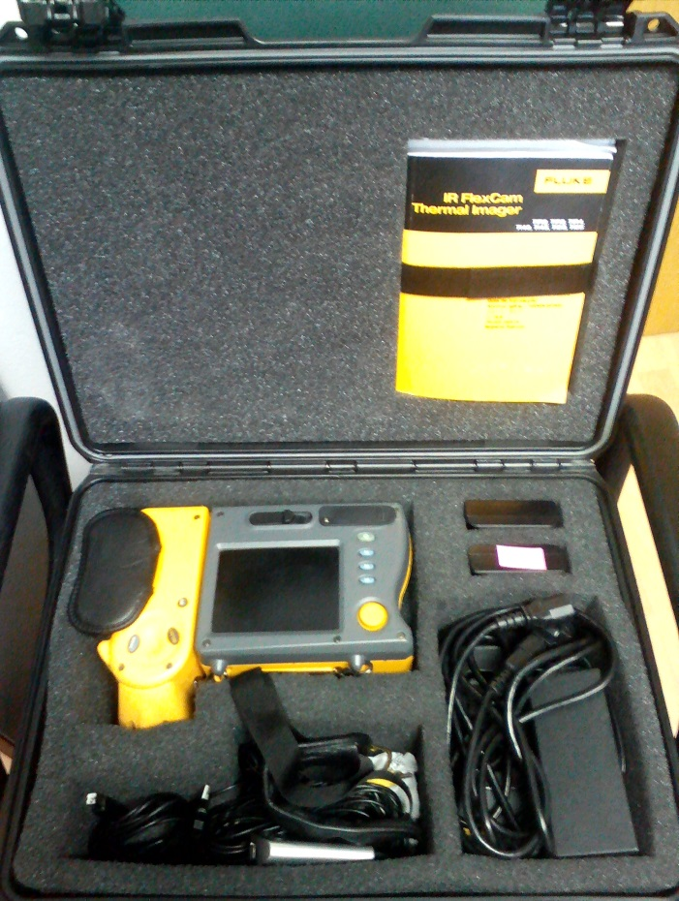

Figure 13: example of equipment (infrared camera) used for thermal inspection

* **Choose a survey of a thermographic inspection**

A thermographic inspection is either an interior or exterior survey. The energy auditor decides which method would give the best results under certain weather conditions:

* The interior thermographic inspection is used during windy weather, because it is hard to detect temperature differences on the outside surface of the building.
* The exterior thermographic inspection shows the weakness of entire building envelope; thermal bridges, irregularities in the installation of building elements and materials, irregularities at the installation of thermal insulation, leaks and damages of windows, humidity in building and other critical areas that are difficult to detect.
* **Choose a time of a thermographic inspection**

You have to prepare for a thermal scan to ensure accurate results:

* move furniture away from exterior walls and remove drapes,
* close all the windows and doors,
* perform a thermographic inspection in colder months, because the most accurate thermographic images usually occur when there is a large temperature difference between inside and outside air temperatures,
* minimum temperature difference is 10°C, the recommended temperature difference is 20°C,
* avoid performing a thermographic inspection in warmer months, because it can be misleading by the air conditioner on,
* preform the thermographic inspections in morning hours.
* **How and where to take pictures (thermograms) with a camera**
* Camera needs to be positioned on the surface or on a spot where heat loss would occur most likely, for more about thermal bridges and joinery, *see Section 5.1.1 Thermal bridges*.
* Camera needs to be hold still due to its sensitivity to movement.
* On thermograms, the temperature variations of the building's envelope or joinery ranges from white for warm regions to black for cooler areas.
* **For reviewing and editing thermograms download and install software**

Each camera has its own software program, where it is possible to view and edit content, taken by infrared camera.

* **Upload thermograms from an infrared camera to computer**

Pictures can be edited by focusing thermal scan on a specific point or region (wall, windows etc.), temperature scale can be added and adjusted and specific points can be highlighted for extra view on where heat loss is immense.

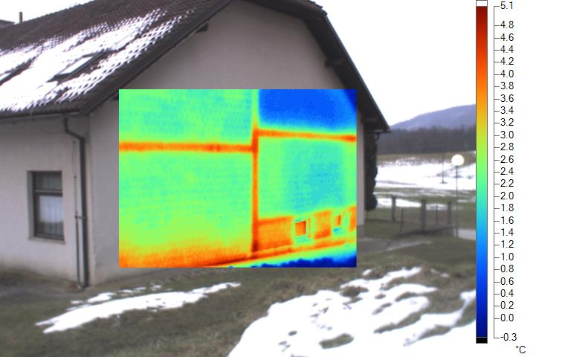

Figure 14: Example of thermogram

* 1. MICROCLIMATE PARAMETERS AND INDOOR AIR QUALITY

In general terms, microclimate is considered as the climate of a small, specific place within an area as contrasted with the climate of the entire area. Even outdoors, an area as small as a park can have several different microclimates depending on how much sunlight, shade, or exposure to the wind there is at a particular spot.

The indoor environment of a building is separated from the outside with construction elements, (preferably also a thermal envelope) which creates a specific indoor microclimate. Furthermore, each room in the building can have vastly different microclimatic parameters influenced by its cardinal direction (east, west, north, south), position (for e.g. attic vs. cellar, proximity to unheated rooms), presence or absence of windows (solar gains), usage profile (number of people using a particular room in a given time frame), energy consuming devices and elements of the heating system (that heat the indoor air through convection and radiation) and thermal bridges, only to name a few.

The demand for excellent indoor air quality is increasing due to raised awareness by the public that recognize the potential health risks and productivity impacts by indoor air pollutants. In addition, monitoring equipment such as data loggers or even open source air pollutant sensors have become low-cost/accessible to a large group of people.

There is also a growing tendency to increase energy conservation in buildings by reducing ventilation rates. For e.g., energy refurbishment of old buildings by adding additional thermal insulation decreases air permeability rates making the building more “air tight”, which in absence of a comprehensive adaptation of the ventilation systems can have a strong negative effect on indoor air quality. School facilities specifically are subjected to high risk, due to the learner density, that can easily surpass 2m2 or 6m3 of conditioned floor area/air volume per person, creating an uncomfortable and potentially dangerous environment for its users during normal classroom occupancy periods.

In simplified terms, humans can be considered as heat engines capable of producing work at low efficiency that produce heat and indoor air pollutants, effecting the microclimate parameters in their environment. In turn, humans perceive and react to their surroundings whereby the subjective sense is also known as thermal comfort.

Thermal comfort

Thermal comfort is most simplistically defined as satisfaction (satisfactory perception) of building users with the thermal environment and can be calculated as a heat transfer energy balance. For more, *see chapter 1.3 Energy efficiency basics.*

Temperature

The ideal temperature in buildings varies with respect to the purpose and general use of the living quarters in question. Ideally, the temperature is in the range from 20°C to 22°C, depending on the purpose of the room (for more, *see chapter 4.1.1 HVAC system – heating)* and other factors such as air flow and surface temperature of construction elements (floor, wall, ceiling, etc.) that make up the room (also heavily dependent on the state of thermal insulation). Radiant temperature is the weighted average temperature of all exposed surfaces in a room and is not measured separately.

Humidity

The amount of water vapor in the air at any given time is usually less than that required to saturate the air. A single person can contribute several liters of moisture into the indoor air every day, which must be ventilated out of the building in a controlled manner.

Relative humidity (rh) is the percent of saturation humidity, generally calculated in relation to saturated vapor density. The ideal level of rh at the mean temperature of 20°C is 60 %. This value may be used as the optimal benchmark.

Air velocity

Air velocity effects heat transfer between the body and the environment. The effects of air velocity on thermal comfort are heavily dependent on the nature of activity (sedentary, moderate-intensity, vigorous intensity) the building user is engaging in. It may be presumed that it should not breach in a significant way, the recommended values which range from 0,15 to 0,20 m/s (meters per second).

**Personal factors**

Clothing and metabolic heat of individuals play an important role in thermal comfort perception, however are often disregarded due to problems with conducting measurements and infringement of privacy and personal rights.

Air quality

Indoor air quality is essential to secure a healthy and comfortable environment to its users. It depends on many factors, including sources of pollution (indoor and outdoor) in the vicinity, profile of occupancy and the ventilation and air conditioning systems. The effects of low air quality can have substantial negative impacts, ranging from discomfort (can also be caused by other microclimate parameters) and impaired performance (drowsiness, inability to concentrate or perform mental or physical tasks) to acute effects (occur immediately after exposure - headaches, itchy eyes and runny noses) and chronic effects (long-lasting responses to long term or frequently repeated exposures – most commonly associated health consequence is manifested in the form of various cancers).

**Indoor air pollutants**

[Carbon dioxide](https://en.wikipedia.org/wiki/Carbon_dioxide) (CO2) is a gaseous pollutant that is sure to be found indoors and is caused by human metabolic activity at a rate that coincides with the intensity level of activity being carried out. Currently normal levels of CO2 outdoors are usually just above 400 ppm, yet indoor levels can easily surpass this value many times over. CO2 is not poisonous and presents a direct danger only in at a very high concentration (from 5 % onwards), depending on the time an individual is subjected to it. The normal international safety limit is 0.5 % or 5000 pm, however problems with concentration can be recorder already at a level of 1000 ppm. At 3 times the value of the normal international safety limit, breathing increases by 50% compared to the normal rate, leading to an increased heart rate and blood pressure. Most common indicators of high CO2 concentrations include drowsiness, possible headaches, impaired concentration and ability to perform tasks. CO2 is relatively easy to measure (low-cost sensors) an provides a good indicator of the suitability of the air ventilation rate in accordance to occupant density and their metabolic activity levels.

Radon

Radon is an odourless and colourless natural noble gas that forms in the decay chain of Uranium and is practically omni present in the earth’s crust. The concentration of Radon in a particular environment is dependant mainly on geological factors, soil texture, water content and the pressure difference between the gas in the soil and the surface. It`s heavier than air, therefore it tends to be trapped in lower floors of the building (like basements).

The Joint Research Centre of the European Commission indicates that recent studies have shown that radon in homes causes about 20.000 lung cancer deaths in the European Union each year. This is about 9% of the total lung cancer deaths in the EU and about 2% of cancer deaths overall. Indoor reference concentration levels are from 200 to 400 Bq/m3. Improving the ventilation of ground floors and basement and reducing the permeability of the foundations of the building can mitigate most of the potential issues with the gas.

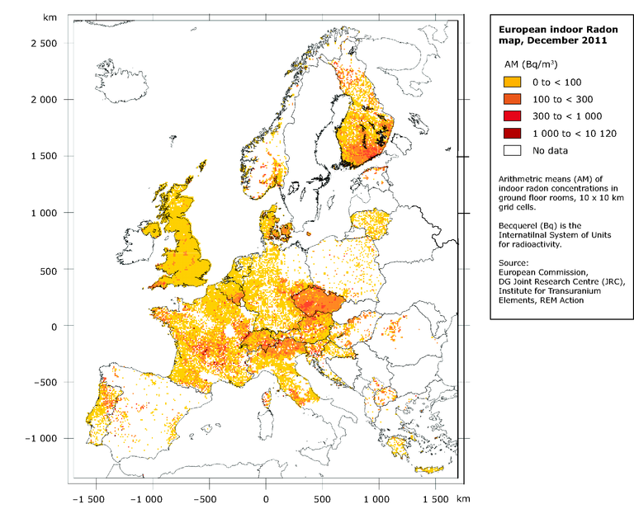

Figure 15: Indoor Radon map of Europe[[6]](#footnote-7)

Volatile organic compounds - VOC

VOCs are gases emitted from various products (solids and liquids) and include a wide range of chemicals, that may have either short and/or long-term health effects. They are basically carbon-based chemicals that easily evaporate at room temperature. Organic chemicals as such are broadly used in household care products. For example, buildings materials such as carpets, paints and adhesives, home and personal care products like cosmetic, cleaning products, degreasers, only to name a few, can release organic compound while being in use and to a certain degree, also when they are stored.

Health effects range from the acute like irritation of the eyes, nose and throat, headaches, nausea and dizziness to chronic with increased risk of cancer and damage of the livers, kidney and central nervous system. Some of the most common VOC pollutants include acetone (from paints, nail polish, cigarette smoke, household chemical products, etc.), benzene (from solvents, smoke, water and soil contamination, etc.) and formaldehyde (air fresheners, plug-in fragrances, essential oils, cleaning products, some pillows, clothes and upholstered furniture or curtains, etc.).

Other gaseous pollutants include:

* carbon monoxide (CO) – It is an odourless and colourless gas produced by the incomplete combustion of fossil fuels, wood and gas. It is very poisonous even at low concentrations. Acts by rendering a person gradually unconscious, from shortness of breath, to moderate headaches, fatigue, respiratory failure and finally death. Possible sources include gas water heaters, gasoline and diesel powered electric generators and any other form of internal combustion engines, propane and kerosene heaters and stoves, spray paint, solvents, degreasers, paint removers and even cigarette smoke.
* Sulphur dioxide (SO2) – Is colourless with very strong odour, it is also highly reactive. Main source include combustion (including transport exhaust), improperly vented gas, oil, wood and cool appliances (furnaces, heaters, stoves) as well as cigarette smoke. Presence is detected by a burning sensation in the nose and throat, which lead to impaired breathing that can be life threatening at high levels even in short term exposure.
* Nitrogen dioxide (NO2) – main sources are combustion appliances, motors, UV light sources, lung irritant.
* Hydrogen sulphide (H2S) – main source is organic waste, it is an irritant with strong odour.

TASK: Perform a microclimate inspection

* For definition, *see section 5.2 Microclimate parameters and indoor air quality*
* **Prepare equipment for measurement of microclimate parameters**

Microclimate measurements are conducted with an instrument with microclimatic probe. Usually, the instrument's purpose is to measure air velocity, relative humidity, luminous emittance and air temperature. Instruments can also calculate air flow and dew point.

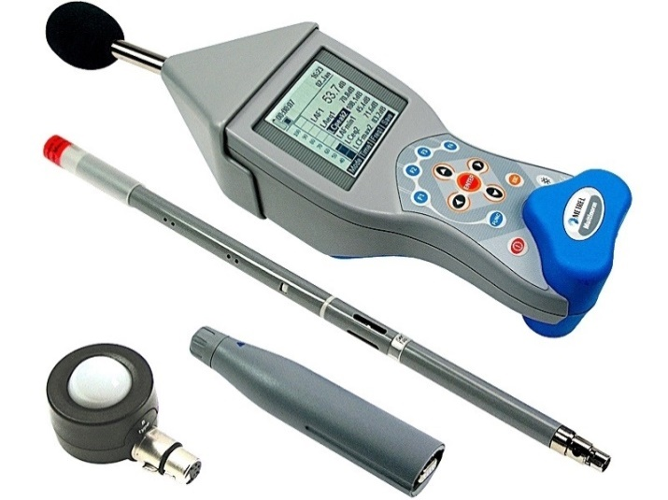

Figure 16: Example of an instrument, used for microclimate measurements

* **Place the instrument correctly**

The instrument should be placed correctly in the measured place so the data can be more accurate:

* Air temperature – assure that the sensor accepts temperature energy only from air. The instrument should be prevented being subjected to radiation from neighbouring heat sources. The exposition time of the instrument to the measured air depends from each instrument.
* Relative humidity – for accurate measurement, the exposition time in one measurement place should be long enough (depends on the instrument). Also, do not breath in the direction of the sensor.
* Air velocity – if the main airflow direction cannot be defined, take 3 measurements along 3 perpendicular axis (x,y,z).
* Dew point – because dew point is calculated from air temperature and relative humidity, longer exposition time of the instrument should be considered for more accurate measurements.
* Air flow – for more accurate results, do not open any windows or doors in the indoor space, where the measurement takes place. Also, do not walk or run near the sensor, so the measurement does not get distorted.
* Illuminance emittance – instrument should be oriented parallel to the surface which is evaluated. Do not cast any shadows on the sensor.
* **Start with the measurements**

It is recommended that the measurements are conducted in all spaces, which are used (for living, working, etc.). In schools, it is recommended that the measurements are conducted in all classrooms, locker rooms, offices and indoor recreational spaces. Each measurement number (or measurement point) contains the data about air temperature, relative humidity, air velocity, air flow, illuminance and dew point.

* **For reviewing and editing download and install software**

Each camera has its own software program, where it is possible to view and edit content, taken by the instrument.

* **Upload the results on computer**

Upload the content by connecting the instrument to a computer via USB port.

* **Edit content**

Usually, the results are in a table with all measured parameters:

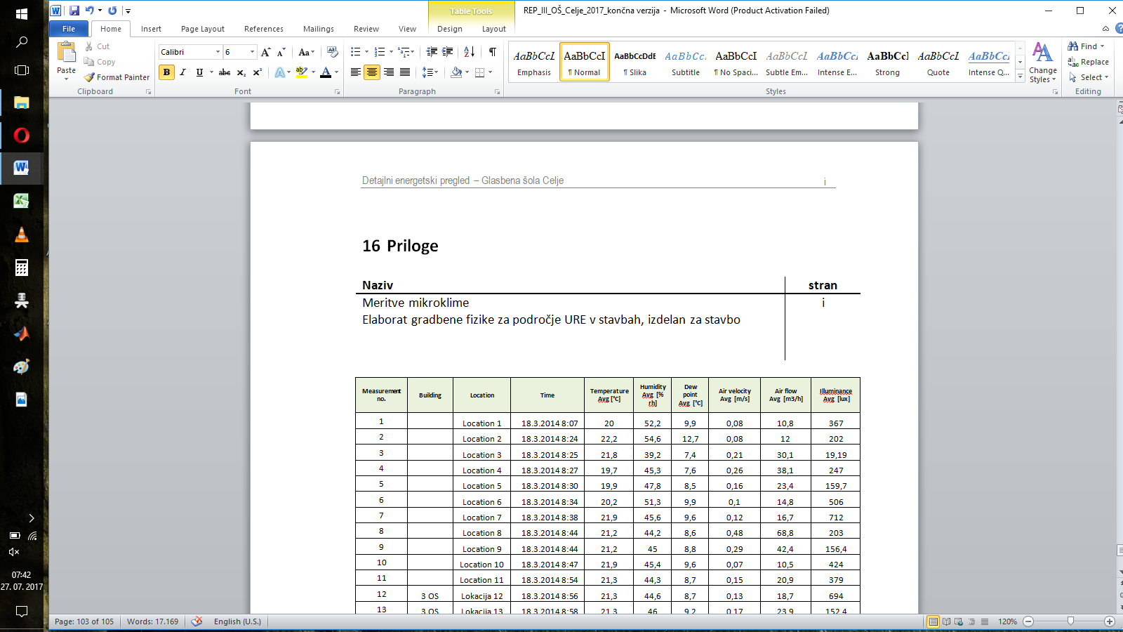

Table: Example of the results, measured by an instrument with a microclimate probe

The user can then edit the data, for example he can determine:

* lowest and highest measured temperature in the building,
* lowest and highest relative humidity in the building,
* lowest and highest air velocity in the building and
* lowest and highest air flow in the building.

|  |  |  |  |
| --- | --- | --- | --- |
| **Highest measured temperature (°C)** | **Lowest measured temperature (°C)** | **Highest measured humidity (% rh)** | **Lowest measured humidity (% rh)** |
| **23,5** | **16** | **60,1** | **38,3** |
| **Highest measured air velocity (m/s)** | **Lowest measured air velocity(m/s)** | **Highest measured air flow (m3/h)** | **Lowest measured air flow(m3/h)** |
| **0,48** | **0,06** | **68,8** | **9** |

Table: Example of the max. and min. parameters, measured indoor

The user can check the min. conditions of thermal comfort in areas being subject to heating (during winter). Each country has its own standards for min. conditions. Note that the conditions vary based on amount of physical activity, present in the area.

|  |  |  |  |  |  |  |
| --- | --- | --- | --- | --- | --- | --- |
| **Building type/space:** | **Space occupancy (person/m2)** | **Indoor air temperature (°C)** | **Relative humidity  (%)** | **Max. concentration CO2   (ppm)** | **Amount of fresh air, in case of mechanical ventilation**  **(m3/h m2)** | **Avg. illuminance (lux)** |
| Kindergarten – playroom – II. age bracket | 0,5 | 22 | 40 - 60 | 1667 | 10,1 | 300 |
| Kindergarten – playroom – I. age bracket | 0,5 | 24 | 40 - 60 | 1667 | 10,1 | 300 |
| Kindergarten – sports room | 0,5 | 20 | 40 - 60 | 1667 |  | 300 |
| Kindergarten – washroom |  | 22 | 40 - 60 | 1667 |  | 300 |
| School – classroom | 0,5 | 22 | 40 - 60 | 1667 | 8,6 | 300 |
| Gym, sports hall | 0,5 | 19 | 40 - 60 | 1667 |  | 300 |
| Locke rooms | 1 | 21 | 40 - 60 | 1667 |  | 300 |
| Bathrooms | 0,5 | 24 | 40 - 60 | 1667 |  | 200 |
| Toilets |  | 20 | 40 - 60 | 1667 |  | 200 |
| Offices, administration rooms | 0,1 | 22 | 40 - 60 | 1667 | 2,5 | 500 |
| Lobby, auditorium, hallways, dining rooms | 1 | 20 | 40 - 60 | 1667 |  | 200 |
| Pool area | 0,5 | 25 - 28 | 35 - 60 | 1667 |  | 300 |
| Ordinations | 0,1 | 24 | 40 - 60 | 1667 |  | 500 |

Figure: Example of min. conditions of thermal comfort, standardized in Slovenia

Here is an example of two charts, one presenting indoor air temperature and relative humidity, another presenting air velocity. The measurements were taken on in one of the schools in Slovenia.

The figure presents measurements of indoor air temperature and relative humidity. On the left side of the chart there is a temperature scale and on the right side the is a humidity scale. Measurement numbers are presented on a horizontal axis. The light blue area represents a zone where relative humidity is recommended from 40 to 60 % relative humidity (rh) and a black line is a recommended indoor air temperature, in Slovenia is 20°C. As seen from this example, results show that most spaces where measurements took place have a good % of relative humidity, while the air temperature is a little bit above recommended temperature in almost all of the measured points.

The figure below presents air velocity in measured places. Humans are very sensitive to differences in air velocity in rooms. Schools are a very good example of that. On the left side, is a air velocity scale. Measurements are presented on a horizontal axis. The light green area represents a recommended air velocity zone from 0,15 to 0,20 m/s, if assumed that the indoor air temperature is between 20 – 22 °C. The results show great fluctuation in air velocity because, the spaces are used for different purposes.

* 1. ENERGY MEASURES

After the energy experts perform the energy audit they will set a priority list of possible measures of EE and RES to improve energy situation in your building.

Identification of measures

During the energy audit, it is possible to set a list of energy savings and potential energy measures. The institutions itself can propose their own incentives based on available materials and publications.

While considering the possible measures it is necessary to present this ideas to the management of the institution, because in such interviews you find out that some ideas have already been attempted to be implemented but have failed or they have been considering them, but have been rejected because of inconsistencies due to various restrictions. It is also important to determine which energy saving measures have already been implemented, which projects are in progress and which they are still planning.

**Evaluation phase**

The main goal of evaluation phase is to evaluate the measures by:

* Technical point of view. Is the planned equipment properly dimensioned? Whether the planned equipment will be effective? Did you consider pollution? Are there any unwanted side effects?
* The adequacy of the measures in terms of environmental protection and if the measures are planned in the long-term and not only in the short term.

If you intend to implement more measures on one system, you must consider the interaction of measures to calculate the potential savings. For example: if you calculate to save 30 % at final consumer, 25 % on the system dilution and 25 % savings in boiler room it would be wrong to assume that total of savings is 80 %. If you consider the interaction of measures, it is correct to find that this savings is only 61 %. Consider also that savings on one system can affect on savings elsewhere.

The costs of measures must be assessed realistically. You can get the costs from suppliers or your own work experience.

It is important to assess benefits of measures. The benefits can be financial, improving environmental protection, noise reduction, increasing operational reliability and reduction of maintenance.

At the end, you must prioritize measures by payback period, financial savings and ease of implementation.

* + 1. ENERGY EFFICIENT MEASURES

1. **Organizational measures**

In first part are organizational measures which are low-cost and can be implemented without interruption of the building use and it can be achieved among pupils, teachers and school building manager, by raising awareness of energy efficiency.

* Awareness and education programs of energy efficiency
* Introduction of proper natural ventilation
* Implementing proper illumination
* Introduction of energy bookkeeping
* Monitoring of energy use and costs

1. **Measures with regular maintenance and low-cost investments**

In the second part are measures with regular maintenance and low-cost investments which can be implemented without major investment and without major interruption of the building use. They can be implemented only with a little assistance or advise of energy experts and with help of school building manager.

* Measures on the building envelope
* Maintenance of building furniture
* Improving the sealing of windows and doors
* When repairing windows install low emission glazing and refill gas
* Improving the airtightness of lightweight structures
* Thermal insulation of the attic
* Repair or installation of blinds
* Small measures on the heating system
* The installation of local heating system regulation
* Setting up an optimal lighting system
* Measures in the field of cooling and ventilation

1. **Investment measures**

In the third part are investment measures which are more expensive and technically complex measures which must be always planned and implement by professionals.

* Measures on the building envelope
* Replacement of building furniture
* Installation of low emission glazing with gas filling
* Installation of thermal insulation shutters
* Thermal insulation of the building envelope
* Installation of shades
* Measures on the heating system
* Installation of central heating system regulation
* Transition from central to zone control
* Local regulation of the heating system
* Measures on central heating system
* Replacement of boiler or burner
* Installation of calorimeters
* Measures in the field of electricity use
* Installation of energy-efficient lamps
  + 1. MEASURES OF RENEWABLE ENERGY SOURCES

**Installation of heat pumps:**

* air-source,
* ground-source and
* water-source.

Energy consumption is approximately[[7]](#footnote-8) 12kW/100m2

**Installation of collectors:**

* for heating sanitary water

**Installation of PV cells:**

* producing electricity

Energy consumption is approximately[[8]](#footnote-9) 160Wp (watt-peak) / m2

**Biomass boilers:**

* burning organic matter

Energy consumption is approximately[[9]](#footnote-10) 10kW/100m2

1. ENERGY PERFORMANCE CERTIFICATE - EPC

The Energy Performance Certificates (EPCs) are important instrument that contribute to enhance the energy performance of building. The EPC is required when a building or building unit is sold or rented because it serve as an informational tool for building owners and occupiers.

The EPC means a certificate, which indicates the energy performance of a building or building unit and includes energy performance of a building and reference values such as minimum energy performance requirements in order to make it possible for owners or tenants of the building or building unit to compare and assess its energy performance. EPC provides information about the actual impact of heating and cooling on the energy needs of the building, on its primary energy consumption and on its carbon dioxide emissions.

The energy performance certificate may include additional information such as the annual energy consumption for non-residential buildings and the percentage of energy from renewable sources in the total energy consumption. EPC shall include recommendations for the cost-optimal or cost-effective improvement of the energy performance of a building or building unit, unless there is no reasonable potential for such improvement compared to the energy performance requirements in force. The recommendations included in the energy performance certificate shall cover:

* measures carried out in connection with a major renovation of the building envelope or technical building system(s) and
* measures for individual building elements independent of a major renovation of the building envelope or technical building system(s).

The recommendations included in the energy performance certificate shall be technically feasible for the specific building and may provide an estimate for the range of payback periods or cost-benefits over its economic lifecycle. The validity of EPC shall not exceed 10 years. Each Member State has adopted its own outlook of the EPC (EPC outlook varies from country to country), scale and categories are also differently assessed in each Member State.

* 1. TYPES OF ENERGY PERFORMANCE CERTIFICATE
     1. cEPC – CALCULATED ENERGY PERFORMANCE CERTIFICATE

The calculated energy performance certificate may be issued for each building or building unit, while it is mandatory for residential, new buildings and buildings after complete reconstruction.

It is calculated based on standard terms and indicators in a building or a building unit:

* constant internal temperature of 20 degrees Celsius,
* annual (24 hours per day, each day of the year) heat required to heat the building per unit of conditioned floor area (kWh/m2a),
* annual energy input to the operation of the building per unit of conditioned floor area (kWh/m2a),
* ventilation, set with a fixed air change rate (0,5h-1),
* annual CO2 emissions from the operation of the building per unit of conditioned floor area (kg/m2a) and
* reference location of a building or a building unit.
  + 1. mEPC – MEASURED ENERGY PERFORMANCE CERTIFICATE

The measured energy performance certificate is reserved for existing non-residential buildings (schools, kindergartens, public sector buildings), as the sale of such property does not substantially alter the way a building is used. Its manufacture requires less work. Measured energy performance indicators are:

* annual energy input, intended for conversion into heat per unit of conditioned floor area(kWh/m2a),
* annual electricity consumption due to the operation of the building per unit of conditioned floor area (kWh/m2a) and
* annual CO2 emissions from the operation of buildings per unit of conditioned floor area (kg/m2a).

In buildings with several units, the energy performance certificate may be issued for the entire building. Instead of submitting a certificate for each part of the building a certificate for the entire building can be submitted. With measured energy performance certificate, indicators can be compared based on same usage of buildings

* 1. **ENERGY** PERFORMANCE INDICATORS

Energy performance indicators for energy performance certificate are:

* annual energy input, intended for conversion into heat per unit of conditioned floor area (kWh/m2a),
* annual electricity consumption due to the operation of the building per unit of conditioned floor area (kWh/m2a) and
* annual CO2 emissions from the operation of buildings per unit of conditioned floor area (kg/m2a).
  + 1. ****Energy performance indicators for measured energy performance certificate are:****

Annual energy input, intended for conversion into heat per unit of conditioned floor area $\frac{Q}{A_{u}}=$ $\left[\frac{kWh}{m^{2}}\right]$

|  |  |  |
| --- | --- | --- |
| Q | $$\left[\frac{kWh}{a}\right]$$ | annual energy input, intended for conversion into heat |
| Au |  | conditioned floor area of ​​the building |

Annual electricity consumption due to the operation of the building per unit of conditioned floor area $\frac{Q_{el}}{A_{u}}=$ $\left[\frac{kWh}{m^{2}a}\right]$

|  |  |  |
| --- | --- | --- |
| Qel |  | annual electricity consumption due to the operation of the building |
| Au |  | conditioned floor area of ​​the building |

Annual CO2 emissions from the operation of buildings per unit of conditioned floor area $\frac{m_{CO2}}{A_{u}}=$ $\left[\frac{kg CO2}{m^{2}a}\right]$

|  |  |  |
| --- | --- | --- |
| mCO2 |  | annual CO2 emissions from the operation of buildings |
| Au |  | conditioned floor area of ​​the building |
|  | | |

* 1. CATEGORIES OF ENERGY PERFORMANCE INDICATORS

Categories are classified differently by each Member State, yet the principle remains the same in all EU countries. On the front side, there are categories of buildings based on annual heat required to heat the building per unit of conditioned floor area, from smallest to largest. Categories are graphically shown with a diagram, where green colour represents categories of buildings with low consumption of heat and red colour represents categories of buildings with higher consumption of heat used for heating a building.

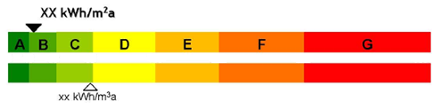

Figure 17: Example of a diagram showing classified categories

Based on annual heat required to heat the building per unit of conditioned floor area, we classify buildings into categorical table of energy efficiency that also differentiates in values from each to each Member State.

* + 1. ENERGY INPUT FOR THE OPERATION OF A BUILDING

Annual energy input to the operation of the building per unit of conditioned floor area is on the front side of EPC. It is graphically shown with a diagram, where green colour represents low energy input for the operation of a building and red colour represents higher energy consumption and higher input for the operation of a building.

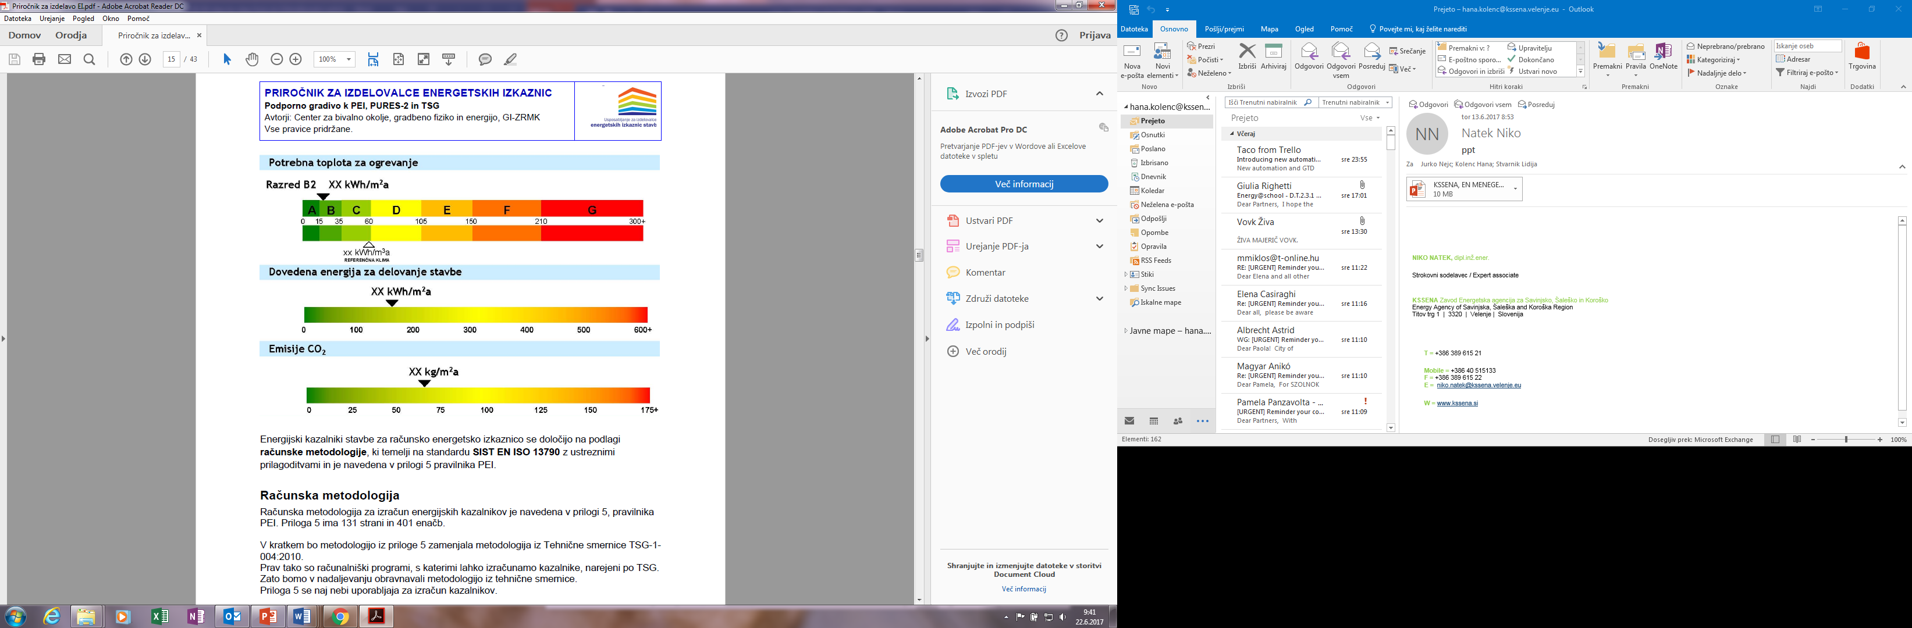

Figure 18: Example of a diagram showing annual energy input to the operation of the building

* + 1. CALCULATION OF EMISSIONS CO2

We can calculate annual CO2 emissions from annual energy input, intended for conversion into heat or annual electricity consumption, caused by energy consumption of a building.

Annual fuel consumption per surface x fuel emission factor = annual fuel emission $\left[\frac{kg CO2}{m^{2}a}\right]$

Annual CO2 are shown on a diagram. Green colour represents low CO2 emissions and red colour represents higher CO2 emissions.



Figure 19: Example of a diagram showing annual CO2 emissions

TASK: Make a detailed review of the building and its operating system

*This template was developed within the project EmBuild, Horizon 2020.*

As it was stated above in chapter enertgy audit: “An energy audit consists a detailed examination of how building uses energy, how high are the costs for used energy and recommended EE and RES measures for improving energy efficiency.”

The audit process starts by collecting information about a building’s operation and about its past record of energy costs. This data is then analysed to get a picture of how the facility uses – and possibly wastes – energy, as well as to help the auditor learn what areas to examine to reduce energy costs.

|  |  |  |  |
| --- | --- | --- | --- |
| **Building:** | | | |
| year of construction: | *building / technical infrastructure* | | |
| building type: | *e.g. administration building, school* | | |
| energy carrier for heat: | *oil / natural gas / electric energy …* | | |
| type of heat supply: | single stoves  constant temp. boiler | low temp. boiler | condensing boiler  heat pump  CHP  district heating |
| age: | > 20 years | 10 – 20 years | < 10 years |
| heating system: | *radiators, floor heating, ventilation with heating etc.* | | |
| heating circuit pumps: | unregulated  multi-level | with electronic control | high-efficient pumps |
| insulation of heating pipes : | none  with voids | sufficient | good |
| control and regulation system: | faulty broken  hard to operate | ok, but no documentation (available) | central control  single room control  building control system |
| heating times adapted to building use | no | unknown | yes |
| heating curve adapted to the standard of the building: | no | unknown | yes |
| hydraulic balanced system: | no | unknown | yes |
| ventilation: | *with windows, mechanical etc.* | | |

|  |  |  |  |
| --- | --- | --- | --- |
| Mechanical ventilation: | □ no heat recovery  □ no maintenance  □ no automatic control | □ heat recovery  < 60% efficiency  □ cleaning or changing filters  □ simple automatic control | □ heat recovery  > 60% efficiency  □ periodical professional maintenance  □ automatic frequency control |
| Cooling | □ SEER<2.5  □ automatic controled  by temperature | □ 2.5<SEER<3.5  □ automatic control by temperature and occupancy schedule | □ SEER>3.5  □ automatic control by temperature – limited range, occupancy schedule and open windows |
| domestic hot water: | none  decentral  central  circulation | | |

|  |  |  |  |  |
| --- | --- | --- | --- | --- |
| exterior walls: | *type of construction, masonry, concrete, wood…* | | | |
|  | without insulation | | with insulation | |
| windows: | single glazing | twin pane  glazing | heat protection  glas | triple glazing |
| top floor ceiling / roof: | without insulation | | with insulation | |
| cellar ceiling: | without insulation | | with insulation | |
| lighting system: | filament lamps | energy saving lamps | fluorescent lamps  LED | |
| responsible person: | no | yes | expert, energy manager | |
| energy monitoring: | no | yes | monthly | |
| energy passport issued: | no |  | yes | |
| potential for low- and no-cost measures: | high potential | fair | low potential | |

**Noticable Problems / reccommendation:**

**Recommendation for long-term renovation steps:**

|  |  |  |  |  |
| --- | --- | --- | --- | --- |
| **component** | **description** | **time** | **costs** | **savings** |
| Cellar ceiling |  |  |  |  |
| Exterior walls |  |  |  |  |
| Windows |  |  |  |  |
| Roof  Top floor ceiling |  |  |  |  |
| heat generation (Boiler etc.) |  |  |  |  |
| heat distribution  (pumps etc.) |  |  |  |  |
| ventilation |  |  |  |  |

TASK: Calculation of consumption and energy costs

Based on gather information of energy consumption in your school you can make a simple calculation of energy certificate indicators.

For calculation of how much annual energy input per unit of conditioned floor area, your building needs for its operation, follow the steps below:

It is important to have an exact information about total energy consumption and consumption by energy carrier.

You can collect this information in three different ways:

* Invoices for heating, electricity and water; for more understanding, regarding invoices, *see TASK: Correct reading of building energy invoice.*
* Installed energy meters
* Energy bookkeeping which ensure that the necessary data from invoices is stored and managed properly.

Collect this data in the proposed tables by energy carrier and water, showing consumption and costs per month for three years. It is recommended to collect the data for a period of 12 to 36 months, to get more precise information. Here are the examples of such tables for water consumption (per month for three years).

|  |  |  |  |  |  |  |  |  |  |  |  |  |  |  |  |  |  |  |  |  |  |  |  |  |  |  |  |  |  |  |  |  |  |  |  |  |  |  |  |  |  |  |  |  |  |  |  |  |  |  |  |  |  |  |  |  |  |  |  |  |  |  |  |  |  |  |  |  |  |  |  |  |  |  |  |  |  |  |  |  |  |  |  |  |  |  |  |  |  |  |  |  |  |  |  |  |  |  |  |  |  |  |  |  |  |  |  |  |  |  |  |  |  |  |  |  |  |  |  |  |  |  |  |  |  |  |  |  |
| --- | --- | --- | --- | --- | --- | --- | --- | --- | --- | --- | --- | --- | --- | --- | --- | --- | --- | --- | --- | --- | --- | --- | --- | --- | --- | --- | --- | --- | --- | --- | --- | --- | --- | --- | --- | --- | --- | --- | --- | --- | --- | --- | --- | --- | --- | --- | --- | --- | --- | --- | --- | --- | --- | --- | --- | --- | --- | --- | --- | --- | --- | --- | --- | --- | --- | --- | --- | --- | --- | --- | --- | --- | --- | --- | --- | --- | --- | --- | --- | --- | --- | --- | --- | --- | --- | --- | --- | --- | --- | --- | --- | --- | --- | --- | --- | --- | --- | --- | --- | --- | --- | --- | --- | --- | --- | --- | --- | --- | --- | --- | --- | --- | --- | --- | --- | --- | --- | --- | --- | --- | --- | --- | --- | --- | --- | --- | --- | --- |
| |  |  |  | | --- | --- | --- | | **2014** | **Water (m3)** | **Cost (€)** | | January | 170 | 1.208 | | February | 112 | 1.136 | | March | 188 | 1.231 | | April | 201 | 1.247 | | May | 158 | 1.193 | | June | 163 | 1.199 | | July | 34 | 1.038 | | August | 27 | 1.030 | | September | 183 | 1.224 | | October | 195 | 1.212 | | November | 161 | 1.224 | | December | 180 | 1.221 | | **Total** | **1.772** | **14.164** | | |  |  |  | | --- | --- | --- | | **2015** | **Water (m3)** | **Cost (€)** | | January | 167 | 1.204 | | February | 129 | 1.160 | | March | 208 | 1.258 | | April | 165 | 1.205 | | May | 166 | 1.206 | | June | 163 | 1.202 | | July | 30 | 1.036 | | August | 35 | 1.169 | | September | 206 | 1.388 | | October | 165 | 1.336 | | November | 187 | 1.364 | | December | 167 | 1.338 | | **Total** | **1.788** | **14.868** | | |  |  |  | | --- | --- | --- | | **2016** | **Water (m3)** | **Cost (€)** | | January | 160 | 1.328 | | February | 136 | 1.297 | | March | 193 | 1.370 | | April | 169 | 1.339 | | May | 170 | 1.340 | | June | 181 | 1.355 | | July | 26 | 1.196 | | August | 47 | 1.224 | | September | 183 | 1.402 | | October | 179 | 1.397 | | November | 183 | 1.402 | | December | 165 | 1.379 | | **Total** | **1.792** | **16.029** | |

|  |  |  |
| --- | --- | --- |
|  | Consumption (m3) | **Cost (€)** |
| 2014 | 1.772 | 14.164 |
| 2015 | 1.788 | 14.868 |
| 2016 | 1.792 | 16.029 |
| Average | 1.784 | 15.020 |

After collecting data about water consumption, it is important to show the monthly trend in graphic form, like in the graph below:

Example of monthly water consumption for year 2014

This allows us to notice the changes in consumption during the year and possible consumption trends. Seasonal or cyclical patterns of consumption indicate the probability of major seasonal loads. General rising or decreasing trends may indicate changes in productivity or performance. Major deviations from the trend may indicate failures in the system, such as water leaks.

**From the collected data about energy consumption you can calculate several important parameters. Here is the example of calculation of energy consumption and energy costs for heat and power:**

* **Basic data**

For example take a primary school with 463 pupils and employees. The conditioned floor area is 5082,43m2. The energy carrier for heating is natural gas.

* **Determine the following parameters**
* Average consumption (kwh) and consumption (kWh/person)
* Average costs (€/year), costs (€/person) and costs (€/m2)
* Annual CO2 emissions (kgCO2/ m2a)
* EUI-energy number (kWh/m2a)
* **Collect data of natural gas consumption for three years**

|  |  |  |  |  |  |  |  |  |  |  |  |  |  |  |  |  |  |  |  |  |  |  |  |  |  |  |  |  |  |  |  |  |  |  |  |  |  |  |  |  |  |  |  |  |  |  |  |  |  |  |  |  |  |  |  |  |  |  |  |  |  |  |  |  |  |  |  |  |  |  |  |  |  |  |  |  |  |  |  |  |  |  |  |  |  |  |
| --- | --- | --- | --- | --- | --- | --- | --- | --- | --- | --- | --- | --- | --- | --- | --- | --- | --- | --- | --- | --- | --- | --- | --- | --- | --- | --- | --- | --- | --- | --- | --- | --- | --- | --- | --- | --- | --- | --- | --- | --- | --- | --- | --- | --- | --- | --- | --- | --- | --- | --- | --- | --- | --- | --- | --- | --- | --- | --- | --- | --- | --- | --- | --- | --- | --- | --- | --- | --- | --- | --- | --- | --- | --- | --- | --- | --- | --- | --- | --- | --- | --- | --- | --- | --- | --- | --- |
| |  |  | | --- | --- | | **2014** | **Natural gas consumption (m3)** | | January | 7.135 | | February | 6.543 | | March | 3.859 | | April | 1.402 | | May | 106 | | June | 0 | | July | 0 | | August | 5 | | September | 0 | | October | 214 | | November | 5.279 | | December | 8.999 | | **Total** | **33.542** | | |  |  | | --- | --- | | **2015** | **Natural gas consumption (m3)** | | January | 10.413 | | February | 9.344 | | March | 6.603 | | April | 2.984 | | May | 0 | | June | 0 | | July | 0 | | August | 6 | | September | 0 | | October | 3.146 | | November | 7.092 | | December | 10.214 | | **Total** | **49.802** | | |  |  | | --- | --- | | **2016** | **Natural gas consumption (m3)** | | January | 10.915 | | February | 7.126 | | March | 5.978 | | April | 1.735 | | May | 794 | | June | 0 | | July | 0 | | August | 0 | | September | 12 | | October | 3.968 | | November | 6.321 | | December | 11.299 | | **Total** | **48.148** | |

* **Collect data consumption of electricity for three years**

|  |  |  |  |  |  |  |  |  |  |  |  |  |  |  |  |  |  |  |  |  |  |  |  |  |  |  |  |  |  |  |  |  |  |  |  |  |  |  |  |  |  |  |  |  |  |  |  |  |  |  |  |  |  |  |  |  |  |  |  |  |  |  |  |  |  |  |  |  |  |  |  |  |  |  |  |  |  |  |  |  |  |  |  |  |  |  |
| --- | --- | --- | --- | --- | --- | --- | --- | --- | --- | --- | --- | --- | --- | --- | --- | --- | --- | --- | --- | --- | --- | --- | --- | --- | --- | --- | --- | --- | --- | --- | --- | --- | --- | --- | --- | --- | --- | --- | --- | --- | --- | --- | --- | --- | --- | --- | --- | --- | --- | --- | --- | --- | --- | --- | --- | --- | --- | --- | --- | --- | --- | --- | --- | --- | --- | --- | --- | --- | --- | --- | --- | --- | --- | --- | --- | --- | --- | --- | --- | --- | --- | --- | --- | --- | --- | --- |
| |  |  | | --- | --- | | **2014** | **Consumption (kWh)** | | January | 13.440 | | February | 10.259 | | March | 10.567 | | April | 10.730 | | May | 9.278 | | June | 7.693 | | July | 3.395 | | August | 3.384 | | September | 10.489 | | October | 10.067 | | November | 12.200 | | December | 12.691 | | **Total** | **114.193** | | |  |  | | --- | --- | | **2015** | **Consumption (kWh)** | | January | 13.188 | | February | 10.452 | | March | 12.137 | | April | 8.811 | | May | 8.861 | | June | 7.188 | | July | 2.860 | | August | 3.527 | | September | 9.254 | | October | 10.235 | | November | 11.358 | | December | 11.395 | | **Total** | **109.266** | | |  |  | | --- | --- | | **2016** | **Consumption (kWh)** | | January | 12.144 | | February | 10.518 | | March | 12.000 | | April | 8.913 | | May | 9.554 | | June | 7.980 | | July | 2.702 | | August | 3.629 | | September | 9.068 | | October | 11.097 | | November | 11.320 | | December | 11.982 | | **Total** | **110.907** | |

* **Average consumption (kwh)**

**Heating energy**

For further processing you have to convert the consumption of energy carrier in basic unit to kWh by multiplying the consumption value to heating value of energy carrier.

Heating value, *see chapter 1.1. Energy efficiency basic*

|  |
| --- |
| Hi=9,44 kWh/m3 |

|  |  |  |
| --- | --- | --- |
|  | Consumption (m3) | Consumption (kWh) |
| 2014 | 33.542 | 316.636 |
| 2015 | 49.802 | 470.131 |
| 2016 | 48.148 | 454.517 |
| Average | 43.831 | 413.761 |

**Electricity**

|  |  |
| --- | --- |
|  | Consumption (kWh) |
| 2014 | 114.193 |
| 2015 | 109.266 |
| 2016 | 110.907 |
| Average | 111.455 |

* **Average costs (€/year), costs (€/person) and costs (€/m2)**

**Heating energy**

The price of natural gas is constantly changing. In presented example, there were average prices per year taken (in 2014 it was 0,0671 €/kWh, in 2015 it was 0,0682 €/kWh and in 2016 it was 0,0626 €/kWh).

|  |  |  |  |  |  |  |
| --- | --- | --- | --- | --- | --- | --- |
|  | Consumption (kWh/year) | Consumption (kWh/person) | Costs  (€/kWh) | Costs  (€/year) | **Costs (€/person)** | **Costs (€/m2)** |
| 2014 | 316.636 | 683,9 | 0,0671 | 21.246 | 45,9 | 4,2 |
| 2015 | 470.131 | 1015,4 | 0,0682 | 32.063 | 69,3 | 6,3 |
| 2016 | 454.517 | 981,7 | 0,0626 | 28.453 | 61,5 | 5,6 |
| Average |  | 892,7 |  | 27.254 | 58,9 | 5,3 |

**Electricity**

The price of electricity is constantly changing. For the example take the average prices in 2014 it was 0,1647 €/kWh, in 2015 it was 0,1710 €/kWh and in 2016 it was 0,1575 €/kWh.

|  |  |  |  |  |  |  |
| --- | --- | --- | --- | --- | --- | --- |
|  | Consumption (kWh/year) | Consumption (kWh/person) | Costs  (€/kWh) | Costs  (€/year) | **Costs (€/person)** | **Costs (€/m2)** |
| 2014 | 114.193 | 264,6 | 0,1647 | 18.803 | 40,97 | 3,7 |
| 2015 | 109.266 | 236 | 0,1710 | 18.698 | 39,68 | 3,68 |
| 2016 | 110.907 | 239,5 | 0,1575 | 17.465 | 37,97 | 3,44 |
| Total |  | 246,7 |  | 18.322 | 39,54 | 3,6 |

* **Annual CO2 emissions (kgCO2/year)**

**Heating energy**

For the calculation of annual CO2 emissions, you have to multiply average consumption of energy carrier per area by energy carrier emission factor.

For energy carrier emission factor, *see chapter 1.1. Energy efficiency basic*

|  |
| --- |
| Heating oil=0,202 $\frac{{tCO}_{2}}{MWh}$ = 0,202 $\frac{{kgCO}_{2}}{kWh}$ |

Annual CO2 emission=

Annual CO2 emission per area= $\frac{83.579 {kgCO}_{2}}{5082,43m^{2}}=16,44\left[\frac{{kgCO}_{2}}{m^{2}a}\right]$

**Electricity**

There are different emission factors for each country participating in project. In presented example, is the emission factor for electricity 0,582 tCO2/MWh

|  |
| --- |
| Emission factor for electricity= 0,582 $\frac{{tCO}_{2}}{MWh}$ = 0,582 $\frac{{kgCO}_{2}}{kWh}$ |

Annual CO2 emission=

Annual CO2 emission per area= $\frac{64.867 {kgCO}_{2}}{5082,43m^{2}}=12,76\left[\frac{{kgCO}_{2}}{m^{2}a}\right]$

|  |  |  |  |
| --- | --- | --- | --- |
|  | Consumption (kWh/year) | CO2 (kg) | CO2 (kg/m2) |
| Heating energy | 413.761 | 83.579 | 16,44 |
| Electricity | 111.455 | 64.867 | 12,76 |
| Water | / | / | / |
| Total |  | 148.446 | 29,2 |

* **Energy use intensity (EUI)**

Energy use intensity indicator provides the means to equalize the way that energy use is compared between various types of building and evaluate the means of reducing overall energy consumption. For the calculation of energy number, you need an annual average final energy consumption of heat and power for three years and conditioned floor area of building.

$$Energy number EUI=\frac{Consumption (kWh)}{A}$$

**Heating energy**

$${EUI}_{h}=\frac{413.761kWh}{5082,43}=81,41\frac{kWh}{m^{2}a}$$

**Electricity**

$${EUI}_{e}=\frac{111.455 kWh}{5082,43}=21,93\frac{kWh}{m^{2}a}$$

**Total EUI**

$$EUI= {EUI}_{h}+{EUI}_{e}$$

$$EUI= 81,41\frac{kWh}{m^{2}a}+21,93\frac{kWh}{m^{2}a}$$

$$EUI= 103,34 \frac{kWh}{m^{2}a}$$

|  |  |  |
| --- | --- | --- |
|  | Consumption (kWh/year) | Energy number ($\frac{kWh}{m^{2}a}$) |
| Heating energy | 413.761 | 81,41 |
| Electricity | 111.455 | 21,93 |
| Total |  | 103,34 |

* **Represent the final results in table**

Average annual consumption and costs for 2014, 2015 and 2016

|  |  |  |  |  |  |  |
| --- | --- | --- | --- | --- | --- | --- |
|  | Consumption | Consumption (Mwh) | Consumption  (unit/person) | Costs (€) | Costs (€/person) | Cost (€/m2) |
| Heating energy | 48.148 m3 | 413,7 | 982,7 kWh/person | 27.246 | 58,9 | 5,3 |
| Electricity | 111.455 kWh | 111,5 | 146,7 kWh/person | 18.322 | 39,54 | 3,6 |
| Water | 1.784 m3 | / | 3.85 m3/person | 15.020 | 32,4 | 2,96 |
| **Total** |  | **525,2** |  | **60.588** | **130,84** | **11,86** |

Average consumption and costs for 2014, 2015 and 2016

|  |  |  |  |
| --- | --- | --- | --- |
|  | Emission (kgCO2) | Emission (kgCO2/ m2) | Energy number (kWh/m2a) |
| Heating energy | 83.579 | 16,44 | 81,41 |
| Electricity | 64.867 | 12,76 | 21,93 |
| Water | / | / | / |
| **Total** | **148.446** | **29,2** | **103,34** |

Annual energy input to the operation of the building per unit of conditioned floor area is graphically shown with a diagram, where green colour represents low energy input for the operation of a building and red colour represents higher energy consumption and higher input for the operation of a building.

Energy use intensity



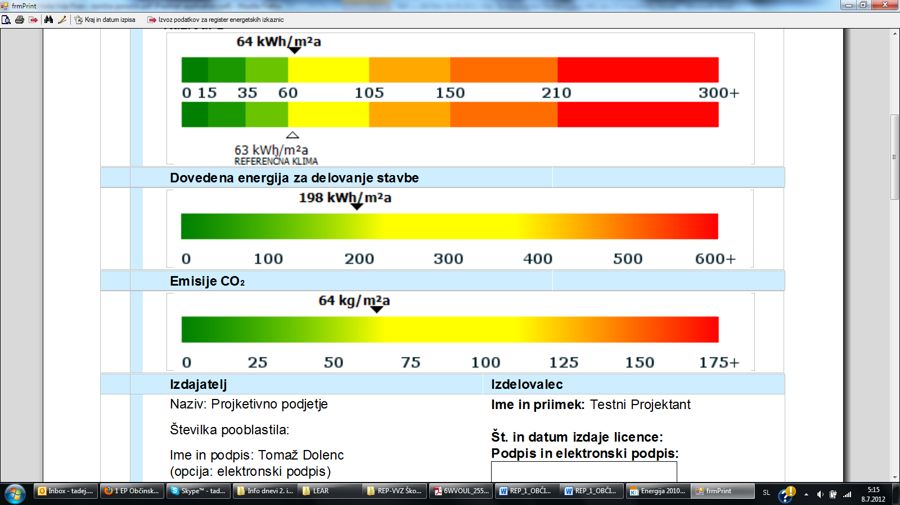

The annual CO2 emissions are calculated from annual energy input, intended for conversion into heat or annual electricity consumption, caused by energy consumption of a building.

Annual CO2 are shown on a diagram. Green colour represents low CO2 emissions and red colour represents higher CO2 emissions.

Annual CO2 emission



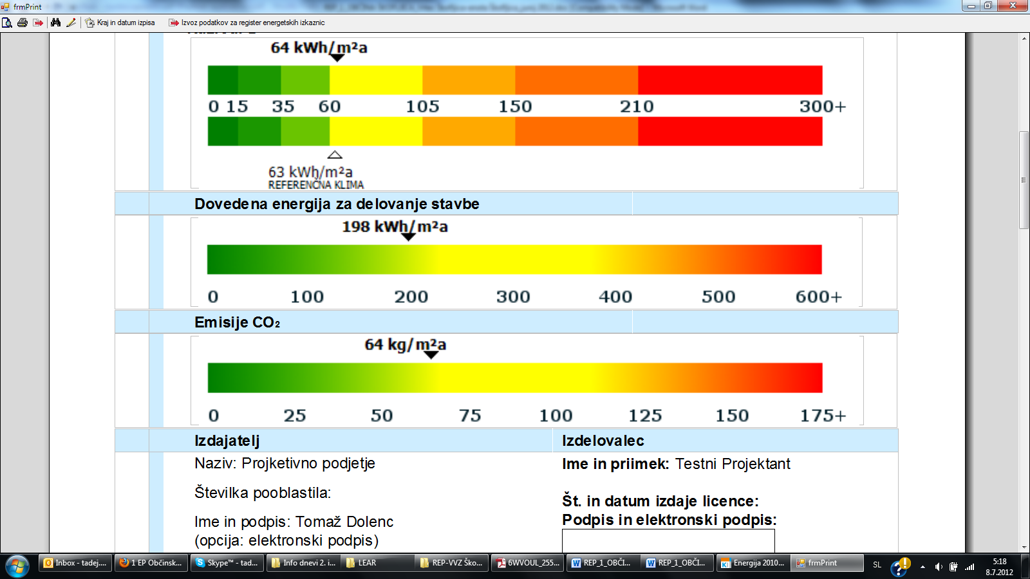

**Abbreviations**

|  |  |
| --- | --- |
| AC | Alternating current |
| CEGE | Continuing energy guardian training program |
| cEPC | Calculated energy performance certificate |
| E@S | Energy@School |
| EE | Energy efficiency |
| EG | Energy guardian |
| EGSMP | Energy guardian smart school management plan |
| EIA | Energy information administration |
| EMP | Energy management plan |
| EPC | Energy performance certificate |
| EU | The European Union |
| EUI | Energy use intensity |
| HVAC | Heating, ventilation and air conditioning |
| IPCC | Intergovernmental panel on climate change |
| LED | light-emitting diode |
| mEPC | Measured energy performance certificate |
| MPAN | Meter point administration number |
| NRT | Near-real time |
| PV | Solar photovoltaic |
| RES | Renewable energy sources |
| SEG | Senior energy guardian |
| TSO | Transmission system operator |
| VAT | [Value-added tax](https://en.wikipedia.org/wiki/Value-added_tax) |
| VEGTP | Vocational energy guardian training program |
| VOC | Volatile organic compounds |

**Definitions**

V(Volt)

… difference of potential that would carry one ampere of current against one-ohm resistance:

U (Voltage) = R (Resistance) · I (Current) [V = Ω · A]

A(Ampere)

... current of one ampere is one coulomb of charge going past a given point per second:

I (Current) = Q (Charge) / t (Time) = U (Voltage) / R (Resistance) [A = C/sec = V/Ω]

Ω(Ohm)

… an electrical resistance between two points of a conductor when a constant potential difference of one volt, applied to these points, produces in the conductor a current of one ampere, the conductor not being the seat of any electromotive force:

R (Resistance) = U (Voltage) / I (Current) = 1 / G (Conductance) = P (Power) / I2 (Current2)

[Ω = V/A = 1/S = W/A2]

W(Watt)

… when an object's velocity is held constant at one meter per second against constant opposing force of one newton the rate at which work is done is 1 watt. In terms of electromagnetism, one watt is the rate at which work is done when one ampere of current flows through an electrical potential difference of one volt:

P (Power) = E (Energy) / t (Time) = F (Force) · d (distance) / t (Time) = U (Voltage) · I (Current) [W = J/s = N · m/s = V · A]

J(Joule)

… energy transferred to (or work done on) an object when a force of one newton acts on that object in the direction of its motion through a distance of one metre or the work required to move an [electric charge](https://en.wikipedia.org/wiki/Electric_charge) of one [coulomb](https://en.wikipedia.org/wiki/Coulomb) through an [electrical potential difference](https://en.wikipedia.org/wiki/Voltage) of one [volt](https://en.wikipedia.org/wiki/Volt):

E (Energy) = F (Force) · d (Distance) = Q (Charge) · U (Voltage) = P (Power) · t (Time)

[$\frac{kg·m^{2}}{s^{2}}=N·m=C·V=W·s]$

lx(Lux)

... illuminance is a measure of how much luminous flux is spread over a given area:

Lux (Illuminance) = Lum (Luminous flux) / A (Area) = Iv (Luminous intensity) · Sr (Steridian) / A (Area) [lx = lm/m2 = 1 cd·sr/m2]

U-value – thermal transmittance

... is the rate of transfer of heat in [watts](https://en.wikipedia.org/wiki/Watt) through one square metre of a structure, divided by the difference in temperature across the structure:

U-value (Thermal transmittance) = Qa (Heat flow) / ΔT (Temperature difference)

[U-value = W/m²K]

Hi – heating value

... is the amount of heat produced by combustion a unit quantity of a fuel:

Hi (heating value) = E (Energy) / m (Mass) [kWh/kg = $kW·s$/kg = W $·s$/g]

ρ - density

... of a substance is its mass per unit volume:

ρ (density) = m (Mass) / V (Volume) [ρ = kg/m3 = g/mm3]

v - velocity

 ... is the rate of change of position with respect to time:

v (Velocity) = d (Distance) / t (Time) [v = m/sec = km/h]

Kh value

... is the measurement based on watt-hours per revolution (rotation):

Kh value = E (Meter voltage) · I (Current)·N (Number of stators)/ RPM (revolutions per minute) · 60

[Kh = Wh/revolution = meter V·A·n/revolution]

1. Source: (http://ecen.com/eee18/enerq\_e.htm) [↑](#footnote-ref-2)
2. Source: (https://www.dpandl.com) [↑](#footnote-ref-3)
3. http://www.slideserve.com/lawrencia/izobra-evanje-svetovalcev-za-energetsko-izrabo-lesne-biomase [↑](#footnote-ref-4)
4. Source: (http://re.jrc.ec.europa.eu/pvgis/index.htm) [↑](#footnote-ref-5)
5. Source: (https://science.nasa.gov/science-news/science-at-nasa/2002/solarcells) [↑](#footnote-ref-6)
6. https://www.eea.europa.eu/data-and-maps/figures/european-indoor-radon-map-december-2011 [↑](#footnote-ref-7)
7. Source: (http://www.climatecontrol.co.nz/residential/how-to-choose-a-heat-pump) [↑](#footnote-ref-8)
8. Source: (https://www.quora.com/How-much-electricity-do-we-get-from-a-unit-area-of-a-solar-panel)

   4 Source: (<http://www.fire-power.it/en/biomass-boiler/pellmax-100>) [↑](#footnote-ref-9)
9. [↑](#footnote-ref-10)