D.T 2.2.3 "USER EXPERIENCED DESIGN FOR OPTIMIZATION AND USER-FRIENDLINESS OF THE APP TO BE USED BY EGS”

Edited by PP6 UNIBO + FINMATICA

Version 01

06.2018

D.T. 2.2.3 “USER EXPERIENCED DESIGN FOR OPTIMIZATION AND USER-FRIENDLINESS OF THE APP TO BE USED BY EGS”

Version 01

06.2018

Edited by PP6 UNIBO + FINMATICA

INDEX

INTRODUCTION  AUTHENTICATION AND AUTHORIZATION  INSERTING AND EDITING DATA OF A CLASS  INSERTION, MODIFICATION AND VISUALIZATION OF A SENSOR  ELECTRIC/THERMAL CONSUMPTION GRAPH  SCORING OF SCHOOLS | 4  4  5  7  9  11

- INTRODUCTION

In order to collect and visualize the consumption data of each school, a web front-end has been designed and implemented that can be used both from fixed and mobile devices.
The user interface is based on responsive technologies, in such a way as to allow the adaptation of the graphic components to the different screen size used to access the application.
The data is saved on the Zabbix monitoring system. In a second moment it will be possible to use the characteristics of this system to manage the different cases of energy Ghost related to non-optimized term / electric consumption.
The functionalities exposed by the web front-end are the following:
• authentication and authorization of Energy Guardians users
• entry, modification and display of presence and temperature data for each class being monitored
• insertion, modification and visualization of data for each electric / thermal sensor
• graph of electric / thermal consumption on a specific date
• school score

2. AUTHENTICATION AND AUTHORIZATION

For each school there will be a list of Energy Guardians users, who will be inserted and profiled to access only their school data.
Each Energy Guardians user will have access credentials available to log in:

SCREEN 1: Access to the monitoring system

The home page is divided into two panels: on the left the menu is loaded with the classes and sensors that have been communicated during the initial configuration of the school in the system; on the right are the identification data of the school and a map with the classes being monitored and the sensors for electrical and thermal consumption.

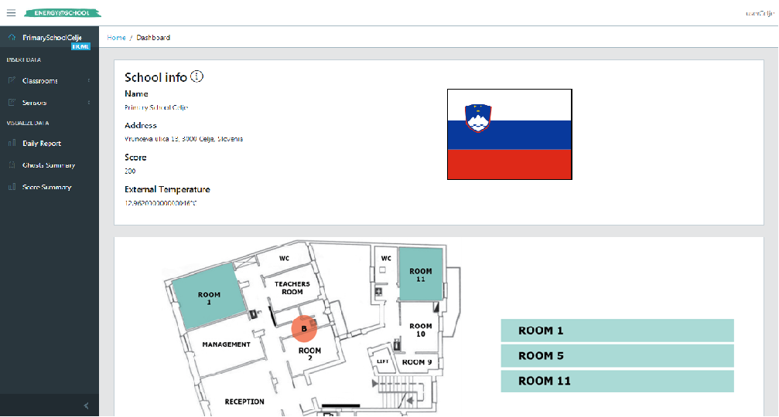
SCREEN 2: Identification data and map of the school

3.Inserting and editing data of a class

In the menu on the left, in the INSERT DATA section, you can manage the data of the monitoring object classes by selecting the Classrooms item: all the classes that have been identified to collect the presence and temperature data are shown in a tree graph.

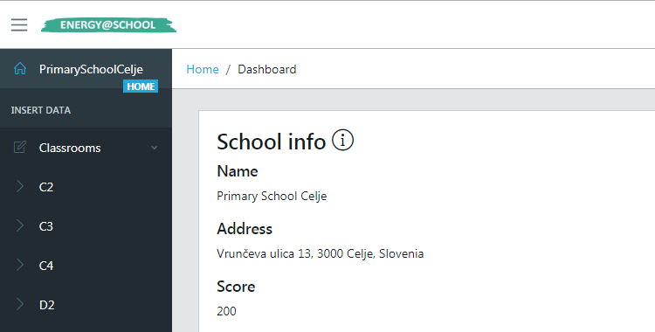
SCREEN 3: Possibility of managing the individual classes selected for monitoring

Clicking on the single class opens a window for entering and displaying data. There are three insertion intervals (the times are only indicative and may vary by a few hours), the grid on the right allows you to check the data already saved. By selecting a row in the grid, the data is shown in the left-hand form and can be updated.
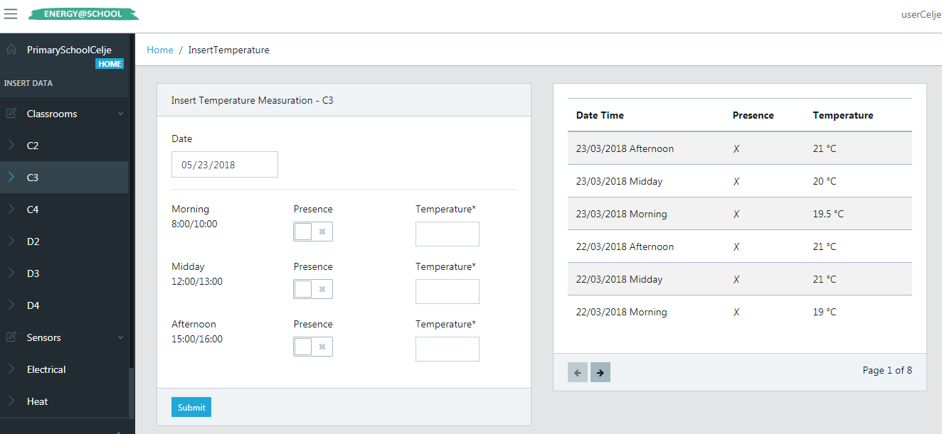
SCREEN 4: Details of the historical consumption of a class and insertion of current consumption

4. Insertion, modification and visualization of a sensor

Selecting the Sensors item in the INSERT DATA section displays the sensors in your school. In the example, an electrical consumption sensor and a thermal consumption sensor were installed and configured in the Zabbix system.

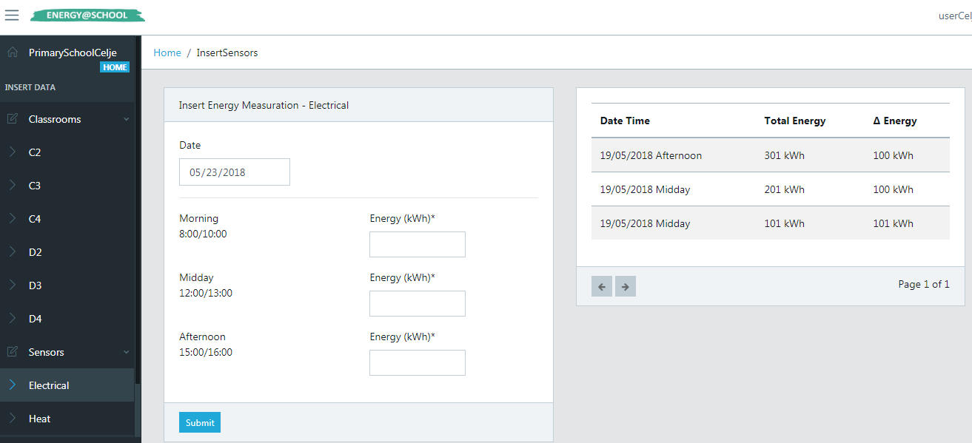

SCREEN 5: insertion of Electrical consumption data
For electrical sensors, the input in kWh is expected, showing the incremental values ​​measured in the three time bands. These values ​​will then be used to calculate the electricity consumed between one interval and another. The grid on the right shows both the incremental value and the difference from the previous one.
The values ​​of the thermal sensors could be expressed in units other than kWh, for example in cubic meters. In this case, the Energy Guardians user must enter the value that the sensor returns and the conversion into thermal kWh will be performed by the system based on the type of heating system that the school has installed.

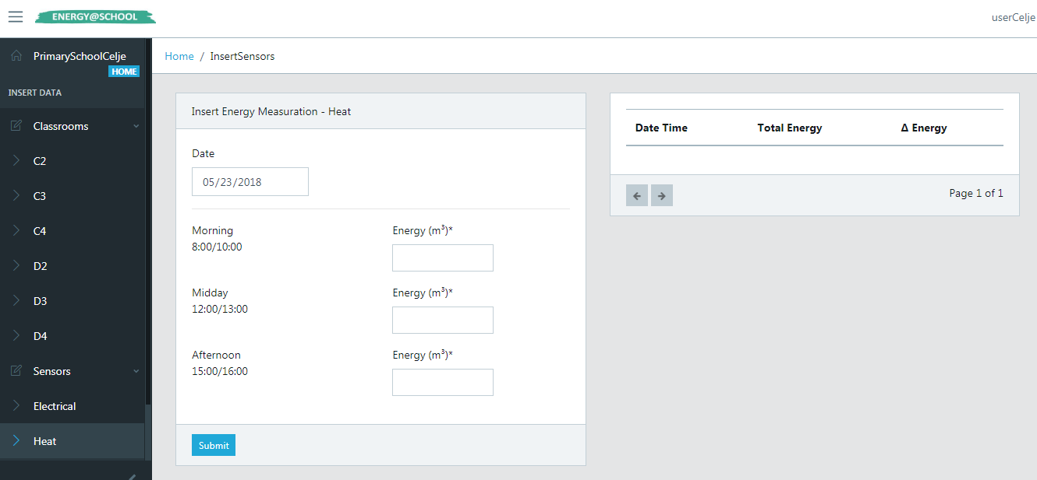

SCREEN 6: Insertion of thermal consumption data

5.Electric / thermal consumption graph

The graphs representing consumption can be consulted using the Daily Report item in the VISUALIZE DATA section.
At the beginning of the page is the date selector to view the electricity consumption.
Selecting a date displays the electrical consumption in terms of the difference between the three measurement ranges:
• the first bar expresses the difference between the last value of the previous day and the first of the selected one (consumption relative to the evening / night)
• the second bar expresses the difference between the second and the first value (morning consumption)
• the third bar expresses the difference between the third and the second value (afternoon consumption)
• the line represents the average consumption recorded to date

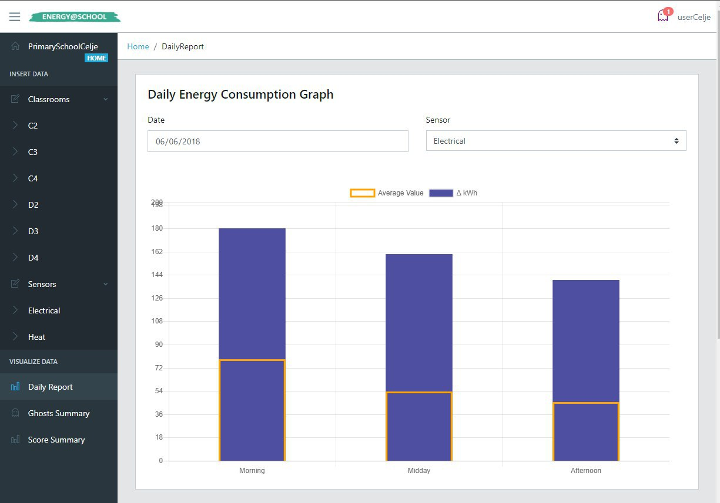

SCREEN 7: Daily Energy consumption graph

In the second part of the page is the selector of the date and of the class whose data are to be displayed. The graph shows the following values:
• class temperature in the three time slots
• external temperature
• average temperature of the class
• thermal well-being area (18 ° C - 22 ° C)

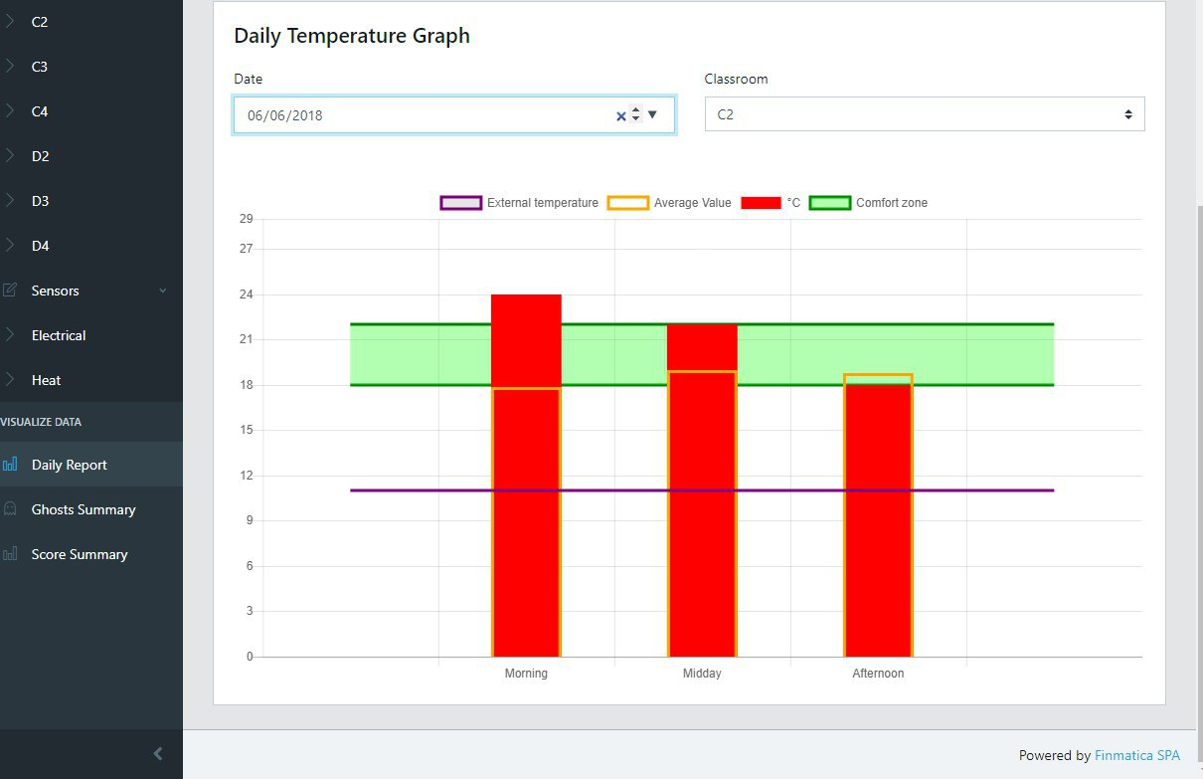

SCREEN 8: Daily temperature graph

6.SCORING OF SCHOOLS
The scores of each school are represented in a bar chart which is updated based on the points acquired or lost during the game.
The scores are assigned according to the behaviours adopted by the JEGs in order to reduce energy consumption without reducing the well-being conditions of the school.

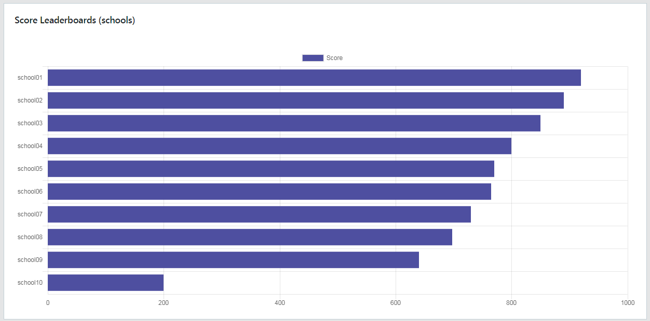
SCREEN 9: Score Leaderboards

