Output fact sheet

Strategies and action plans

Version 2

Project index number and acronym | CE1352 S3HubsinCE
Output number and title | Output O.T2.1 Joint Strategy & Action Plans for the Constellation of CERIS3 Excellence
Responsible partner (PP name and number) | - Carinthia University of Applied Sciences (PP01)  - Fraunhofer Institute for Machine Tools and Forming Technology IWU (PP04)  - Intellimech (PP05)  - ECIPA – Training and Service Agency Limited Liability Consortium (PP06)  - Slovenian Tool and Die Development Center (PP08)  - Croatian Chambers of Economy – Varazdin County Chamber (PP10)
Project website | https://www.interreg-central.eu/Content.Node/S3HubsinCE.html
Delivery date | 02/2020

Summary description of the strategy/action plan (developed and/or implemented), explaining its main objectives and transnational added value
The Output describes a joint transnational strategy, designed by CERIS 3 Navigation Crews, which lays the foundation for a long-term cooperation method among Digital Innovation Hubs. S3HubsinCE aims to use the model of the digital innovation hub, and linkages between these hubs created through collaborative exchange on smart specialization thematic priority areas, to create a common transnational support structure. This structure has a goal to generate stronger connections between RIS3 stakeholders to promote value creation and enhanced competitive advantage in Central Europe.
The strategy and the action plans included in this Output have been designed by Project Partners, who were tasked with designing and planning a Digital Innovation Hub Pilot Action and support actions. Altogether the Partnership was organized to develop 60 pilot actions, which enhanced the collaboration between central European Digital Innovation Hubs, whilst simultaneously promoting trans-regional strategy development with regards to research & innovation smart specialization.

Partners had to design and plan two types of actions: Training & Mobility (“T&M”) Actions and Transfer & Cooperation (“T&C”) Actions. The purpose and objective of these action types are distinct.
T&M Actions focused on promoting connectivity and exchange between Digital Innovation Hubs on the thematic priority areas of central Europe’s smart specialization agenda and promoting the enhancing of understanding between research and innovation ecosystems.
T&C Actions focused on creating market-oriented, transnationally focused actions to create added-value for RIS3-critical organizations.

Each Navigation Crew ensured that its active members were connected with actions, both training and mobility, and transfer and cooperation-oriented, at a transnational level. The table below provides an overview of how many connected actions were tabulated for each Navigation Crew. It is important to note that some actions are repeated between Navigation Crews, because the scope of the action was to develop a multipronged technology-solution to an identified regional challenge.
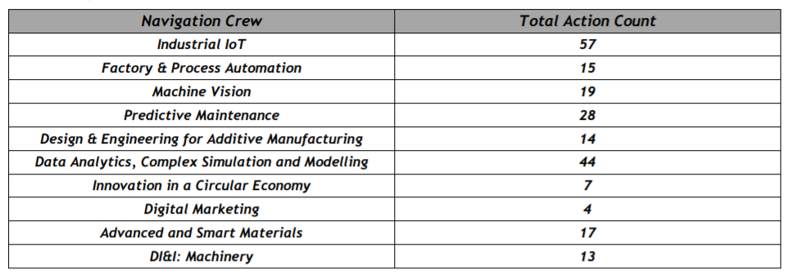

NUTS region(s) concerned by the strategy/action plan (relevant NUTS level)
- CUAS – AT21, Kärnten (NUTS 2)
- FB – AT11, Burgenland (NUTS 2)
- Bwcon – DE11, Stuttgart (NUTS 2)
- Fraunhofer IWU – DED4, Chemnitz (NUTS 2)
- Intellimech – ITC4, Lombardia (NUTS 2)
- Ecipa – ITH3, Veneto (NUTS 2)
- KPT – PL21, Malopolskie (NUTS 2)
- TECOS – SI01, Vzhodna Slovenija (NUTS 2)
- PBN – HU22, Nyugat-Dunántúl (NUTS 2)
- Croatian Chamber of Economy – Varaždin- HR04, Kontinentalna Hrvatska (NUTS 2)

Expected impact and benefits of the strategy/action plan for the concerned territories and target groups
The strategy should guide the transnational cooperation among involved DIHs and their stakeholders thus expanding their usual approach to service delivery.
To promote onward sustainability and stewardship of these actions two digital tools are used. The first, ASANA, is an internal project tool used for detailed project action planning and update provision. It allows the Partners to work together and inform each other about implementation timelines. The second, DIHNET.eu/S3HubinCE online community is a public tool, which all stakeholders can join to receive information about the Digital Innovation Hubs connected within the network, and the actions which each Partner and Digital Innovation Hub team are arranging to connect and exchange on research and innovation ecosystem development.
A wide range of actors will benefit from this approach: Digital Innovation Hubs, Service Providers and enterprises that reach out to these hubs to innovate their processes and products.

Sustainability of the developed and/or implemented strategy/action plan and its transferability to other territories and stakeholders
The implemented actions have provided evidence of the effectiveness of the strategy and the related actions.
The Output defines a strategy and a thematic approach that can easily be transferred and reused in other territories and by other Digital Innovation Hubs.
The main lesson – or evidence – learnt during the design of the strategy and the planning of the actions is that an “on-site” based understanding of the commonalities and needs is essential. Even though online tools have facilitated interaction, there is nothing stronger and more effective than meeting and discussing with several stakeholders to understand how long term cooperation can work.

References to relevant deliverables and web-links
If applicable, pictures or images to be provided as annex
Main relevant Project Deliverables:
- DT2.1.2 – Report on the Joint strategy for the Constellation pf CERIS3 Excellence
- DT2.2.2 – Report on the 10 Transnational Action Plans & DIH Concepts

Weblinks:
DT2.2.2
https://www.interreg-central.eu/Content.Node/S3HubsinCE/Report-on-the-10-Transnational-Action-Plans--DIH-Concepts.pdf

Images:
https://www.interreg-central.eu/Content.Node/S3HubsinCE/DIH-Poster.pdf

Brochure:
https://www.interreg-central.eu/Content.Node/S3HubsinCE/DIH-Brochure.pdf

DIGITAL INNOVATION HUB PILOT ACTIONS:
