Output fact sheet
Pilot actions (including investment, if applicable)
Version 3

Project index number and acronym | CE1277 Arrival Regions
Output number and title | O.T2.1 - Pilot actions testing social innovation in the integration of non-EU nationals
Investment number and title  (if applicable) | n/a
Responsible partner (PP name and number) | Burgenland District
Project website | interreg-central.eu/arrivalregions
Delivery date | 26.08.2021

Summary description of the pilot action (including investment, if applicable) explaining its experimental nature, demonstration character and transnational added value
There are already existing projects working either with adult migrants in their labor integration or with children and teenager in their social integration, but until now, there was no program available for young working migrants that work in their social integration in BLK.

The fact that this pilot action not only works with migrants but also with Germans living a few days together in camps, would help solving the barrier of unfamiliarity and unawareness existing between both parts of the society. The idea of the 3-days-camps instead of one-day-activities is more effective, efficient and sustainable, as new friendships among the camp participants could emerge.

The first camp was very successful, participants (17 participants) were active and motivated and some of them, both German and migrants signed up for a team leader training.

The main difficulties we had to face were related to the pandemic, as the pilot action is about social integration and living together. We unfortunately didn’t have the chance to improve the original idea of the pilot action, as further camps weren´t possible.

Therefore, the rest of the activities were implemented in an online format. Here we faced a loss of interest in participating in the online activities among some of the participants of the first camp as well as some technical challenges among others. We also faced some challenges while recruiting male German participants. In the online activities about 8-12 participants were present.

The transnational value of the Pilot Action can be found in “EMI BLK” itself, as the main idea came from the Swedish project “Ny Pa Landet”, visited during one of the study trips. Although it was adapted to the necessities of BLK, the Pilot Action can be implemented in any other region.

Therefore, the Pilot Action experimented with an innovative idea, bringing German and migrant workers together and facing different topics about integration, openness and self-identity in a safe space. EMI BLK showed as well the necessity within the society of these kind of projects, that make on one hand migrants feel welcomed and on the other hand German to open their minds to new realities.

NUTS region(s) concerned by the pilot action (relevant NUTS level)
DEE08, Burgenland

Expected impact and benefits of the pilot action for the concerned territory and target groups and leverage of additional funds (if applicable)
The Pilot Action has managed to support the social integration of non-EU migrants. Through the camps idea all participants had a safe place to talk about all themes proposed. They also found a support they didn´t think they´d have, as they are already integrated into the labor market and therefore outside all integration projects.

In addition, the fact that the target group was not only integrated by migrants but also by German provided a very important framework to both parts in order to improve their intercultural skills, crucial for promoting tolerance among locals.

The fact that they received the opportunity to become team leader was also crucial, as they finally and maybe for the first time since their arrival in Germany could actively do and plan and not only take part as participants of an initiative or project. To have German in the same positions is a great value to the project, as migrants live neither the “helped role” as participants nor the “power role” as leaders, but the same role than the German participants as equals.

We would like to add that there are not a lot of opportunities for them to get to know young locals in BLK despite their work places, and through EMI BLK they could find new friends from other regions of BLK, while getting to know BLK better, not only through the camps but also through these new friendships.

7 Stakeholders also benefitted from the Pilot Action, not only by networking within BLK but also in other partner regions. Besides, they were directly involved in the project activities, helping them to improve cultural awareness and sensitivity within their institutions.

However, the BLK is the most interested party in keeping its working migrants in the region. Without a successful social integration, migrants won´t feel welcome and will finally move to larger cities in order to find a community they can fit in.

Sustainability of the pilot action results and transferability to other territories and stakeholders
Regarding the possible continuation of the Pilot Action beyond Arrival Regions, the Burgenland District already proposed the possibility and also necessity of continuing the Pilot Action as an independent project, not only because of its success among participants but also because of the impossibility to run it as planned because of the pandemic. In this case, the trained team leaders could also implement their new-gained knowledge in project management and actively support the new project. We mustn´t forget that EMI BLK is very time and energy demanding, e.g. bigger funding and stronger support from both personnel and stakeholders are needed.

The exchange not only among project partners but also with external ones is crucial for the transferability of the pilot action in other territories. As we said before, EMI BLK can be easily adapted to the necessities of other regions and different target groups. In addition, different kind of stakeholders can be involved depending on their capacities and goals in their own institutions.

After running the pilot action, there are some lessons learned that another regions or institutions should consider if adopting the approach to their own regions. While acquiring new participants, it´s important to pay attention in finding participants with common interests, in order to provide them with a space with better communication. Also important is the cooperation between the institution that runs the project and the local businesses, which enable the access to new potential participants. Crucial are interviews and informal talks with both participants and stakeholders, to offer to all parts involved the possibility to ask questions or discuss new ideas.

If applicable, contribution to/ compliance with:
- relevant regulatory requirements
- sustainable development – environmental effects. In case of risk of negative effects, mitigation measures introduced
- horizontal principles such as equal opportunities and non-discrimination
The Pilot Action “EMI BLK” promotes equal opportunities among participants through different aspects. The fact that the target group are “both sides of society”, e.g. migrants and German, put them into a common ground.

During the first camp, as participants didn´t know each other yet, the project partner divided them into groups, in which each nationality was represented, as well as female/male participants. The first team leaders were migrants and German both female and male.
After the first camp, all participants had the opportunity to sign for the team leader training, which offered them a space to work together regardless any other aspect.

From the very beginning, it was made clear that every opinion has to be heard and respected. This way, participants felt safe to share their thoughts during different activities, like the offline and online workshops.

References to relevant deliverables (e.g. pilot action report, studies), investment factsheet and web-links
If applicable, additional documentation, pictures or images to be provided as annex
The output is based on the following deliverables:
- D.T2.1.4 Stakeholder alliance
- D.T2.2.2 Pilot action concept
- D.T2.5.2 Pilot final report

The deliverables can be accessed at https://www.interreg-central.eu/Content.Node/p2--HOME---Non-EU-Nationals-and-Integration-through-Access7.html

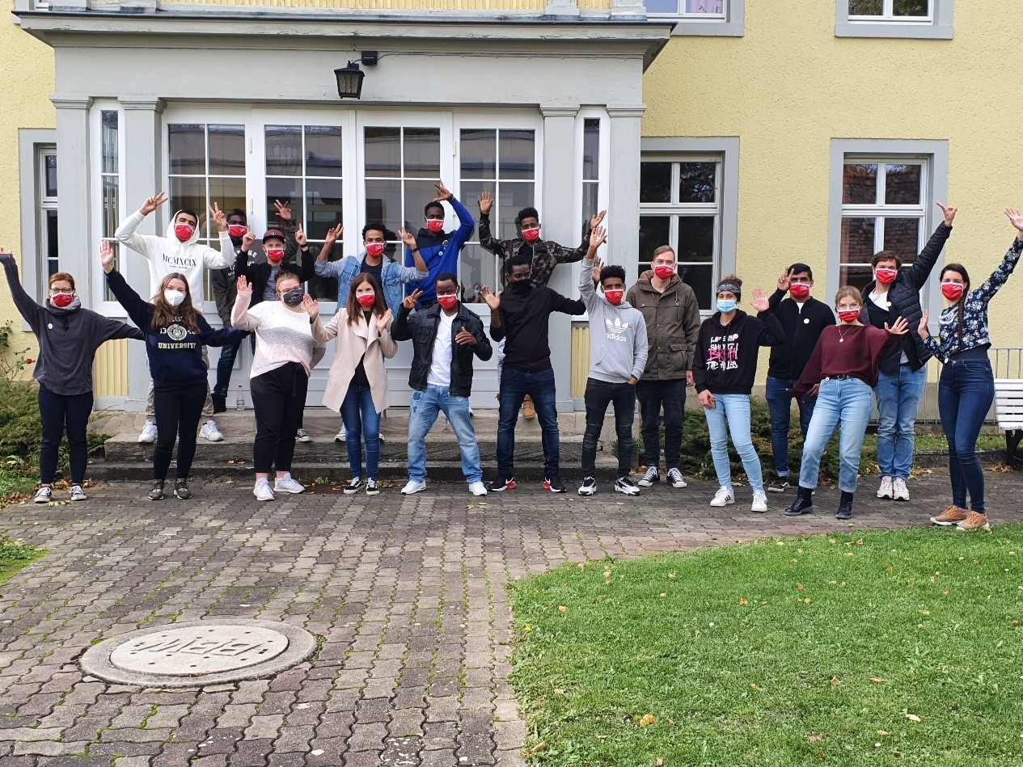
Participants at the 1st camp. Picture: Konrad-Martin-Haus

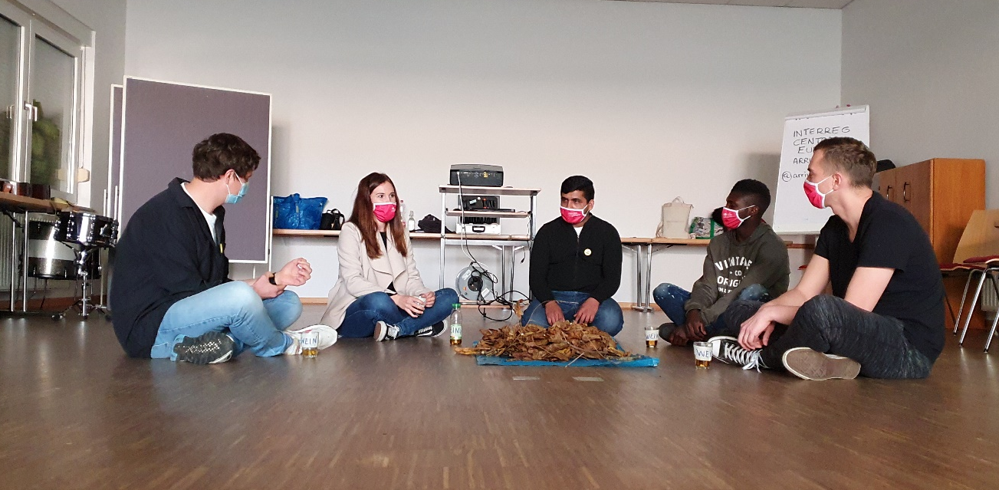
Theatre play created by the participants of the camp. Picture: Anna Blumtritt

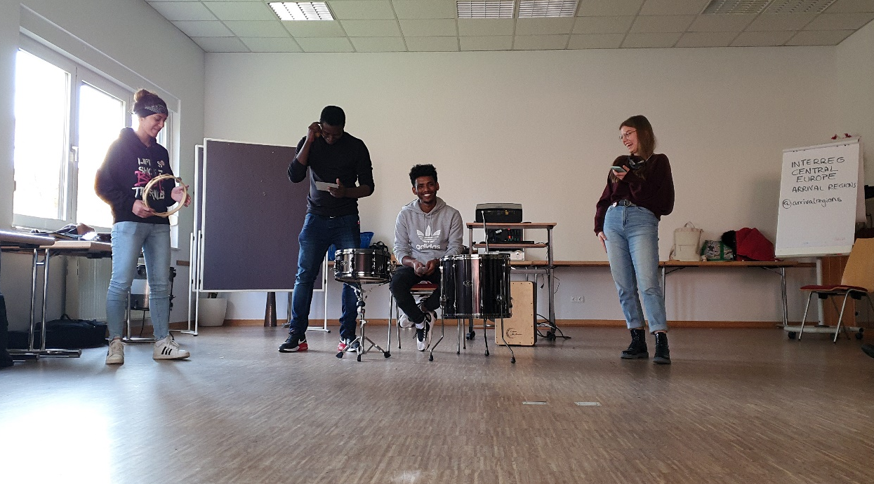
Participants perform their piece of music during the 1st camp; picture: Anna Blumtritt

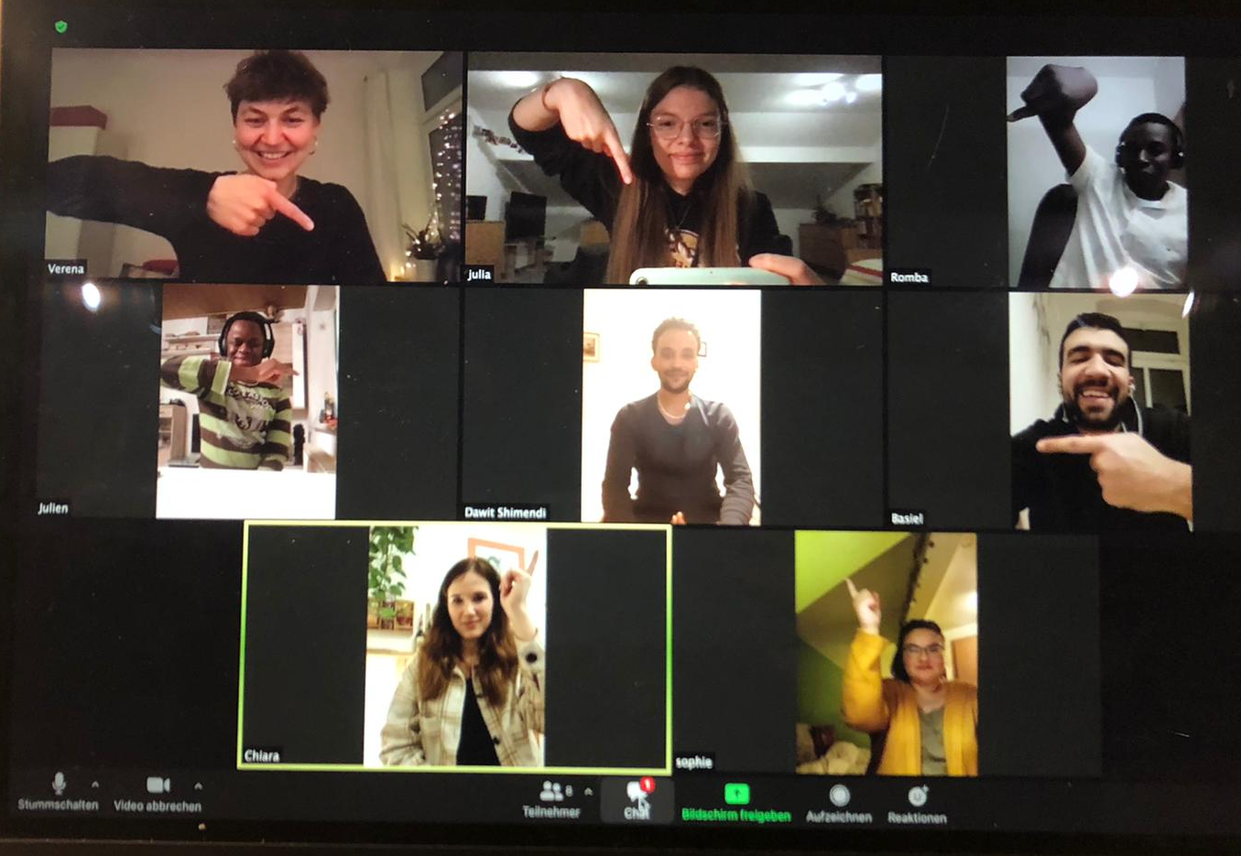
Teamleader coachings via Zoom deal with project management, e.g. the project cycle. Pictures: Julia Rothe & Anna Blumtritt

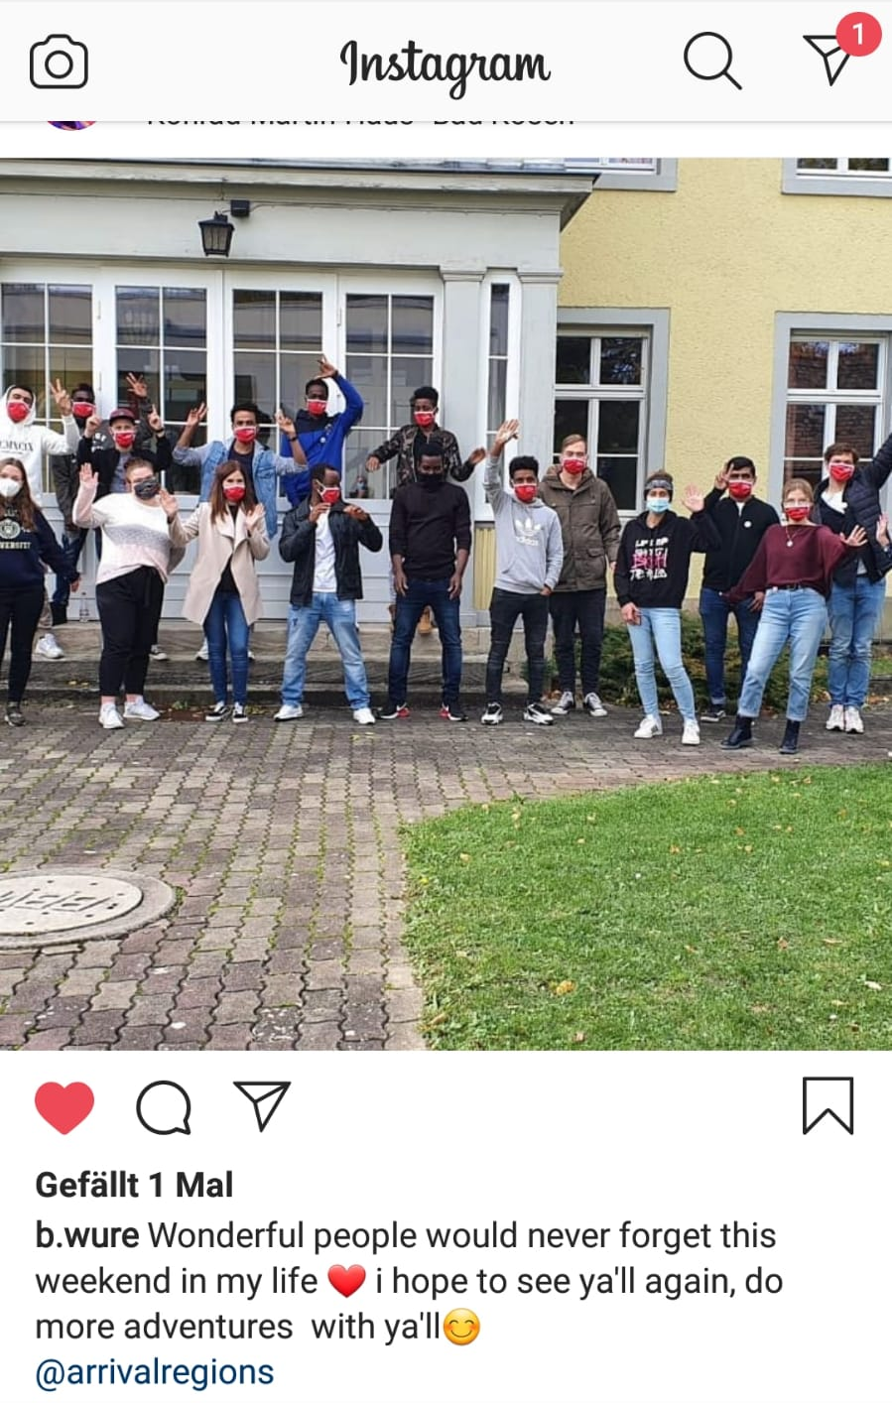
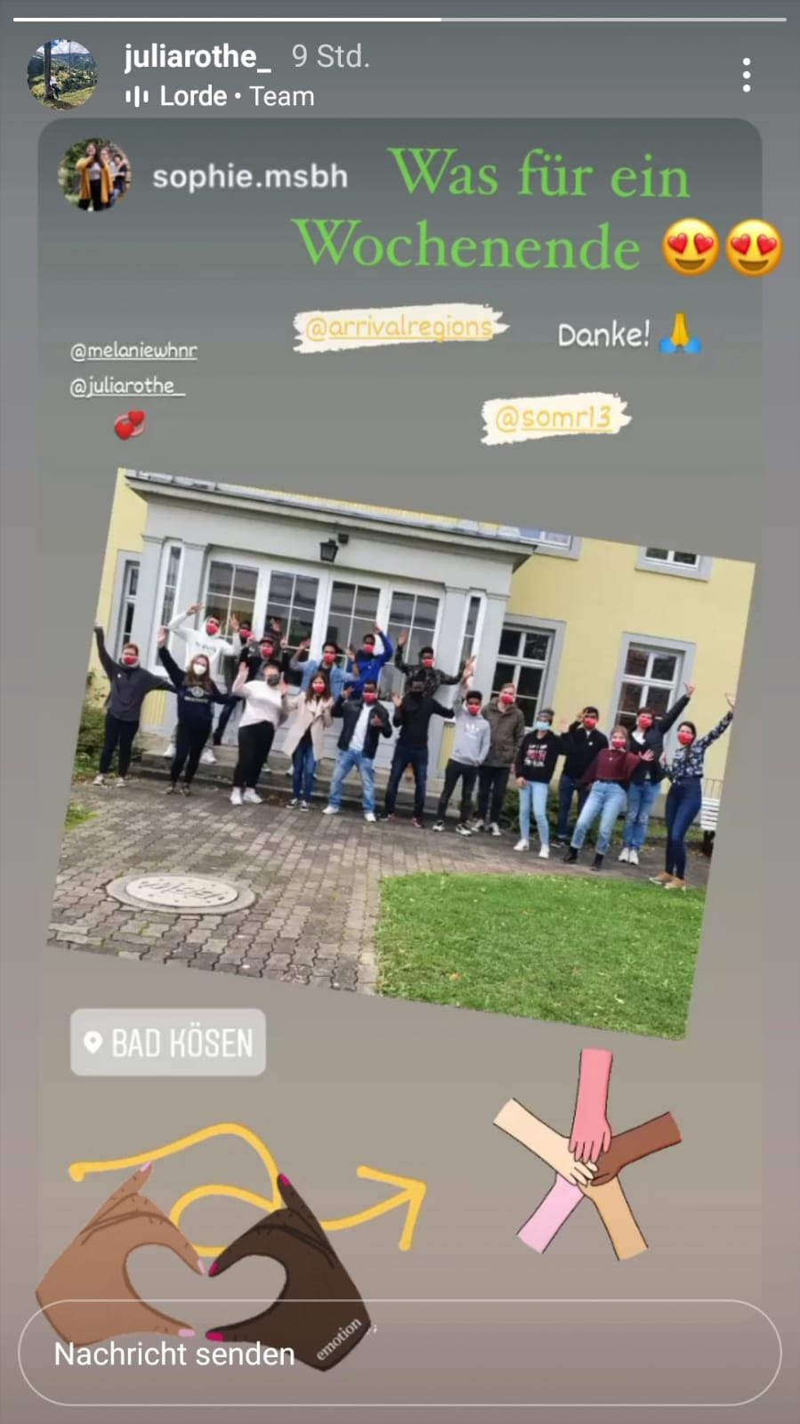
Screenshots from participants´ publications on Instagram after the 1st camp

