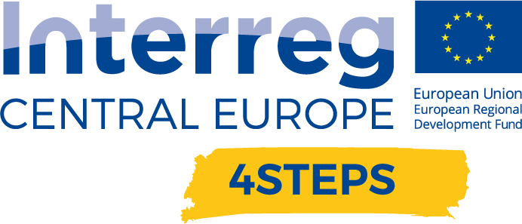
D.C. 5.1 Local focus groups events year 1

D.C. 5.1 Report – Local focus groups events year 1 –  PP6-PBN-Hungary  1st round: 17th June 2020  2nd round: 9th July 2020 | FINAL VERSION  07/2020

- Name of the event, implementing date and place
Name of the event:

HUN: Az Ipar 4.0 és a Digitális Innovációs Központ (DIH) fogalma, szerepe, térségi potenciális hatása
ENG: The definition and role of Industry4.0 and Digital Innovation Hubs and their potential effects in the region
Date:
Based on the availability of the participants, PBN decided to split the DIH workshop into two events, but the topic was the same on both occasions:
- 1st round: 17th June 2020
- 2nd round: 9th July 2020
Location:
Both two occasions were held in PBN’s DIH’s ( am-LAB) location:
HU-9700 Szombathely
Zanati street 32-36

- Number and types of participants/target groups

Number of participants:
1st round: June 17th: 5 people (2 different organisations: 1 university+1 Local Public Authority)

2nd round: 9th July: All in all 12 participants ( 7 different organisations: 1 Local Public Authority, 1 Regional Public Authority, 2 SMEs, 2 Higher Education and Research, 1 BSO)

- Below, participants of both rounds of workshops (17th June; 9th July) are indicated
- There were overlappings in the participants in the two wokrshops (e.g: representatives of City of Szombathely took part in both rounds)
o In case more than one person participated on the workshops from one organisation, we counted the number of organisations not the people who participated (e.g: Two representatives from City of Szombathely have been counted only 1)

☐ Local public authority (how many: 1 )
☐ Regional public authority (how many: 1 )
☐ Sectoral agency (how many: 0 )
☐ Higher education and research (how many: 3 )
☐ Education/ Training Centre and Schools (how many: 0 )
☐ SMEs (how many: 2 )
☐ Business Support Organizations (how many: 1 )
☐ General public (how many: )
☐ National Public Authority (how many: 0 )

- Topics tackled and links to deliverables, outputs
In the beginning of the focus group events, the representative of PBN was shortly summarising the results of the 4STEPS project, focusing on the WPT1 technical achievements.
The procedure of SME involvement (D.T1.1.3), the country and transnational mapping results (D.T1.2.1) as well as the final version of the supporting I4.0 Catalogue was shared with the participants. Attendees were also informed about the definition of the TML index on transnational level (D.T1.3.1).

During to the workshop, participants could be informed and extend their knowledge about the:
- DIHs in general, their concept and roles currently and in the upcoming programming period
- R&D challenges on European level
- Objectives of the European Commission
- Main tools of EU Commission to reach these objectives
- Focus Areas of Horizon Europe
- Focus Areas of Digital Europe
- Main concepts (DIH; digitization; Artificial Intelligence; Machine Learning; Internet of things; Industrial Internet of things; Data Science; Augmented Reality; Virtual Reality
- Ongoing co-operations with EU stakeholders

Due to the information about DIHs, the main technical concepts, as well as the co-operations with EU stakeholders, participants have a comprehensive picture about these topics, which they could communicate and disseminate with other stakeholders (e.g: national level; SMEs; citizens..)

- Expected effects and follow up

The discussion between PBN representative and the participants was really fruitful, and they expressed their appreciation about the current work of PBN and its DIH, am-LAB. Besides, they are open to cooperate in the future and they are advocating such workshops like this one in order to further expand their knowledge

- Annexes: e.g. agenda of the event, pictures, media coverage web- links etc

The following materials have been uploaded to the common google drive project folder, and can be found here. The listed materials have been also shared with WPC leader as well
Agenda (Hungarian and English), the signed participant list of the two round events (June 17 and 9th July)

• Filled overall report of the 2round event (current document)
• Agenda (Hungarian, English)
• Participant list (June 17th and July 9th)
• PBN’s Presentation held (Hungarian)

